**Projectile & Circular Motion**

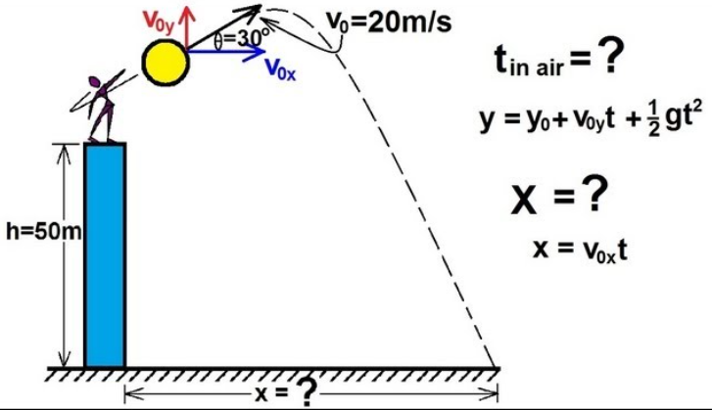

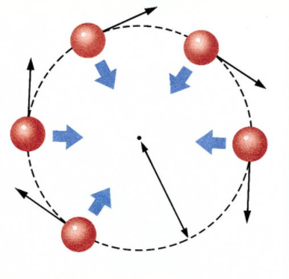

**See** [**https://www.learningctronline.com/courses**](https://www.learningctronline.com/courses) **for Materials and Resources.**

**Topics:**

1. Projectile & Circular Motion

**Objectives:**

* + Identify five types of projectile motion.
  + Resolve horizontal and vertical components of various projectiles (horizontal, upwardly launched, non-horizontal off a cliff).
  + Rotational, linear (tangential) speed. Revolution. Centripetal & Centrifugal force. Simulated Gravity.

TAKE NOTE

1. Reading (Hewitt Text)

1. Note Taking Worksheet Chapter 9
2. Worksheet: Trajectory of Projectiles
3. Problem Set Projectiles
4. Lab: Non-Horizontal Projectiles off a Cliff
5. Lab: Circular Motion
6. HONORS Notes Study Guide for Test
7. Test: Projectile & Circular Motion
8. Week 8 Devotional (<https://www.learningctronline.com/devotional>)

**Text**: Chapter 9: Circular Motion 9.1 – 9.6 (Hewitt)

Chapter 3: Projectile Motion 3.1 – 3.5

**Class Notes: Note Taking Worksheet (Chapter 9) Document**

**Homework**:

* Problem Set Projectiles
* Worksheet: Trajectory of Projectiles

**Lab**: Non-Horizontal Launch off Cliff Projectiles

* Perform the lab as directed using the worksheet provided.
* Complete all calculations and data, showing work whenever appropriate.
* Conclusions should be answered in complete sentences that convey a complete thought.
* Save the documents into your LAB folder in the Physics folder on your desktop.

**Lab**: Circular Motion

* Perform the lab as directed using the worksheet provided.
* Complete all calculations and data, showing work whenever appropriate.
* Conclusions should be answered in complete sentences that convey a complete thought.
* Save the documents into your LAB folder in the Physics folder on your desktop.

**TEST:**  Projectiles & Circular Motion

1) the academic integrity policy

* Tests must be completed **WITHOUT** referring to books, notes, the internet, people, or any outside resources.
* Students **MAY** use the approved Periodic Tables, approved Reference Tables, or approved equation (formula) sheet (provided by the teacher) along with calculators and scratch paper.
* A guardian should be proctoring the test. Proctoring means to monitor the following:

2) Take the **"in one sitting"**, meaning that once you start the test, you must complete it without interruption.

3) There is a **45-minute time limit** on this test. Please have the proctor write the time taken at the top of your answer sheet with their signature or initials.

4) Proctors should NOT be reading the test or engaging students during the test.

5) Do NOT use RED font. Black font is best.

Supplemental Resources (Optional)

1. Paper Airplane Challenge

<http://somup.com/crhb2nF98I> Projectile Motion (5:49)

<http://somup.com/crhb20F9Ri> Circular Motion (8:06)