Wild Edibles: Field Activity

Goldenrod Dissection

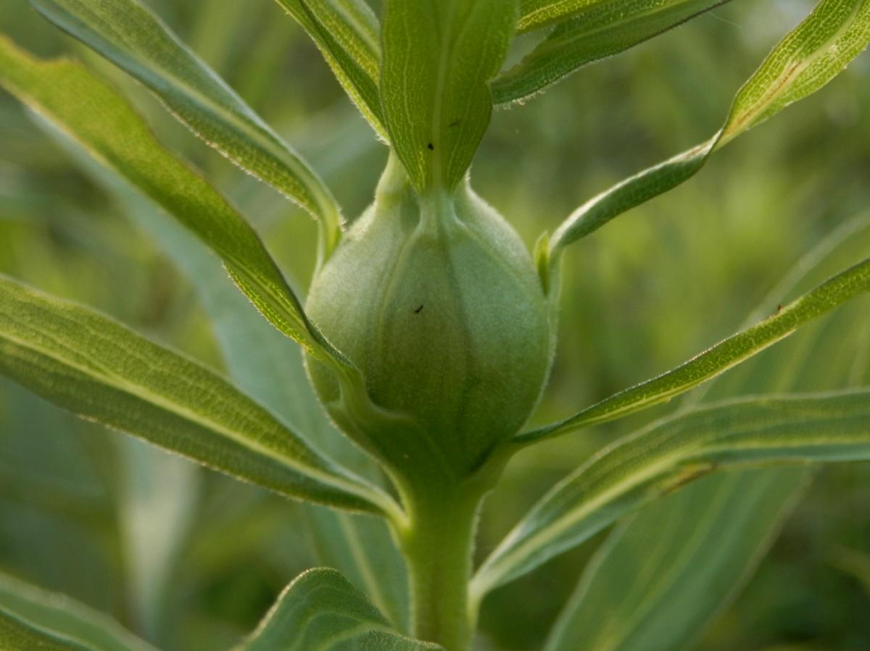

MATERIALS

Goldenrod gall Dissection probe

Scalpel Magnifying glass

Dissection/Binocular Microscope Paper towels

Petri dish

This activity should be performed in sequence. Don’t skip steps.

1. Obtain a Peterson Field Guide and look up “Goldenrod.” Go outside and obtain a stalk of Goldenrod that contains a “gall”. A “gall” is a swelling of a plant usually due to a fungus or a parasite. The gall will be spherical in shape and approximately ½ inch to 1 inch in diameter. It is located on the stem of the Goldenrod plant and is easy to find.

2. Obtain a dissecting probe, a scalpel and a paper towel. The paper towel will be your dissection board.” You may use an actual dissection board if one is available.

3. Cut off the stem around the gall so you are left with only the green ball. Throw away the excess plant material.

4. Be careful dissecting the gall because the wasp larvae living in it is near the center. Use the dissecting probe to stabilize the gall rather than your hand. This will avoid any cuts or accidents.

5. Using the scalpel, cut into the gall approximately 1/3 of the way. Remove the scalpel from this incision and move it to the left or the right ¼ inch. Tilt the scalpel towards the first incision and make your second cut. This will remove a “pie-shaped” wedge from the gall, yet will leave the center “inner core.”

6. A gall has and “outer core” that is whitish and hard, and an “inner core” that is light-greenish and almost see through. The bright-white, small wasp larvae is buried in the “inner core.”

7. Continue to dissect away the “outer core” of the gall as in procedure 6 until you are left with only the light-greenish, almost see-through “inner core.” Throw the excess plant material into the waste basket.

8. Carefully dissect the “inner core” of the gall until you expose the bright-white, small wasp larvae. The larvae will vary in size and shape. It may be round and as small as a BB or as big as a pellet. It may be cylindrical and look like a fly larvae (maggot). Describe what you see in your gall.

9. Carefully remove the wasp larvae from the gall using the dissection probe. Place the wasp larvae on the paper towel and throw away the excess plant material.

10. Observe the wasp larvae for several minutes. Notice and WRITE DOWN its size, its shape, and its movements.

11. Insert an image of the wasp larvae: “**Goldenrod Wasp Larvae with Unaided Eye**.”

12. Now go around to at least two other groups and observe their larvae. Underneath your sketch, write a short paragraph comparing your larvae with the other larvae (compare size, shape, movements).

13. Obtain a petri dish from the lab counter. Place your larvae into the petri dish. If a dissection microscope is available, take your larvae and view it under the microscope for several minutes. If a microscope is not available, use a magnifying glass until the binocular microscope is available.

14. Focus the dissection microscope on different parts of the wasp larvae. For instance, notice how both ends of the larvae appear. Are they the same? Describe how the larvae moves (like an accordion, side to side, up and down?).

15. Once again, insert an image of the wasp larvae: “Goldenrod Wasp Larvae Under Dissection Microscope.” This image should include much more detail.

16. Throw away the wasp larvae (no sticking it down someone’s shirt). Clean out the petri dish and place it back NEATLY on the lab counter.

17. Be sure your table is wiped off and clean. Your parents will appreciate it.

