Velocity



v = Δx

t

d

v

t

v = d

t

s = d

t

v = (vf – vi)

2

sin θ = opp / hyp

cos θ = adj / hyp

tan θ = opp / adj

45

√2

√2

2

30

60

√3

2

1

Acceleration

∆v

a

t

a = ∆v/t

a = (vf – vi)

t

vf = vi + at

d = vit + ½ at2

d = ½ a t2

vertical displacement

Vf2 = Vi2 + 2ad

C2 = A2 + B2 – 2ABcos(c)

y

x

R

θ

4

5

53

37

3

Gravity

F = G m1 m2 / d2

v = gt or v = at

Instantaneous Velocity

d = ½ g t2

vertical displacement

Newton's Laws

ΣF = m a

@

@

W

f┴

W = m g

Weight

fparallel = mgsin@

f┴= mgcos@

u = Ff / FN

dx = Rcos θ

dy = Rsin θ

x2 + y2 = R2

Momentum

p = mv

m1v1 = m2v2

ft = ∆mv

(impulse)

Energy & Work

KE = ½ mv2

GPE = mgh

TE = PE + KE

W = fd

Power = W/t

MA = dE / dR

MA = fR / fE

Eff = Wout / Win

Eff = AMA / IMA

Electricity

I

R

V

V = IR

I = q

t

P = IV

RT = R1 + R2 + R3 + …

Series

IT = I1 = I2 = I3 = ….

series

VT = V1 + V2 + V3 + …

Series

IT = I1 + I2 + I3 + ….

Parallel

1 = 1 + 1 + 1 + …

RT R1 R2 R3

Parallel

VT = V1 = V2 = V3 + …

Parallel

F = k q1 q2

d2

k = 9.0 x109 N m2 / C2

E

q

F

E = F/q

V = Ed

q = cV

V = W/q

E = Pt 🡪 E = I2Rt

Electromagnetism

F = q v B

F = B I L

C = q/V

ΦB = B A cos *θ*

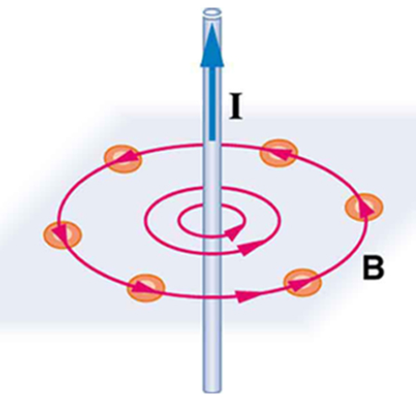 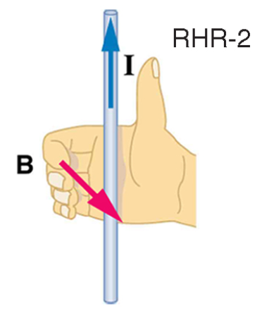

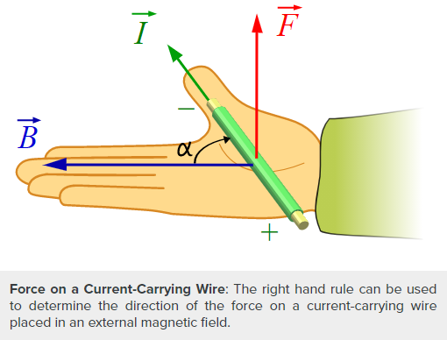

Projectile Motion

dy = Vyt + ½ gt2

dx = Vxt

Vx = Vicos@

Vy = Visin@

Circular Motion

ωcyc = v / 2πr

ωrad = v / r

ac = V2/r

L = mvr

Irot = mr2

Torque = fr

T = 1/f = 2π/ω

Atom / Quantum

*E = hν c = f λ* E = hf = hc/λ

combined with f = c/λ

f = *v*

*h = 6.626 × 10–34 J·s*

*c = 2.998 x 108 m/s*

*1.6 x 10-19 j/eV*

En = -13.6 eV(1/n2)

*For Hydrogen atom*

Average Orbital Radius

Of an Energy Level

Rn = kn2

*where k = 5.3 x 10-11 m*

Elemental Charge (e)

±1.6 x 10-19 C

Heat

q = mc∆T

4.18 J/(g· ⁰C) = 1 cal/ g· ⁰C

cwater

∆Hf = 80.0 cal/g

∆Hv = 540.0 cal/g

Sound

T = 1/f

V = f λ

L = λ / 2

*Open organ pipe*

**% Error = |(Accepted – Observed)/accepted| x 100%**

L = λ / 4

*Closed organ pipe*

Light

i = r

ni sin θi = nt sin θt

n = c / v

sin θc = nt / ni

M = hi / ho or - di / do

1/f = 1/do + 1/di

*c = 2.998 x 108 m/s*

**“AGES”**

**A** 🡪 What is the problem **ASKING** for? [*Highlight this in the question. This is the destination*.]

**G** 🡪 What are you **GIVEN** (information)? [*Label all amounts/variables given. This is the starting point*.]

**E** 🡪 What **EQUATION** should be used? [*Write the equation/formula needed. This is the map*.}

**S** 🡪 **SOLVE** *the problem by plugging in measurements with units*. Does it makes SENSE?