**REDOX Reactions Chapter 20**

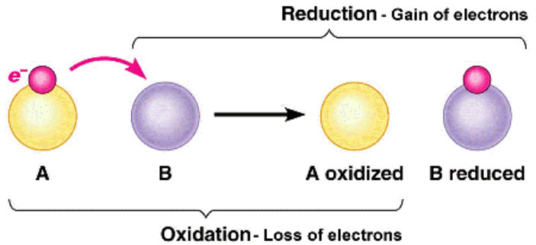

**See** [**https://www.learningctronline.com/courses**](https://www.learningctronline.com/courses) **for Materials and Resources.**

**Topics:**

1. REDOX Reactions

**Objectives:**

1. Follow rules to assign oxidation numbers to atoms in compounds.
2. Recognize oxidation-reduction (REDOX) reactions and define oxidation and reduction, distinguishing oxidized & reduced species and oxidizing & reducing agents in a REDOX reaction.
3. Write half reactions for oxidation-reduction reactions.
4. Use the half-reaction method to balance oxidation-reduction equations.
5. Use the Electron transfer method/Oxidation number method to balance oxidation-reduction equations.

TAKE NOTE

1. Notes/Study Guide (1 week)
2. Lesson Check/Sample problems or Alternative Worksheet
3. Lab Quiz: REDOX Simulation & Lemon Battery
4. Test Corrections (Acids & Bases)
5. Upcoming REDOX & Electrochemistry Test (after Week 32)
6. Upcoming Semester Exam (after Week 32) … Study Guide Available (Chapter 11-12, 14-21 due within 10 days after week 32’s class)
7. Class Song: “Riesen (Teacher) Knows Best”
8. Week 31 Devotional (<https://www.learningctronline.com/devotional>)

**Text**: Chapter 20: REDOX Reactions pp. 690-725

Read the assigned pages in the text.

**Class Notes: PowerPoint or PDF**

**Notes/Study Guide:** Fill in the Chapter 20 worksheet to understand the class notes.

**Homework**: Text

(1) Answer the KEYED **“Lesson Check”** questions at the end of each.

(2) Answer the **“Sample problems”** found in the “Sample Problem” boxes throughout the chapter. An answer KEY is provided for you to use to self-correct your homework problems.

* Put your answers into complete thoughts in a Word document. Do NOT just put the answer, but write a phrase or sentence that you can study from for your tests. Save your work in a WORD document and SAVE into your HOMEWORK folder in the Chemistry folder on the desktop.
* Assignments will be “spot checked” during class or submitted via email.

**Alternate Homework**:

1. REDOX Worksheet
2. Chapter 20 Study Guide Pearson (optional)

**Labs**: REDOX Simulation & Lemon Battery

1. Perform the labs (2) using the video and worksheets provided.  
     
   [Redox Simulation](http://somup.com/cqeqbqnTTq) (6:26)  
     
   The final 40 seconds shows activity of Mg, Zn, Fe, and Pb.
2. Answers are provided at the end of the document for guidance. Do NOT copy and paste these answers, but write using your own words.
3. Save the document into your LAB folder in the Chemistry folder on your desktop.  
   Study for understanding, and when ready, take the Lab Quiz.
4. You may **NOT** use the worksheet on this lab test.

**TEST:** After next week is the REDOX / Electrochemistry Test (Chapters 20-21) and the Semester Exam (Chapters 11-21).

Supplemental Resources (Optional)

1. Chapter 20 Study Guide Pearson

[Determining Oxidation State](http://somup.com/cFXl25niyM) (7:09)  
  
[Parable of the Sower](http://somup.com/cqeZVmnO1s) (3:04)