Newton’s Third Law Lab Demos

<http://cnx.org/content/m42074/latest/?collection=col11406/latest>

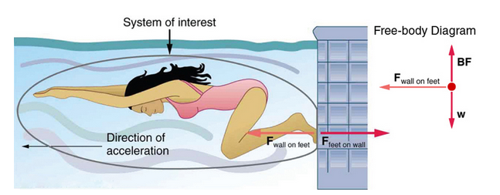

**Figure 1:**

* When the swimmer exerts a force **F(feet on wall)** on the wall, she accelerates in the direction opposite to that of her push. This means the net external force on her is in the direction opposite to **F(feet on wall)**.
* This opposition occurs because, in accordance with Newton’s third law of motion, the wall exerts a force, **F(wall on feet)**on her, equal in magnitude but in the direction opposite to the one she exerts on it.
* The line around the swimmer indicates the system of interest. Note that **F(feet on wall)** does not act on this system (the swimmer) and, thus, does not cancel **F(wall on feet).**
* Thus the free-body diagram shows only **F(wall on feet)**, **W**, the gravitational force, and **BF**, the buoyant force of the water supporting the swimmer’s weight. The vertical forces, **W** and **BF** cancel since there is no vertical motion.

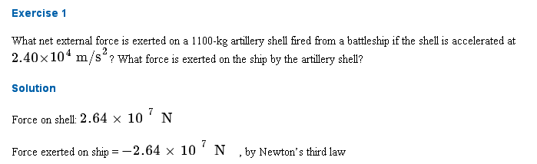A physics professor pushes a cart of demonstration equipment to a lecture hall, as seen in [**Figure 2**](http://cnx.org/content/m42074/latest/#import-auto-id2324690). Her mass is 65.0 kg, the cart’s is 12.0 kg, and the equipment’s is 7.0 kg.

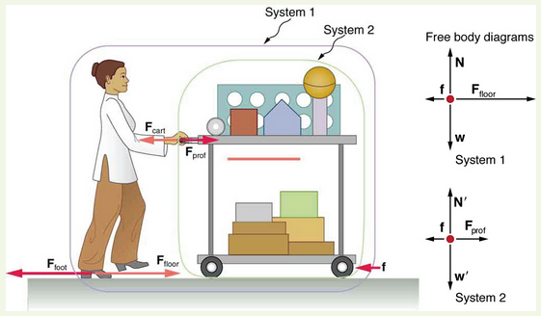

**Figure 2:**

A professor pushes a cart of demonstration equipment. The lengths of the arrows are proportional to the magnitudes of the forces (except for , since it is too small to draw to scale). Different questions are asked in each example; thus, the system of interest must be defined differently for each. System 1 is appropriate for [**Example 2**](http://cnx.org/content/m42074/latest/#fs-id2092526), since it asks for the acceleration of the entire group of objects. Only  and  are external forces acting on System 1 along the line of motion. All other forces either cancel or act on the outside world. System 2 is chosen for this example so that  will be an external force and enter into Newton’s second law. Note that the free-body diagrams, which allow us to apply Newton’s second law, vary with the system chosen.

Calculate the acceleration produced when the professor exerts a backward force of 150 N on the floor. All forces opposing the motion, such as friction on the cart’s wheels and air resistance, total 24.0 N.

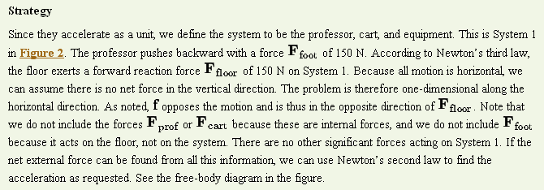

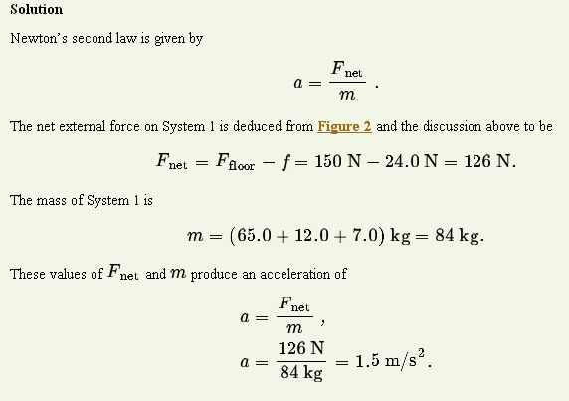

Calculate the force the professor exerts on the cart in [**Figure 2**](http://cnx.org/content/m42074/latest/#import-auto-id2324690) using data from the previous example if needed.

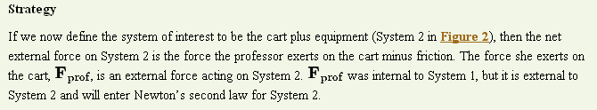

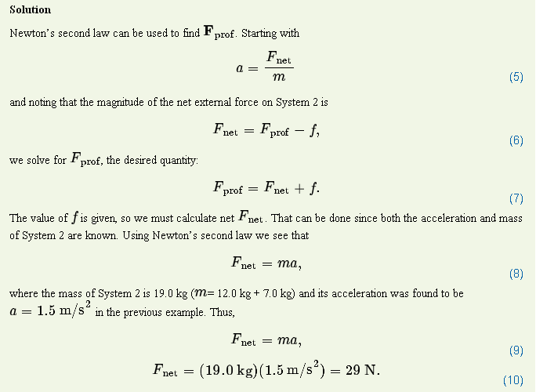

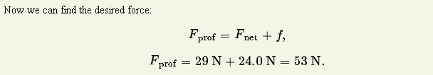

**Section Summary**

* **Newton’s third law of motion** represents a basic symmetry in nature. It states: Whenever one body exerts a force on a second body, the first body experiences a force that is equal in magnitude and opposite in direction to the force that the first body exerts.
* A **thrust** is a reaction force that pushes a body forward in response to a backward force. Rockets, airplanes, and cars are pushed forward by a thrust reaction force.