**<http://somup.com/cqerrcnTsz> Lab Video (6:11)**

**Titration of Strong and Weak Acids & Bases**

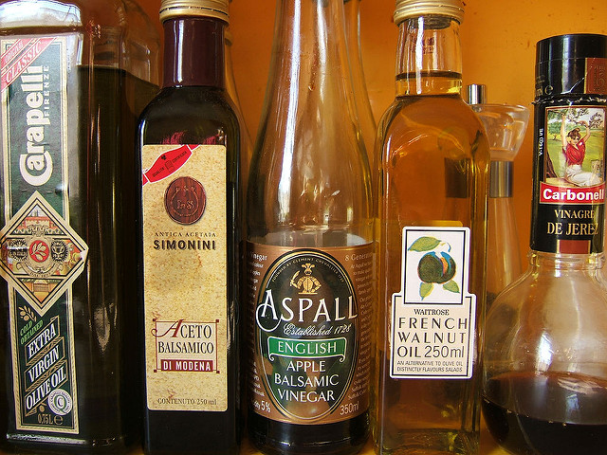 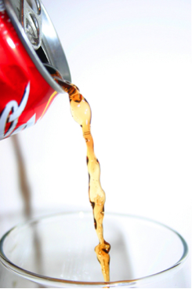

**Figure 1. A Variety of Flavored Vinegars (left) and Soda Pop (right)**

**What Is the Concentration of Acid in Your Vinegar?**

Have you checked out the vinegar aisle in a supermarket recently? If you have, you may have noticed that some stores carry a variety of vinegars. Vinegars are widely used in households and the food industry. Which vinegar should you buy? It depends what you want to use it for. The distilled white vinegar is ideal for pickling and cleaning, whereas balsamic vinegars are great for salad dressings. You may have noticed some vinegars taste more sour than others. This is due to the amount of _____ they contain. The acid in vinegar is a weak acid called _____ acid (ethanoic acid). Vinegar bottles usually have the concentration of acetic acid on the label. The acid concentration is determined by reacting it with a base. This technique is called _____ and is widely used in laboratories to determine _____ concentrations of substances.

**How Much Acid Is in Your Soda?**

You have probably heard that soda is bad for you, mostly because of the sugar content, but also because of the acid content. The _____ in soda can damage your teeth if you consume it in large quantities. Not all sodas have the same acid content, and some are more acidic than others. How can you determine how much acid is in your favorite soda? You can do that by reacting it with a _____ and then using the amount of base required to fully react with the acid in soda to calculate the amount of acid. This is how the food industry also tests its products. This technique is called titration and is widely used to determine unknown concentrations of substances in laboratories, industries, and households.

**Strong and Weak Acids**

Acids and bases are classified according to the degree to which they _____ in water. Strong acids and bases dissociate _____, whereas weak acids and bases only _____ dissociate into ions. For example, HCl, which is a _____ acid, dissociates _____ into _____ ion (H3O+) and its conjugate base, Cl– (chloride ion) as shown in the reaction below:

begin mathsize 12px style HCl left parenthesis a q right parenthesis space plus space straight H subscript 2 straight O left parenthesis l right parenthesis space rightwards arrow straight H subscript 3 straight O to the power of plus left parenthesis a q right parenthesis space plus space Cl to the power of – left parenthesis a q right parenthesis end style

However, a _____ acid (HA) only _____ dissociates into hydronium ion and its conjugate base (A–), and equilibrium is established.

begin mathsize 12px style HA left parenthesis a q right parenthesis space plus space straight H subscript 2 straight O left parenthesis l right parenthesis space rightwards arrow space straight H subscript 3 straight O to the power of plus left parenthesis a q right parenthesis space plus space straight A to the power of – left parenthesis a q right parenthesis end style

|  |
| --- |
| begin mathsize 12px style K subscript straight a space end subscript equals space fraction numerator left square bracket straight H subscript 3 straight O to the power of plus right square bracket left square bracket straight A to the power of minus right square bracket over denominator left square bracket HA right square bracket end fraction end style |

The equilibrium constant is called the acid _____ constant (*K*a) and is calculated using the formula below.

where [H3O+], [A–], and [HA] are the molar concentrations of the hydronium ion, conjugate base, and undissociated acid, respectively at equilibrium. *K*a is a measure of the acid’s _____. The _____ the *K*a, the _____ the acid is. For example, the *K*aof HCl (_____ acid) is ~106, while the *K*aacetic acid (_____ acid) is ~10-5.

**Acid–Base Reactions**

When an acid reacts with a base, a _____ reactionoccurs. The __+ ions from the _____ and the (___)– ions from the _____ combine to form _____ and are therefore neutralized. The other product of reaction is a _____. For example, hydrochloric acid reacts with sodium hydroxide to form sodium chloride and water (written two ways to show water as ions).

begin mathsize 12px style HCl left parenthesis a q right parenthesis space plus space NaOH left parenthesis a q right parenthesis space rightwards arrow space NaCl left parenthesis a q right parenthesis space plus space straight H subscript 2 straight O left parenthesis l right parenthesis end style

HCl(aq) + NaOH 🡪 NaCl(aq) + H+(OH)-

A reaction between a _____ acid and a _____ base results in a _____ solution (pH = ___). A reaction between a _____ acid and a _____ base results in a _____ solution (pH > 7), whereas one between a _____ acid and a _____ base results in an _____ solution (pH < 7). The change in pH during the titration allows for monitoring using acid–base _____ and pH _____.

**Acid–Base Titration**

Titration is one of the most useful analytical techniques for determining the _____ of an _____ solution. Titrations are classified based on the type of reaction between _____ (*unknown amount of solution of known concentration that is added to another solution*) and _____ (*known amount of solution of unknown concentration being titrated*). One of the most common titration is *acid–base*. In an acid–base titration either a solution of a base of known concentration (titrant) is used to determine the unknown concentration of a solution of an acid (analyte) or vice versa. During a titration, the titrant is delivered from a burette to the analyte solution until the reaction is complete and _____ *point* is reached.

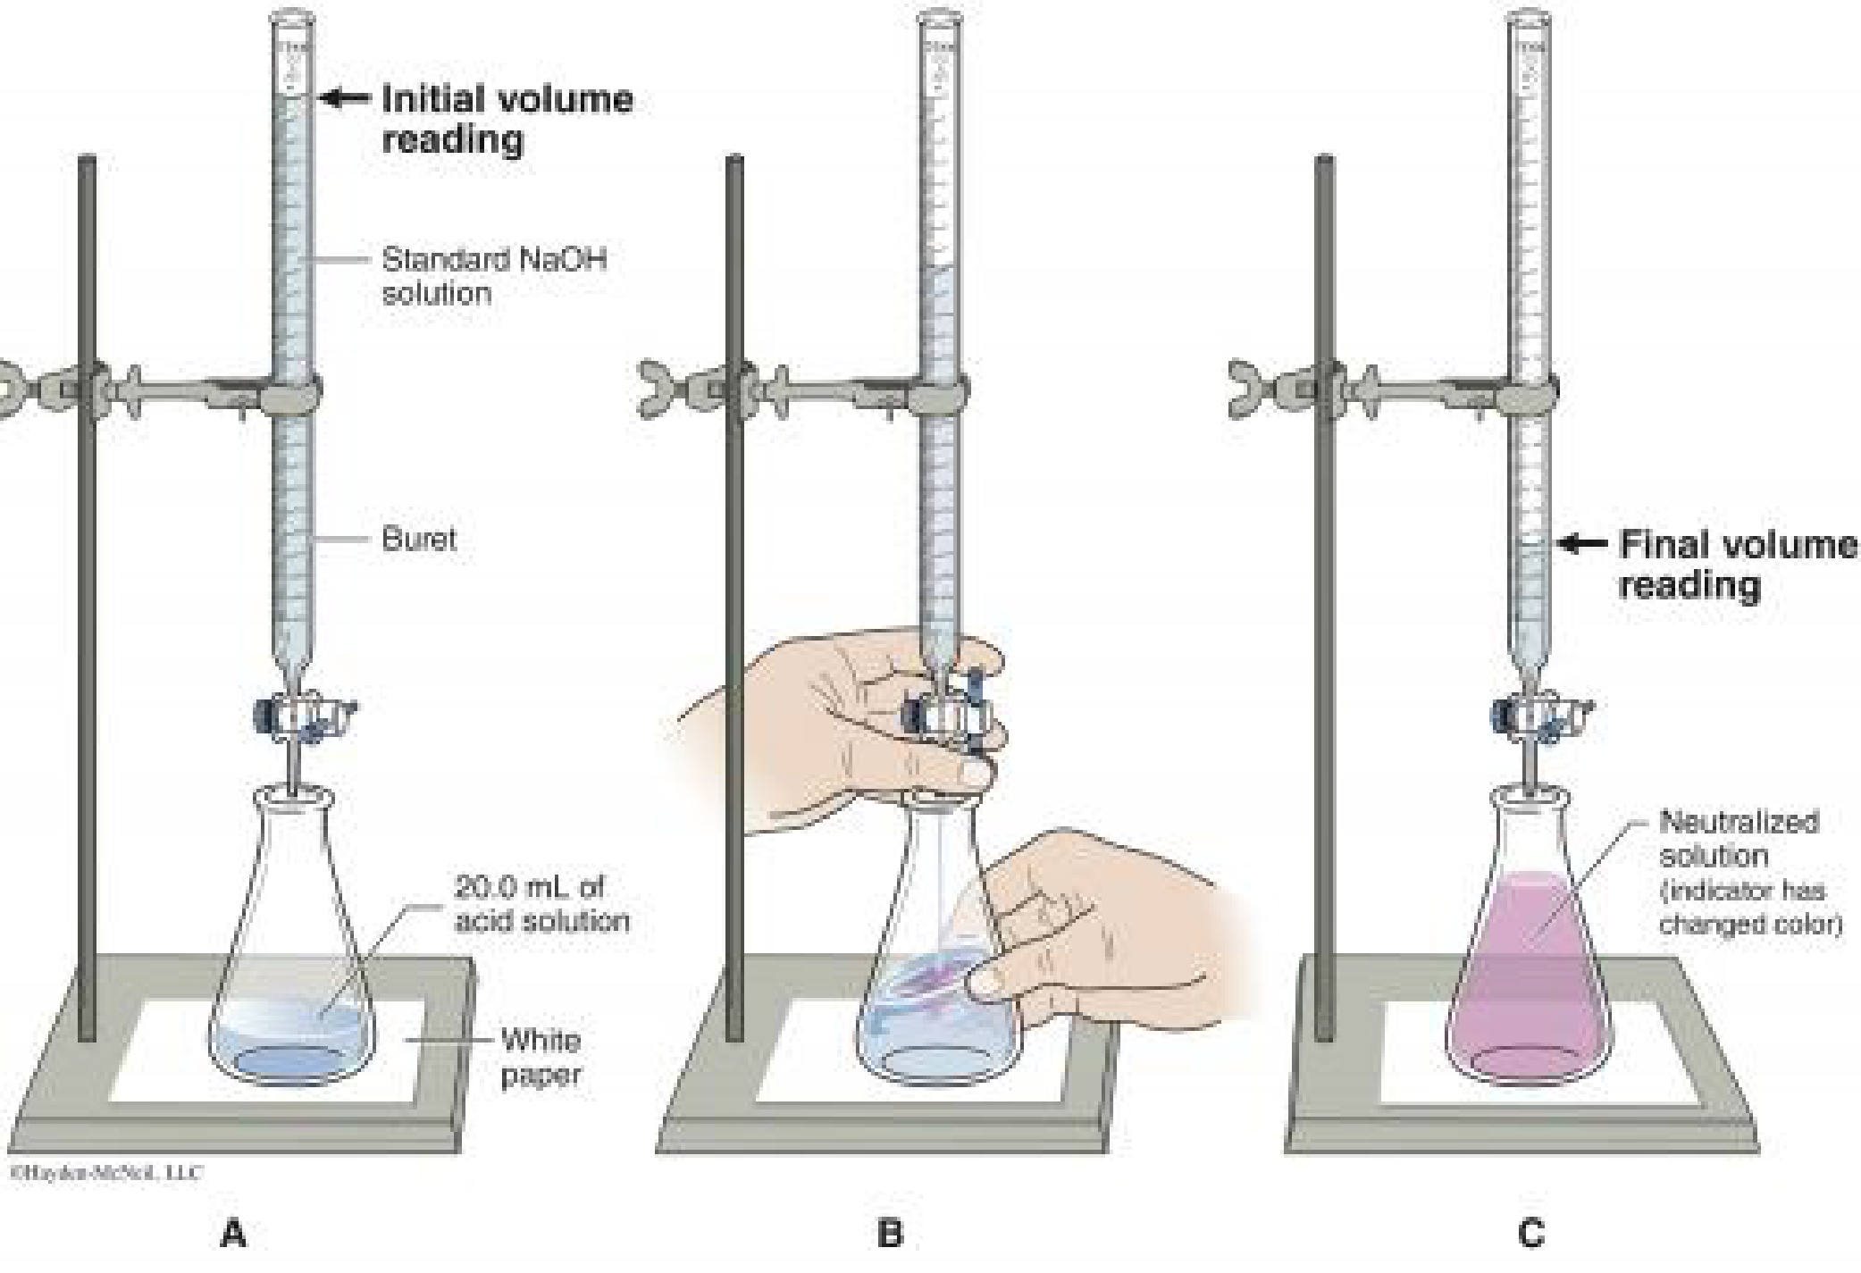

**Figure 4. Sample Titration Set-Up**

A solution of an _____ of unknown concentration (analyte) is titrated using a _____ of _____ concentration (titrant).

The equivalence point in a titration is reached when a stoichiometric number of moles of one reactant are added to the unknown solution such that both reactants are completely consumed. The equivalence point can be detected using several methods.

* _____ – a change in the _____ of the indicator added to the solution
* *pH* _____ – a sudden change in the pH of the solution as it transitions from being acidic to basic or vice versa

A graph called a *titration curve* is obtained by plotting the change in the pH of the solution versus volume of titrant added. At the _____ point of an acid–base reaction, a _____ rise in the pH of the mixed solution occurs. When a strong acid is added (titrated) to a strong base of the same molarity, the equivalence point will be near pH ___ or _____.

**Figure 2: Strong Base 🡪 Strong Acid Titration**

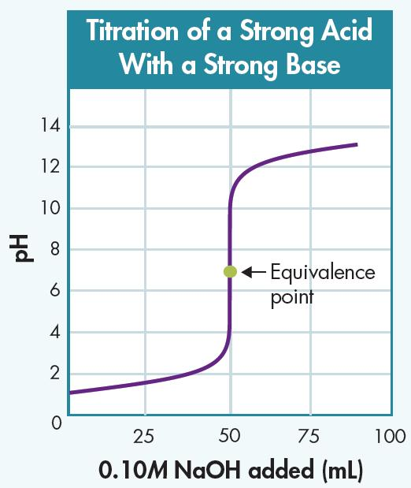

When a strong acid is added to a weak base (**Figure 3A**) or a weak acid is titrated with strong base (**Figure 3B**), the equivalence point is NO longer at a pH of ___ as with the strong acids and strong bases. Yet, there is still a _____ change in pH at the equivalence point.

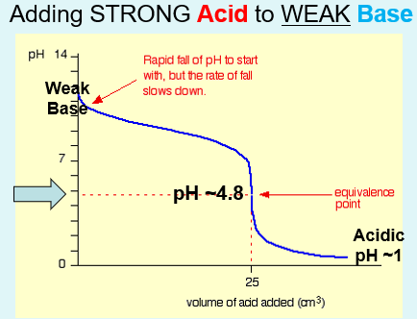 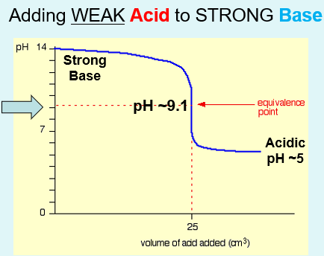

**Figure 3A Strong Acid 🡪 Weak Base 3B Weak Acid 🡪 Strong Base Titration**

**Concentration Calculations in Titrations**

Calculations involving titration is identical to “dilutions” in molar concentrations (M1V1 = M2V2). Titration is based on the _____ and _____ of the _____ and _____ involved.

MbVb = MaVa

This calculation can be applied to all concentrations and strengths of the acids and bases titrated, but must include the _____ factor of a balanced chemical reaction.



HCl(aq) + NaOH 🡪 NaCl(aq) + H+(OH)- … ____ mole ratio of acid:base

H2SO4(aq) + **2**NaOH 🡪 Na2SO4(aq) + 2H+(OH)- … ____ mole ratio of acid:base

**About This Lab**

In this lab, you will titrate both a strong and a weak acid with a strong base. You will use both an indicator and a pH meter to monitor the neutralization reactions. You will use phenolphthalein as the indicator. Phenolphthalein is an indicator that is colorless in acidic and neutral solutions and pink in basic solutions.

[**http://somup.com/cqerrcnTsz**](http://somup.com/cqerrcnTsz) **Lab Video (6:11)**

**Titration of a Strong Acid and Strong Base**

1. Initial Data:

|  |  |  |
| --- | --- | --- |
| Base | |  |
| Formula |  |
| Molarity |  | Name of Indicator |
| Initial Volume Dispensed |  |  |
| Acid | |  |
| Formula |  |
| Initial pH |  |
| Initial Volume |  |

2. Data Collection:

You do NOT need to record the volume in the flask.

|  |  |  |
| --- | --- | --- |
| Base Added  Dispensed Volume (ml) | pH | Acidic or Basic |
|  |  |  |
|  |  |  |
|  |  |  |
|  |  |  |
|  |  |  |
|  |  |  |
|  |  |  |
|  |  |  |
|  |  |  |
|  |  |  |
|  |  |  |

3. How was the neutralization of the acid by the base observed?

4. Compare the volume of acid to the volume of base when the neutralization occurred.

5. Describe the pH as the experiment proceeded, noting any sudden change.

6. 1 M NaOH was the titrant used to titrate HCl. Use the amounts of base and acid at neutralization to determine the molarity of the acid.

HCl(aq) + NaOH 🡪 NaCl(aq) + H+(OH)-

**Titration of a Weak Acid and Strong Base**

1. Initial Data:

|  |  |  |
| --- | --- | --- |
| Base | |  |
| Formula |  |
| Molarity |  | Name of Indicator |
| Initial Volume Dispensed |  |  |
| Acid | |  |
| Formula |  |
| Initial pH |  |
| Initial Volume |  |

2. Data Collection:

You do NOT need to record the volume in the flask.

|  |  |  |
| --- | --- | --- |
| Base Added  Dispensed Volume (ml) | pH | Acidic or Basic |
|  |  |  |
|  |  |  |
|  |  |  |
|  |  |  |
|  |  |  |
|  |  |  |
|  |  |  |
|  |  |  |
|  |  |  |
|  |  |  |
|  |  |  |

3. How was the neutralization of the acid by the base observed?

4. Compare the volume of acid to the volume of base when the neutralization was complete.

5. What happened at the equivalence point (equal amount of base added to an equal amount of acid)?

6. 1 M NaOH was the titrant used to titrate HCH3COOH. Use the amounts of base and acid at neutralization to determine the molarity of the acid.

HCH3COO-(aq) + NaOH 🡪 NaCH3COO-(aq) + H+(OH)-

7. Observe the pH of the strong acid (HCl) to the pH of the weak acid (HCH3COO-).

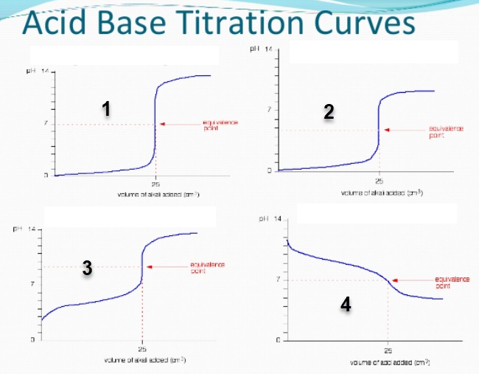

**Conclusions**

1. Which graph best represents the titration of NaOH(aq) and HCl(aq)?

a. How do you know?

b. Describe the equivalence point in terms of amounts of acid and base, and pH.

2. Which graph best represents the titration of NaOH(aq) and HCH3COO-(aq)? Explain.