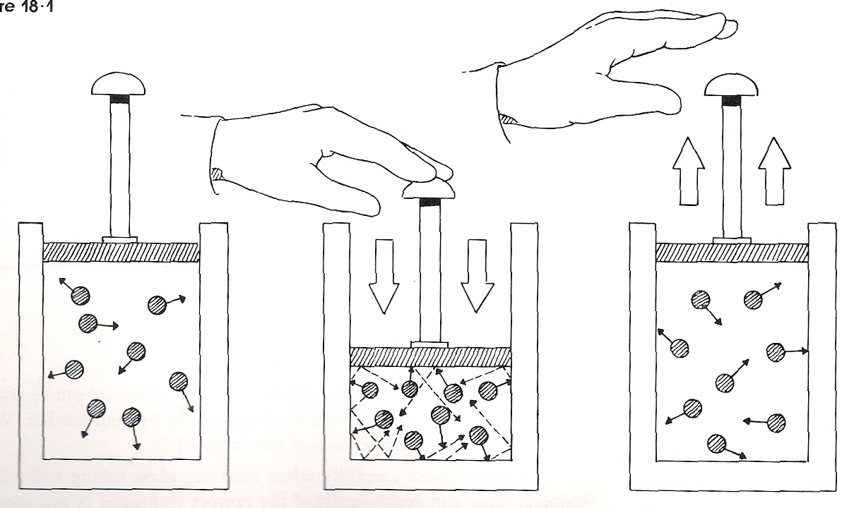

The ______________ (*space*) and ____________ (*force/area*) of a gas are related. Consider a chamber filled with air and sealed so that no air can get in or out. If the piston is pushed in as in #2 above, the volume of air in the chamber _____________. The pressure inside, however, _______________ (*more collisions*). The piston cannot be pushed in beyond a certain point, because the pres­sure within the chamber becomes very great and cannot be overcome.

If the piston is released as in # 3 above, it will move __________. As the piston moves, the volume of air in the chamber ______________ and the pressure ____________ (*less collisions*).

A quantitative relationship between the volume of a gas and its pres­sure was first established by Robert Boyle in 1662, and is called Boyle's law. According to this law, the volume of a fixed quantity of gas is _________________ proportional to the pressure exerted by that quantity of gas, provided the _________________ of the gas remains constant. This law can be expressed mathematically in the following way: **Boyle's law:** P1V1 = P2V2

1. If a 250 mL gas sample were pressurized from 1.0 atm to 2.5 atm, what would happen to the volume, assuming constant temperature?
2. What would happen to the pressure if 760 mm Hg are applied to a 1.00 L sample of a gas to compress it to 150 mL. Assume the temperature is kept constant?
3. What happens to volume when a 150 L weather balloon rises through the atmosphere (*from 760 mmHg to 2.50 mmHg*), assuming constant temperature?

The ______________ (*space*) and ____________ (*average kinetic energy*) of a gas are related. Consider the chambers above which are filled with air and sealed so that no air can get in or out. If the temperature is increased (T2), the volume of air in the chamber _____________. The pressure inside, however, _______________ (*the same number of collisions*).

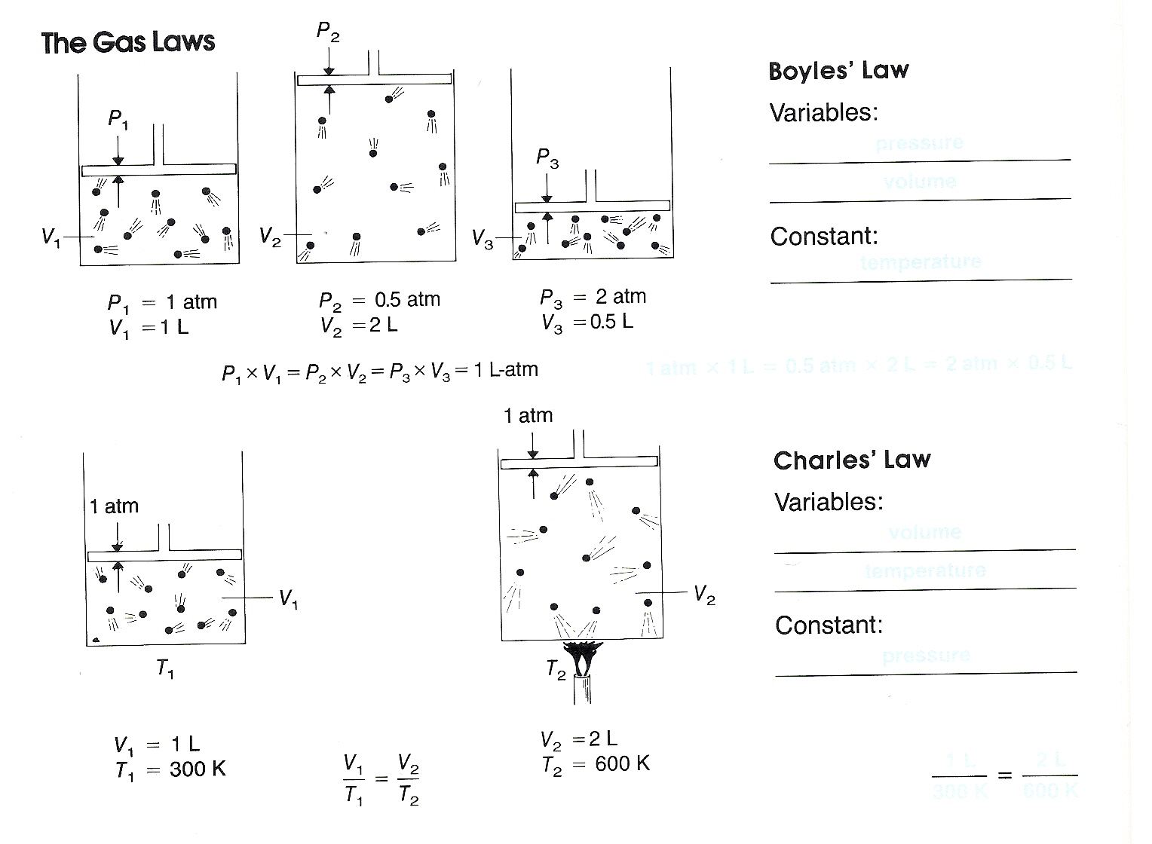

A quantitative relationship between the volume of a gas and its temperature is called Charles’ law. According to this law, the volume of a fixed quantity of gas is _________________ proportional to the temperature exerted of the molecules of that quantity of gas, provided the _________________ of the gas remains constant. This law can be expressed mathematically in the following way: **Charles’ law: V**1 / **T** 1 = **V**2 / **T**2

1. A volume of 20.0L of O2 is warmed from –30.0° C to 85.0° C. If the pressure is kept constant, what happens to the volume?
2. To shrink the volume of a gas from 100 L to 0.25 L, what temperature change must occur, assuming that it started at 25° C and was at constant pressure throughout?
3. What volume makes the most sense if a 25 mL gas sample is cooled from 100° C to 0°C at constant pressure (50 mL 25 mL 15 mL)?
4. What temperature makes the most sense if a 5 mL sample of gas increases to 10 mL heated at a temperature of -170°C at constant pressure (-270° C -170° C -100° C)?

Charles’ Law uses the _______________ temperature scale rather than celsius. This scale uses ____ as its symbol.

Answer Key



The _***volume***______ (*space*) and __***pressure***__ (*force/area*) of a gas are related. Consider a chamber filled with air and sealed so that no air can get in or out. If the piston is pushed in as in #2 above, the volume of air in the chamber _***decreases***___. The pressure inside, however, __***increases***____ (*more collisions*). The piston cannot be pushed in beyond a certain point, because the pres­sure within the chamber becomes very great and cannot be overcome.

If the piston is released as in # 3 above, it will move _***upward***___. As the piston moves, the volume of air in the chamber __***increases***___ and the pressure __***decreases***_ (*less collisions*).

A quantitative relationship between the volume of a gas and its pres­sure was first established by Robert Boyle in 1662, and is called Boyle's law. According to this law, the volume of a fixed quantity of gas is __***inversely***______ proportional to the pressure exerted by that quantity of gas, provided the __***temperature***____ of the gas remains constant. This law can be expressed mathematically in the following way: **Boyle's law:** P1V1 = P2V2

1. If a 250mL gas sample were pressurized from 1.0 atm to 2.5 atm, what would happen to the volume, assuming constant temperature?

***Since the pressure increases, the volume decreases***

1. What would happen to the pressure if 760 mm Hg are applied to a 1.00 L sample of a gas to compress it to 150 mL. Assume the temperature is kept constant?

***Since the volume decreases, the pressure increases***

1. What happens to volume when a 150 L weather balloon rises through the atmosphere (*from 760 mmHg to 2.50 mmHg*), assuming constant temperature?

***Since the pressure decreases, the volume increases***

The __***volume***______ (*space*) and _***temperature***_ (*average kinetic energy*) of a gas are related. Consider the chambers above which are filled with air and sealed so that no air can get in or out. If the temperature is increased (T2), the volume of air in the chamber _***increases***_. The pressure inside, however, _***remains_constant***__ (*the same number of collisions*).

**V**1 / **T** 1 = **V**2 / **T**2

***Pressure***

***Volume***

***Temperature***



A quantitative relationship between the volume of a gas and its temperature is called Charles’ law. According to this law, the volume of a fixed quantity of gas is __***directly***_______ proportional to the temperature exerted of the molecules of that quantity of gas, provided the __***pressure***_______ of the gas remains constant. This law can be expressed mathematically in the following way: **Charles’ law: V**1 / **T** 1 = **V**2 / **T**2

1. A volume of 20.0L of O2 is warmed from –30.0° C to 85.0° C. If the pressure is kept constant, what happens to the volume?

***Since the temperature increases, the volume increases***

2. To shrink the volume of a gas from 100 L to 0.25 L, what temperature change must occur, assuming that it started at 25° C and was at constant pressure throughout?

***Since the volume decreases, the temperature decreases***

3. What volume makes the most sense if a 25 mL gas sample is cooled from 100° C to 0°C at constant pressure (50 mL 25 mL 15 mL)?

***Since the temperature decreases, the volume decreases … 15 ml***

4. What temperature makes the most sense if a 5 mL sample of gas increases to 10 mL heated at a temperature of -170°C at constant pressure (-270° C -170° C -100° C)?

***Since the volume increases, the temperature increases … -100*° C**

Charles’ Law uses the *Kelvin* temperature scale rather than Celsius. This scale uses *K* as its symbol.