**Wild Edible Plants (in your yard) 2**

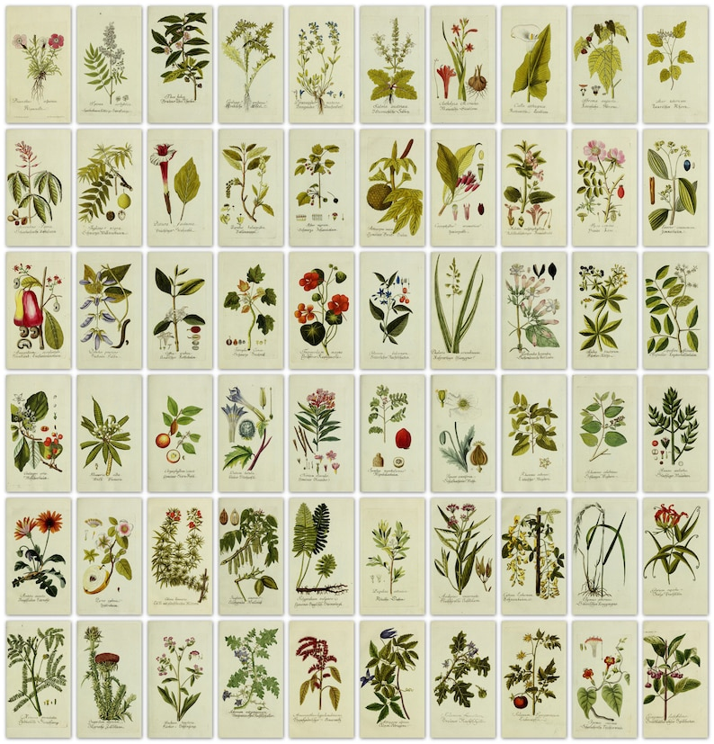

**See** [**https://www.learningctronline.com/courses**](https://www.learningctronline.com/courses) **for Materials and Resources.**

**Topics:**

1. Edible Wild Plants

**Objectives:**

* + Field Guides
  + Identify Wild Edible Plants
  + Field Specimen Activity

TAKE NOTE

1. Review Policies
   1. Late Policy
   2. Grading & Pedagogy – expect to spend 6-8 hrs/week on Projects in Science;
2. Create a Projects in Science folder on your Desktop with the following SUBfolders:
   1. Reference Materials
   2. Homework
   3. Lab
   4. Test
3. Technology
   1. Zoom
   2. Tablet
   3. Lab Supplies
   4. Microsoft Word, PowerPoint, Excel compatibility (especially MAC users)
   5. Access to Movies via Prime, YouTube, Apple TV, Hulu, etc.
4. Review Conduct, Integrity, Plagiarism policy (<https://www.learningctronline.com/policies-conduct-integrity-plagiari>)
5. Cookbook Project [due in 10 days]
6. Reference Material: Field Guide Worksheet 2
7. Create PowerPoint (Plant ID)
8. Lab: Goldenrod Dissection
9. Crossword Review (Optional)
10. Review Wild Edible Plant Identification
11. Quiz (Written)
12. Week 1 Devotional (<https://www.learningctronline.com/devotional>)

**Text**: Peterson Field Guide to Edible Wild Plants

**Reference Material: Edible Wild Plants PowerPoint**

**Homework**:

* Field Guide Worksheet 2
* Review Wild Edible Plant Identification

**Lab**: Create Plant PowerPoint

* Perform the activity as directed using the worksheet provided.
* Save the document into your LAB folder in the Projects in Science folder on your desktop.

**Lab**: Goldenrod Dissection

* Perform the lab as directed using the worksheet provided.
* Save the document into your LAB folder in the Projects in Science folder on your desktop.

**TEST:** Quiz (Written)

1) the academic integrity policy

* Tests must be completed **WITHOUT** referring to books, notes, the internet, people, or any outside resources.
* Students **MAY** use the approved Periodic Tables, approved Reference Tables, or approved equation (formula) sheet (provided by the teacher) along with calculators and scratch paper.
* A guardian should be proctoring the test. Proctoring means to monitor the following:

2) Take the **"in one sitting"**, meaning that once you start the test, you must complete it without interruption.

3) There is a **30-minute time limit** on this test. Please have the proctor write the time taken at the top of your answer sheet with their signature or initials.

4) Proctors should NOT be reading the test or engaging students during the test.

5) Do NOT use RED font. Black font is best.

Supplemental Resources (Optional)

1. Wild Garden Salve
2. Crossword Review Edible Plants

<http://somup.com/c0Qho0AkZa> Goldenrod Gall Dissection (3:43)