**Gas Laws 2 Chapter 14B**

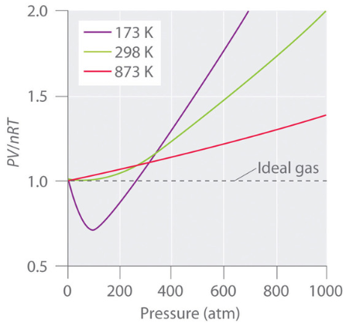 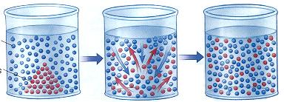

**See** [**https://www.learningctronline.com/courses**](https://www.learningctronline.com/courses) **for Materials and Resources.**

**Topics:**

1. Gas Laws

**Objectives:**

* *State Boyle’s law, Charles’s law, Gay-Lussac’s law, and Avogadro's law and apply these laws to calculate the relationships between volume, temperature, and pressure.*
* *Derive the combined gas law from Boyle’s law, Charles’s law, and Gay-Lussac’s law and calculate for pressure, volume, or temperature.*
* Define partial pressure and apply Dalton’s law of partial pressures to describe the composition of gases.
* State the Ideal Gas Law (PV = nRT) and calculate moles of a gas, understanding the difference between ideal and real gases.
* Understand Graham's Law which states that gases of lower molar mass diffuse and effuse faster than gases of higher molar mass.

TAKE NOTE

1. Notes / Study Guide
2. Lesson Check & Sample Problems or Alternative Worksheets
3. Lab Revision Percent Yield Lab Report
4. Lab Determination of Absolute Zero (Gay-Lussac’s Law)
5. Chapter 14 Test
6. Class Song: Keep Pressing On (“On Top of Ole Smokey”)
7. Week 22 Devotional (<https://www.learningctronline.com/devotional>)

**Text**: Chapter 14: Gas Laws pp. 462-485

Read the assigned pages in the text.

**Class Notes: PowerPoint or PDF**

**Notes/Study Guide:** Fill in the Chapter 14 notes/study guide to understand the class notes.

**Homework**: TEXT

(1) Answer the KEYED **"Lesson Check"** questions at the end of each of the chapter.

(2) Answer the **"Sample problems"** found in the "Sample Problem" boxes throughout the chapter. An answer KEY is provided for you to use to self-correct your homework problems.

* Put your answers into complete thoughts in a Word document. Do NOT just put the answer, but write a phrase or sentence that you can study from for your tests. Save your work in a WORD document and SAVE into your HOMEWORK folder in the Chemistry folder on the desktop.
* Assignments will be “spot checked” during class or submitted via email.

**Alternate Homework**:

1. Boyle’s & Charles’ Laws Simulation
2. Gay-Lussac’s Law & Combined Gas Laws Worksheet

**Lab**: Determination of Absolute Zero (Gay-Lussac’s Law)

* Perform the lab using the lab worksheet and video. You may use class notes to complete the lab worksheet.  
    
  <http://somup.com/cZnl2gpbtr> Charles' Law & Gay-Lussac's Law (3:50)
* Answers have been provided for guidance (scroll down the worksheet), but do not copy and paste.
* Save the document into your LAB folder in the Chemistry folder on your desktop.

**TEST:** Gas Laws

1) the academic integrity policy

* Tests must be completed **WITHOUT** referring to books, notes, the internet, people, or any outside resources.
* Students **MAY** use the approved Periodic Tables, approved Reference Tables, or approved equation (formula) sheet (provided by the teacher) along with calculators and scratch paper.
* A guardian should be proctoring the test. Proctoring means to monitor the following:

2) The test is composed of 20 multiple choice questions and some written problems.

* The **multiple-choice test must be taken "in one sitting"**, meaning that once you start the test, you must complete it without interruption. (40 minutes)
* Take a short break (5-10 minutes)
* The **written portion of the test must be taken "in one sitting"**, meaning that once you start the test, you must complete it without interruption. (30 minutes)

3) There is a **70-minute time limit** on this test. Please have the proctor write the time taken at the top of your answer sheet with their signature or initials.

4) Proctors should NOT be reading the test or engaging students during the test.

5) Do NOT use RED font. Black font is best.

Supplemental Resources (Optional)

1. Chapter 14 Study Guide Pearson

<http://somup.com/cFXiDHn19g> Boiling Water Using ICE! ctr (3:08)

<http://somup.com/cZnl2gpbtr> Charles' Law & Gay-Lussac's Law (3:50)

[Kinetic Theory ctr](http://somup.com/cqQXrheAbh) (2:01) using a super ball

<https://screencast-o-matic.com/watch/cFeY3gDvx1> Pressure Demonstrations (5:32)

PSI (Breaking a Board using Atmospheric Pressure)

Manometer Readings

**Boiling Water below 50 C**

<https://screencast-o-matic.com/watch/cYhFbBkvqv> Called for Freedom to Serve One Another; Galatians 2:13; The Nazarene (3:42)