**Build Static Electricity “TORSION” apparatus:**

Materials: 2 16 oz. Styrofoam cups 2 straws (6-8’’ long) Dirt, sand or weight

Pleated straw Thread Masking Tape

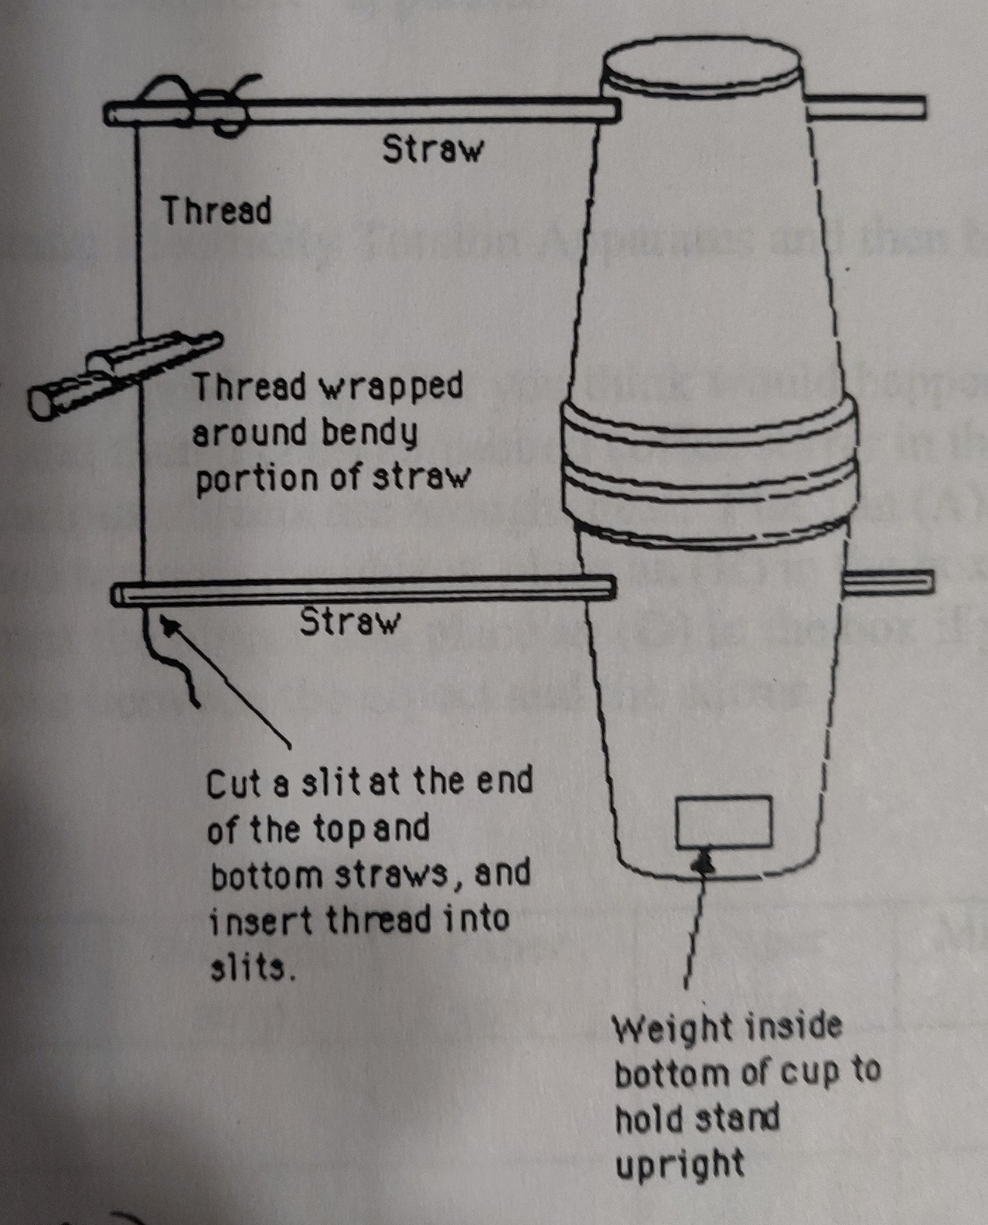

To stabilize the Test Object Holder, you may need to tie a ½ knot with the thread.

Coffee Stirrer (test object)

You can also try dangling the straw holder or test object directly from thread (if you can’t build a test stand). 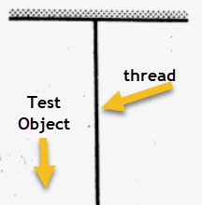

Pleated Straw (holder of objects)

Static Electricity – Rub/Unrub

# **Introduction**

# **Purpose** To investigate various materials and their response to static electricity.

**Discussion**

Existence of charge has been established already. Positive charges are formed by an atom losing a negatively charged particle. The positive subatomic charge is called a proton. Negative charges are formed by an atom gaining a negative charged particle. The negative subatomic particle is called an electron. Neutral charge exists when a substance or atom contains equal amounts of negative and positive charges. The neutral subatomic particle is called a neutron.

Electrostatic force refers to the force of attraction or repulsion between charged objects. In principle, like charges repel each other, whereas unlike charges attract each other.

Atoms frequently experience transfer of Charge due to friction (rubbing, sliding, etc.). Objects or atoms possess excess negative charge when gaining electrons. Objects or atoms possess excess positive charge when losing electrons. Objects or atoms can become charged by contact (conduction) or by proximity (without touch) [induction].

Electroscope – an instrument used to detect small amounts of charge

**Hypothesis**

Ifa neutral object is rubbed, then it becomes charged by the transfer of a particle.

# **Materials** Straw Wool cloth Wooden strip

Nail String Paper strip (straw paper)

Coffee Stirrer Magnet Paper clip

Static Electricity “TORSION” apparatus Thread

**Procedures**

1. Imagine placing an object in the Static Electricity Torsion Apparatus and then bringing a coffee stirrer near that object.

1. Complete the prediction table below by predicting what you think would happen to as an uncharged/unrubbed coffee stirrer and then a charged/rubbed coffee stirrer in the Static Electricity Torsion Apparatus as various objects are brought nearby. Place an (**A**) in the box if you think the stirrer will be attracted towards the object; place an (**R**) in the box if you think the stirrer will be repelled away from the object; and place an (**O**) in the box if you think there will be NO noticeable response between the object and the stirrer.

**PREDICTION TABLE**

|  |  |  |  |  |  |  |  |
| --- | --- | --- | --- | --- | --- | --- | --- |
| **Coffee Stirrer** | Straw | Nail | String | Wooden strip | Paper strip | Paper clip | Magnet |
| Unrubbed |  |  |  |  |  |  |  |
| RUBBED |  |  |  |  |  |  |  |

3. Remove all static from the objects before you use them as shown by the teacher.

1. Place an “unrubbed” coffee stirrer in the Static Electricity Torsion Apparatus.
2. Complete the observation table below according to what actually happens to the coffee stirrer in the Static Electricity Torsion Apparatus as you bring the various objects near it. Use the same symbols as in the prediction table above.
3. Take the coffee stirrer out of the apparatus and rub it vigorously on one end with a wool cloth. Place it in the apparatus and retest all the objects, filling out the chart below.

**OBSERVATION TABLE**

|  |  |  |  |  |  |  |  |
| --- | --- | --- | --- | --- | --- | --- | --- |
| **Coffee Stirrer** | Straw | Nail | String | Wooden strip | Paper strip | Paper clip | Magnet |
| Unrubbed |  |  |  |  |  |  |  |
| RUBBED |  |  |  |  |  |  |  |

7. Repeat the procedures one more time using a MAGNET rather than the coffee stirrer. “UNRUB” all the objects again as shown previously. This time, place the “unrubbed” objects on the desk/table and bring a magnet near them. Fill in your results below:

|  |  |  |  |  |  |  |  |
| --- | --- | --- | --- | --- | --- | --- | --- |
|  | Straw | Nail | String | Wooden strip | Paper strip | Paper clip | Coffee Stirrer |
| Magnet |  |  |  |  |  |  |  |

Calculations and Data

1. Did you encounter any surprises between your predictions and the actual observations? List them.

2. What general statement can you make concerning the static electricity between a rubbed coffee stirrers and the other objects?

3. Did the magnet produce the same results that the rubbed coffee stirrer did? What were the differences and similarities?

a. differences:

b. similarities

4. Did the coffee stirrer have to touch any of the materials to be attracted?

5. How did the coffee stirrer obtain electrostatic influence?

## Conclusions and Questions

1. Based on the simple evidence you collected in this laboratory, are static electricity and magnetism the same? Explain your answer.

2. Do your observations here support your model that you developed in class? Explain.

3. Go back to your model of the refrigerator magnet and electric dryer. Based on the results observed in this activity, modify the model.

4. What type of electrostatic transfer occurs when objects do not touch?

5. What type of electrostatic transfer occurs when objects do touch?

6. Collate a summary of “big ideas” related to static electricity and magnetism.

Static Electricity – Rub/Unrub ANSWERS

**OBSERVATION TABLE**

|  |  |  |  |  |  |  |  |
| --- | --- | --- | --- | --- | --- | --- | --- |
| **Coffee Stirrer** | Straw | Nail | String | Wooden strip | Paper strip | Paper clip | Magnet |
| Unrubbed | **O** | **O** | **O** | **O** | **O** | **O** | **O** |
| RUBBED | **A** | **A** | **A** | **A** | **A** | **A** | **A** |

7. Repeat the procedures one more time using a MAGNET rather than the coffee stirrer. “UNRUB” all the objects again as shown previously. This time, place the objects in the apparatus and bring a magnet near them. Copy the chart below and record your results:

|  |  |  |  |  |  |  |  |
| --- | --- | --- | --- | --- | --- | --- | --- |
|  | Straw | Nail | String | Wooden strip | Paper strip | Paper clip | Coffee Stirrer |
| Magnet | **O** | **A** | **O** | **O** | **O** | **A** | **O** |

Calculations and Data

1. Did you encounter any surprises between your predictions and the actual observations? List them.

***There were most likely many surprises. Students may not have “unrubbed” items as instructed OR before testing each item. There are small breezes in the room that affect results. Plus, students “imagine” results based on their bias.***

2. What general statement can you make concerning the static electricity between a rubbed coffee stirrers and the other objects?

***According to our results, a wool rubbed straw or coffee stirrer attracted all items.***

3. Did the magnet produce the same results that the rubbed coffee stirrer did? What were the differences and similarities?

1. Differences ***The magnet rubbed nail on attracts the metal (iron) objects while the***

***wool rubbed coffee stirrer attracted everything.***

1. Similarities ***Rubbing did something to the rubbed objects. Items were attracted***

***and not repelled.***

4. Did the coffee stirrer have to touch any of the materials to be attracted?

**No. The objects were attracted as the “charged” coffee stirrer was brought nearby but NOT touching.**

5. How did the coffee stirrer obtain electrostatic influence?

**The coffee stirrer was rubbed with wool to obtain a charge.**

## Conclusions and Questions

1. Based on the simple evidence you collected in this laboratory, are static electricity and magnetism the same? Explain your answer.

***Probably not. Since the wool rubbed straw/stirrer attracted everything while the magnet rubbed nail only attracted certain metals, there must be some kind of discrepancy.***

2. Do your observations here support your model that you developed in class? Explain.

***Most likely the class model has lots of holes and needs patching! There are physical principles to observe, test and conclude about before a valid, working model can be established.***

3. Go back to your model of the refrigerator magnet and electric dryer. Based on the results observed in this activity, modify the model.

4. What type of electrostatic transfer occurs when objects do not touch?

***Charge by induction.***

5. What type of electrostatic transfer occurs when objects do touch?

***Charge by conduction (rubbing the object uses friction).***

6. Collate a summary of “big ideas” related to static electricity and magnetism.

* ***Wool rubbed plastic straw/stirrer attracted all test objects.***
* ***Magnet rubbed nails attracted the metal objects tested.***