**Ionic Bonding Chapter 7**

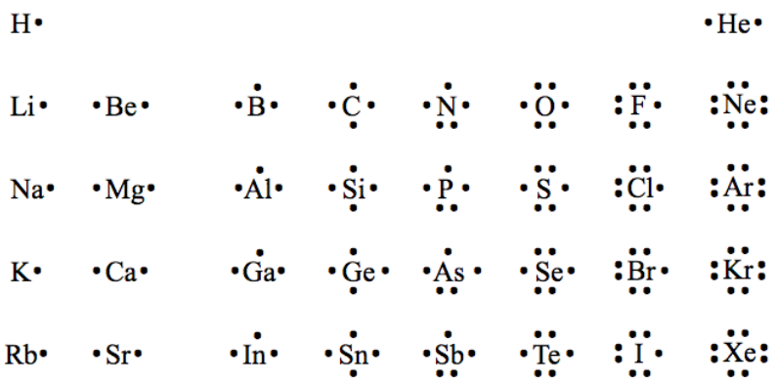

**See** [**https://www.learningctronline.com/courses**](https://www.learningctronline.com/courses) **for Materials and Resources.**

**Topics:**

1. Ionic Bonding

**Objectives:**

1. Understand the conditions of stability for atoms related to bonding.
2. Explain and show how elements become ions (cations and anions).
3. Explain the ionic compounds in terms of formation, electrical charge, structure and Electronegativity Difference.

TAKE NOTE

1. Notes/Study Guide
2. Lab Quiz: Movement of Charge
3. Test Corrections (Periodic Table)
4. Week 9 Devotional (<https://www.learningctronline.com/devotional>)

**Text**: Chapter 7: Ionic and Metallic Bonding pp. 192-208

Read the assigned pages in the text. Omit Coordination Number (p. 205) and naming Crystalline Structures (Figure 7.8).

**Class Notes: PowerPoint or PDF**

**Notes/Study Guide:** Fill in the Chapter 7 worksheet to understand the class notes.

**Homework**: Text

(1) Answer the KEYED **“Lesson Check”** questions at the end of each.

(2) Answer the **“Sample problems”** found in the “Sample Problem” boxes throughout the chapter. An answer KEY is provided for you to use to self-correct your homework problems.

* Put your answers into complete thoughts in a Word document. Do NOT just put the answer, but write a phrase or sentence that you can study from for your tests. Save your work in a WORD document and SAVE into your HOMEWORK folder in the Chemistry folder on the desktop.
* Assignments will be “spot checked” during class or submitted via email.

**Alternate Homework**:

1. Ionic Bonding Study Guide
2. Practice Test Ionic & Metallic Bonding

**Lab**: Movement of Charge

Complete "Movement of Charge" activity which is related to the movement of charge in atoms when forming ionic bonds.

* Download the worksheet and perform the lab activity as instructed.
* Answers are provided at the end of the document for guidance. Do NOT copy and paste these answers, but write using your own words.
* Save the document into your LAB folder in the Chemistry folder on your desktop.
* When ready, take the Lab Quiz.
* You may **NOT** use the worksheet on this lab test.

**TEST:** The test will be given after next week’s lesson.

Supplemental Resources (Optional)

1. PHET Simulation: Atomic Models

[Electron Dot Diagrams ctr](http://somup.com/cFQ3qbncc7) (6:59)  
  
[Electron Dot Diagrams (Lewis Structures)](http://somup.com/cFQ3ldVWWC) (4:57) 5 Steps  
  
[Ionic Bonds & Ionic Compounds ctr](http://somup.com/cFQZ21ncXa) (4:30)  
  
[Ionic Bonding Electron Configurations (H + F) ctr](http://somup.com/cFQqoPVWxU) (4:23)  
  
[Ionic Bonding Electron Configurations (Na + S) ctr](http://somup.com/cFQTlGnc0v) (3:19)  
  
[Today if You Hear His Voice Hebrews 3:7; All This Time](http://somup.com/cYhIYrj3Bz) (4:19)