**Chemical Formulas Chapter 9B**

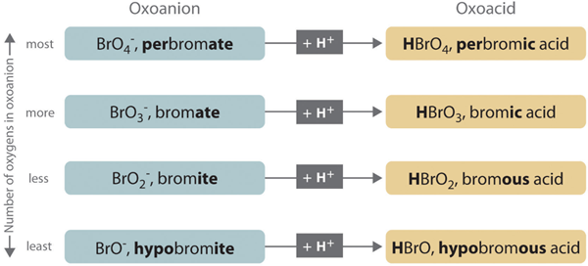

**See** [**https://www.learningctronline.com/courses**](https://www.learningctronline.com/courses) **for Materials and Resources.**

**Topics:**

1. Chemical Names & Formulas

**Objectives:**

1. Explain how to determine the charges (oxidation numbers) of monatomic ions.
2. Apply the rules for naming and writing formulas for compounds with polyatomic ions.
3. Determine the names and formulas of ionic and covalent compounds, of acids and bases.
4. Understand Law of Definite Proportions

TAKE NOTE

1. Notes / Study Guide
2. Lesson Check/Sample problems or Alternative Worksheets
3. Lab Definite Proportions for a Formal Lab Report (Procedures, Calculations and Data)
4. HONORS 🡪 Study Guide [objectives, major points, minor points]
5. Chemical Names & Formulas Test
6. Semester Exam after Chapter 10 (due within 10 days after week 16’s class)
7. Week 14 Devotional (<https://www.learningctronline.com/devotional>)

**Text**: Chapter 9: Chemical Formulas pp. 285-303

Read the assigned pages in the text.

**Class Notes: PowerPoint or PDF**

**Notes/Study Guide:** Fill in the Chapter 9 worksheet to understand the class notes.

**Homework**: TEXT

(1) Answer the KEYED **"Lesson Check"** questions at the end of each of the chapter.

(2) Answer the **"Sample problems"** found in the "Sample Problem" boxes throughout the chapter. An answer KEY is provided for you to use to self-correct your homework problems.

* Put your answers into complete thoughts in a Word document. Do NOT just put the answer, but write a phrase or sentence that you can study from for your tests. Save your work in a WORD document and SAVE into your HOMEWORK folder in the Chemistry folder on the desktop.
* Assignments will be “spot checked” during class or submitted via email.

**Alternate Homework**:

1. Formula Worksheet
2. Chapter 9 Practice Exam Formulas

**Lab**: Law of Definite Proportions

Perform the "Law of Definite Proportions Lab" experiment using the lab video and lab worksheet provided.

* [Law of Definite Proportions Lab Video](http://somup.com/cqhv2YnGxa) (4:23).
* This would include doing the procedures and calculations. You will write up a Formal Lab Report following the guidelines in the Lab Report Format Document within 11 days.  
    
  However, you can wait to do the Formal Lab Report until AFTER you take the tests for this unit. The formal Lab Report is due FOUR (4) days AFTER next week's class (11 days from today).
* Save the document into your LAB folder in the Chemistry folder on your desktop.
* Assignments will be “spot checked” during class or submitted via email.

**TEST:** Chemical Names & Formulas

1) the academic integrity policy

* Tests must be completed **WITHOUT** referring to books, notes, the internet, people, or any outside resources.
* Students **MAY** use the approved Periodic Tables, approved Reference Tables, or approved equation (formula) sheet (provided by the teacher) along with calculators and scratch paper.
* A guardian should be proctoring the test. Proctoring means to monitor the following:

2) The test is composed of 20 multiple choice questions and some written problems.

* The **multiple-choice test must be taken "in one sitting"**, meaning that once you start the test, you must complete it without interruption. (40 minutes)
* Take a short break (5-10 minutes)
* The **written portion of the test must be taken "in one sitting"**, meaning that once you start the test, you must complete it without interruption. (30 minutes)

3) There is a **70-minute time limit** on this test. Please have the proctor write the time taken at the top of your answer sheet with their signature or initials.

4) Proctors should NOT be reading the test or engaging students during the test.

5) Do NOT use RED font. Black font is best.

Supplemental Resources (Optional)

1. Formulas & Naming Ionic Compounds
2. Chapter 9 Study Guide Pearson

[Naming Acids ctr](http://somup.com/cF66Dqnn5u) (5:41) Binary Acids & Acids Containing Oxygen  
  
[Let the Word Dwell is Us Colossians 3:16; From Strife to Love](http://somup.com/cYhD3EjUmO) (4:41)