1. An Indy 500 race car’s velocity increases from +4.0 m/s to +36 m/s over a 4.0 s period.

a. What is the acceleration?

b. The same Indy 500 race car slows from +36 m/s to +15 m/s over 3.0 s. What is its average acceleration over this time interval?

2. A bus is moving at 25 m/s. The driver steps on the brakes, and the bus stops in 3.0 s.

a. What is the average acceleration of the bus while braking?

b. Suppose the bus took twice as long to stop. How would the acceleration compare to the acceleration you found above?

3. Draw a velocity-time graph

a. for an object whose velocity is constantly decreasing from 10 m/s at t = 0.0 s to -10 m/s at t = 2.0 s.

b. What is its average acceleration between 0.0 s and 2.0 s?

c. What is its acceleration when its velocity is 0 m/s?

4. A golf ball rolls up a hill on a Putt-Putt hole.

a. If it starts with a velocity of +2.0 m/s and accelerates at a rate of -0.50 m/s2, what is its velocity after 2.0 s?

b. If the acceleration occurs for 6.0 s, what is its final velocity?

c. Describe, in words, the motion of the golf ball.

5. A bus traveling at +30 km/h accelerates at +3.5 m/s² for 6.8 s. What is its final velocity in km/h?

6. If a car accelerates from rest at a constant 5.5 m/s², how long will be required to reach 28 m/s?

7. A car slows from 22 m/s to 3 m/s with a constant acceleration of -2.1 m/s². How long does it require?

8. A brick falls freely from a high scaffold. What is its velocity after 4.0 s? How far does the brick fall during the first 4.0 s?

9. If you drop a golf ball, how far does it fall in ½ s?

10. A spacecraft traveling at a velocity of +1210 m/s is uniformly accelerated at -150 m/s². If the acceleration lasts for 8.68 seconds, what is the final velocity of the craft? Explain your results in words.

11. A man falls 1.0 m to the floor.

a. How long does the fall take?

b. How fast is he going when he hits the floor?

12. Find the uniform acceleration that causes a car’s velocity to change from 32 m/s to 96 m/s in an 8.0 s period.

13. A pitcher throws a baseball straight up with an initial speed of 27 m/s.

a. How long does it take the ball to reach its highest point?

b. How high does the ball rise above its release point?

14. A motor of a certain elevator gives it a constant upward acceleration of 46 m/min/s. the elevator starts from rest, accelerates for 2.0 s, then continues with constant speed.

a. Explain what this statement of acceleration means

b. What is the final speed after 2 s?

c. Calculate speed after 0.5, 1.0, 1.5, 2.0,3.0, 4.0 and 5.0 s. Sketch a graph showing speed vs. time. Speeds before 2.0 s are given by vt = at; speeds after are 92 m/min

15. Rocket powered sleds are used to test the responses of humans to acceleration. Starting from rest, one sled can reach a speed of 444 m/s in 1.80 s and can be brought to a stop again in 2.15 s.

a. Calculate the acceleration of the sled when starting and compare it to the acceleration due to gravity, 9.80 m/s².

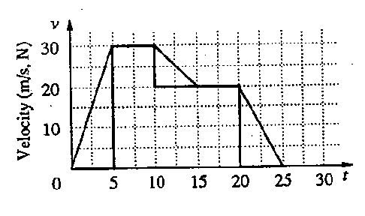b. Find the acceleration of the sled when braking and compare it to the magnitude of the acceleration due to gravity.

16. Use the graph to find the acceleration of the moving object

a. during the first five seconds of travel.

b. between the fifth and the tenth second of travel.

17. A car with a velocity of 22 m/s is accelerated uniformly at the rate of 1.6 m/s² for 6.8 s. What is its final velocity?

18. Describe the motion in each graph in terms of velocity and acceleration.

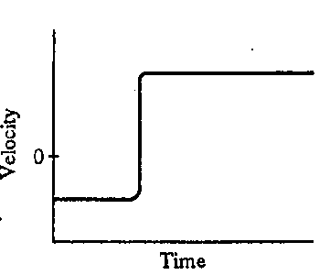 a. 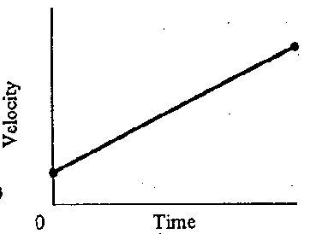 b.

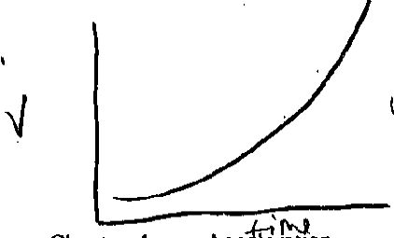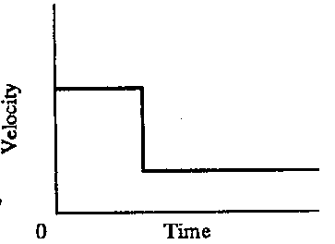

c. d.

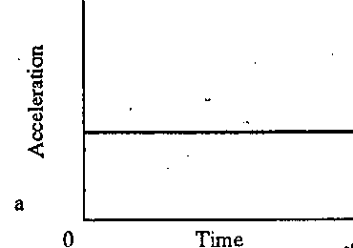

e.

1. An Indy 500 race car’s velocity increases from +4.0 m/s to +36 m/s over a 4.0 s period.

a. What is the acceleration?

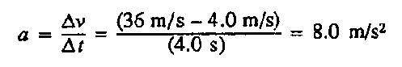

b. The same Indy 500 race car slows from +36 m/s to +15 m/s over 3.0 s. What is its average acceleration over this time interval?

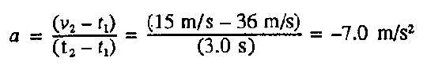

2. A bus is moving at 25 m/s. The driver steps on the brakes, and the bus stops in 3.0 s.

a. What is the average acceleration of the bus while braking?

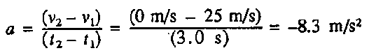

b. Suppose the bus took twice as long to stop. How would the acceleration compare to the acceleration you found above?



3. Draw a velocity-time graph

a. for an object whose velocity is constantly decreasing from 10 m/s at t = 0.0 s to -10 m/s at t = 2.0 s.

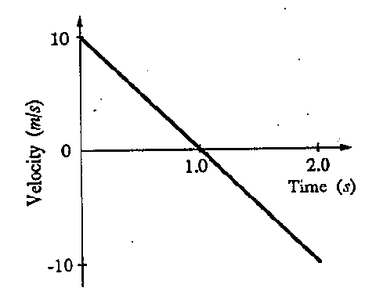

b. What is its average acceleration between 0.0 s and 2.0 s?

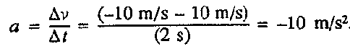

c. What is its acceleration when its velocity is 0 m/s?



4. A golf ball rolls up a hill on a Putt-Putt hole.

a. If it starts with a velocity of +2.0 m/s and accelerates at a rate of -0.50 m/s2, what is its velocity after 2.0 s?

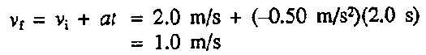

b. If the acceleration occurs for 6.0 s, what is its final velocity?

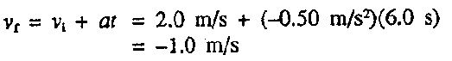

c. Describe, in words, the motion of the golf ball.

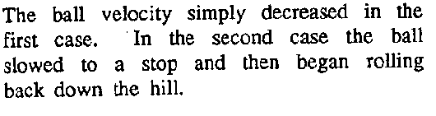

5. A bus traveling at +30 km/h accelerates at +3.5 m/s² for 6.8 s. What is its final velocity in km/h?

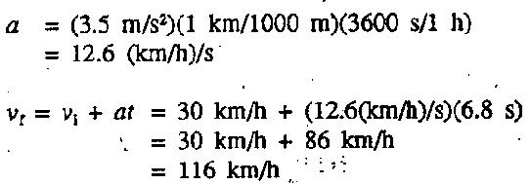

6. If a car accelerates from rest at a constant 5.5 m/s², how long will be required to reach 28 m/s?

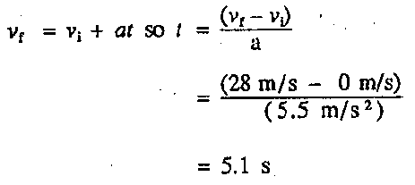

7. A car slows from 22 m/s to 3 m/s with a constant acceleration of -2.1 m/s². How long does it require?

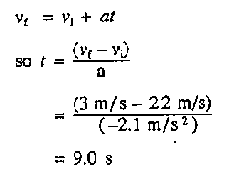

8. A brick falls freely from a high scaffold.

a. What is its velocity after 4.0 s?

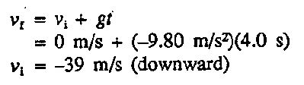

b. How far does the brick fall during the first 4.0 s?

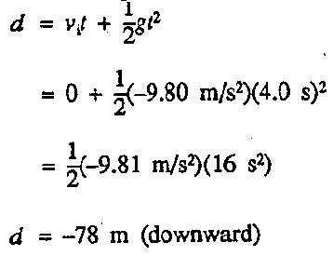

9. If you drop a golf ball, how far does it fall in ½ s?

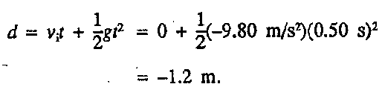

10. A spacecraft traveling at a velocity of +1210 m/s is uniformly accelerated at -150 m/s². If the acceleration lasts for 8.68 seconds, what is the final velocity of the craft? Explain your results in words.

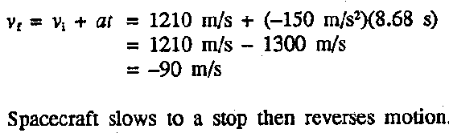

11. A man falls 1.0 m to the floor.

a. How long does the fall take?

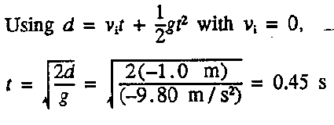

b. How fast is he going when he hits the floor?

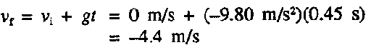

12. Find the uniform acceleration that causes a car’s velocity to change from 32 m/s to 96 m/s in an 8.0 s period.

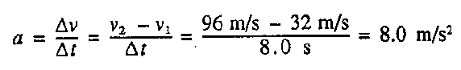

13. A pitcher throws a baseball straight up with an initial speed of 27 m/s.

a. How long does it take the ball to reach its highest point?

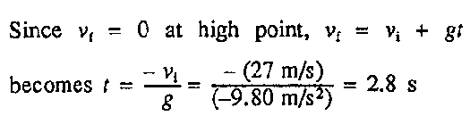

b. How high does the ball rise above its release point?

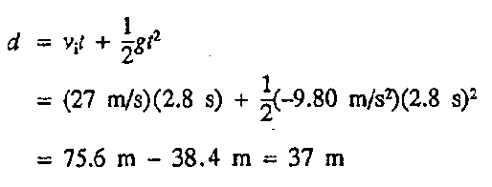

14. A motor of a certain elevator gives it a constant upward acceleration of 46 m/min/s. the elevator starts from rest, accelerates for 2.0 s, then continues with constant speed.

a. Explain what this statement of acceleration means

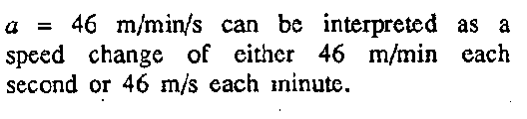

b. What is the final speed after 2 s?

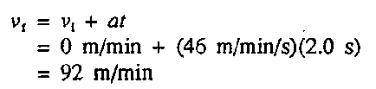

c. Calculate speed after 0.5, 1.0, 1.5, 2.0,3.0, 4.0 and 5.0 s. Sketch a graph showing speed vs time. Speeds before 2.0 s are given by vt = at; speeds after are 92 m/min

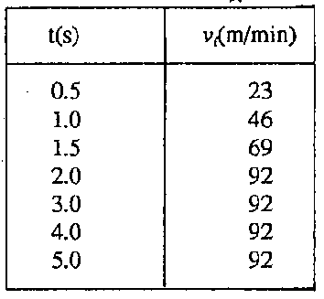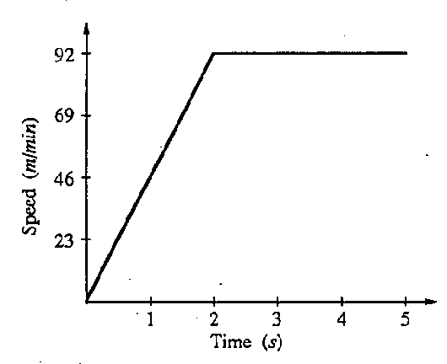

15. Rocket powered sleds are used to test the responses of humans to acceleration. Starting from rest, one sled can reach a speed of 444 m/s in 1.80 s and can be brought to a stop again in 2.15 s.

a. Calculate the acceleration of the sled when starting and compare it to the acceleration due to gravity, 9.80 m/s².

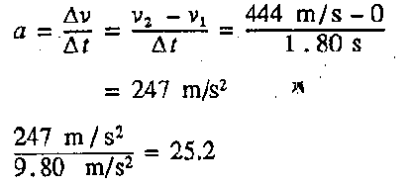

b. Find the acceleration of the sled when braking and compare it to the magnitude of the acceleration due to gravity.

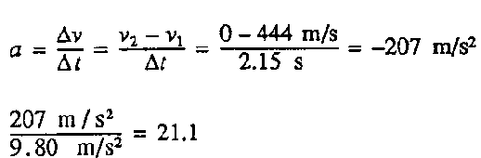

16. Use the graph to find the acceleration of the moving object

a. during the first five seconds of travel.

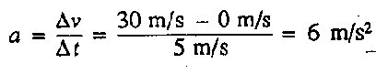

b. between the fifth and the tenth second of travel.

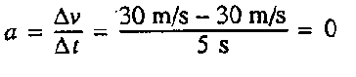

18. Describe the motion in each graph in terms of velocity and acceleration.



a.  b.

*Velocity increases as time increases;* *Constant Velocity in negative*

*+constant acceleration direction; stop; constant V in*

*Opposite (+) direction;*

*acceleration when changing*

*directions.*



c. d.

*Constant Velocity, instant deceleration, Increasing/changing Velocity. Lower constant V. therefore + changing*

*acceleration.*

e. 

*Constant acceleration, meaning Velocity changes at a constant rate*.

17. A car with a velocity of 22 m/s is accelerated uniformly at the rate of 1.6 m/s² for 6.8 s. What is its final velocity?

