**Momentum Chapter 7**

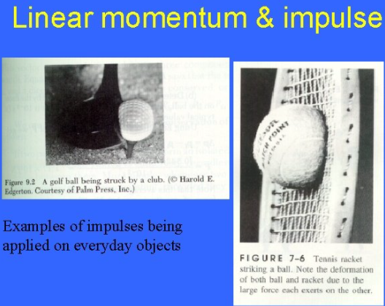

**See** [**https://www.learningctronline.com/courses**](https://www.learningctronline.com/courses) **for Materials and Resources.**

**Topics:**

1. Momentum

**Objectives:**

* Identify and give examples of the components of momentum (mass, speed, direction) in the motion of objects.
* Calculate momentum involving elastic collisions and inelastic collisions while showing the conservation of momentum.
* Define impulse in terms of force, time, and change in momentum. Explain practical applications of impulse (e.g. sports).

TAKE NOTE (Assignments all 1 week)

1. Reading (Hewitt Text)

1. Momentum Impulse Worksheet
2. Lab: Paper Football Activity
3. Problem Set Momentum (1 week)
4. Lab: Momentum & Collisions Part 1

1. Lab: Momentum & Collisions Part 2
2. Quiz Momentum
3. Week 11 Devotional (<https://www.learningctronline.com/devotional>)

**Text**: Chapter 7 Momentum (Hewitt)

**Class Notes: Use the Document provided**

**Homework**:

* Worksheet: Momentum Impulse Worksheet
* Problem Set Momentum

**Lab**: Paper Football Activity

* Perform the lab as directed using the worksheet provided.
* Complete all calculations and data, showing work whenever appropriate.
* Conclusions should be answered in complete sentences that convey a complete thought.
* Save the documents into your LAB folder in the Physics folder on your desktop.

**Lab**: Momentum & Collisions Part 1

* Perform the lab as directed using the worksheet provided.
* Complete all calculations and data, showing work whenever appropriate.
* Conclusions should be answered in complete sentences that convey a complete thought.
* Save the documents into your LAB folder in the Physics folder on your desktop.

**Lab**: Momentum & Collisions Part 2

* Perform the lab as directed using the worksheet provided.
* Complete all calculations and data, showing work whenever appropriate.
* Conclusions should be answered in complete sentences that convey a complete thought.
* Save the documents into your LAB folder in the Physics folder on your desktop.

**TEST:** Quiz Momentum (Review)

There is a **20-minute time limit** on the quiz.

Supplemental Resources (Optional)

1. Momentum (Balls Colliding) Lab
2. Momentum & Energy Problem Set (Basics)

<http://somup.com/crhulUqDkV> Inertia Ring (1:36)

<http://somup.com/cYfT2diyOZ> Momentum: Remember the Titans (1:29) Look for mv and direction.

<https://screencast-o-matic.com/watch/cF6eodYlwS> Elastic Collisions (0:56)

<http://somup.com/cFXQqRniFE> Conservation of Momentum (1:42) Elastic Collisions Using Newton's Cradle

<http://somup.com/cYfTDqiyyO> Conservation of Momentum (1:02) Inelastic Collision Using Motion Carts

<https://screencast-o-matic.com/watch/cFXQqCYSEh> (Bouncing Balls)

(go to 3:55 minute point in video of Newton’s Laws of Motion Demos)

<https://screencast-o-matic.com/watch/cYfTYHAkLS> Momentum of carts (2:15)

<http://somup.com/cr1VFbqrkH> Momentum & Collisions Lab Part 2 (4:45)

<http://somup.com/cr1VYGqrMs> Momentum & Impulse (5:20)

<http://somup.com/crX62U3WSr> Impulse (Watermelon) [2:28]