Make sure you have the approved reference tables, Periodic Tables, and equation sheet.

A double replacement reaction of aqueous solutions of sodium hydroxide (NaOH) and sulfuric acid (H2SO4) takes place. In the balanced equation, the coefficient for sodium hydroxide is:

Which of the following statements is INCORRECT?

a. Complete combustion has occurred when all the carbon in the product is in the form of carbon dioxide.

b. A single reactant is the identifying characteristic of a decomposition reaction.

c. A synthesis reaction has two or more substances reacting to form a single new substance.

d. All chemical reactions can be classified as one of four general types.

Barium reacts with aqueous hydrochloric acid to form Barium Chloride and Hydrogen gas. This is an example of a ___ ___ reaction. In the balanced equation, the coefficient for HCl(aq) is:

The reaction: Fe(s) + O2(g) → Fe2O3(s) is an example of what type of chemical reaction?

A double-replacement reaction takes place when aqueous K2SO4 reacts with aqueous Pb(NO3)2. You would expect one of the products of this reaction to be:

K2+1CO3-2(aq) + Sr+2(NO3-)2(aq) → SrCO3(s) + 2K+NO3-(aq). What is the net ionic equation for the reaction?

In the reaction: 2HgO(s) → 2Hg(l) + O2(g)

a. mercury has a charge of 1+ when bonded with oxygen.

b. one of the products must be a compound.

c. energy in the form of heat, light, or electricity is needed to make the reaction occur.

d. combustion occurs.

The equation 2C3H7OH(g) + __O2(g) → 6CO2(g) + 8H2O(g) is a(n) ___ reaction? The coefficient in front of O2(g) should be

403 g of Phosphorus react with oxygen to produce 923 g of tetra phosphorus decaoxide. Under ideal conditions 956 g of tetra phosphorus decaoxide could be produced. Which statement is NOT true?

identify actual yield, theoretical yield, limiting reactant, percent yield

Based on the chemical reaction: N2(g) + 3H2(g) → 2NH3(g), which statement is TRUE regarding the mass of the reactants compared to the mass of the products?

a. The mass of the reactants is equal to the mass of the products.

b. The mass of the reactants is less than the mass of the products.

c. The mass of the reactants is greater than the mass of the products.

d. There is not enough information given to answer this question.

How many liters of CO2(g) at STP are produced when 68.0 g of CaCO3(s) is heated according to the following equation: CaCO3(s) → CaO(s) + CO2(g) ?

Based on the reaction: 2Fe(s) + 3Cl2(g) ⟶ 2FeCl3(s), if only 1.1 mol of chlorine gas was available, how much product could be produced theoretically?

How many molecules of NO2 are produced when 2.0 × 1020 molecules of N2O4 are decomposed according to the following equation: N2O4 → 2NO2?

CH4(g) + 2O2(g) → CO2(g) + 2H2O(g) is the equation for the complete combustion of methane. If 4.00 g of CH4(g) react completely, how much water is expected?

For the reaction: 3Cu(s) + 8HNO3(aq) → 3Cu(NO3)2(s) + 2NO(g) + 4H2O(l), how many grams of Cu would be needed to react with 2.00 mol HNO3(aq)?

If a balloon containing 1.000 x 103 L of gas at 50.0°C and 101.3 kPa rises to an altitude where the pressure is 27.5 kPa and the temperature is 10.0°C, its volume there can be determined by

A breathing mixture used by deep-sea divers contains helium, oxygen, and carbon dioxide. The total pressure of the tank is 101.3 kPa. Find the partial pressure of oxygen if PHe = 84.0 kPa and Pco2 = 0.10 kPa?

Determine the number of moles of air present in 1.35 L at 100. kPa and 23.0°C (R = 8.317 liter•kPa/mol•K).

A gas is confined within a sealed, rigid container. What effect will raising the temperature of the gas from 0º C to 273º C have on the pressure of the gas?

The temperature of the gas in a sealed balloon decreases. Which statement must be TRUE?

a. The volume increases.

b. The pressure increases.

c. The number of moles decreases

d. The average kinetic energy of the gas particles decreases.

If a region experienced an unusually hot summer, which condition would be most likely to occur?

a. the boiling point of water will increase substantially (e.g. over 5 degrees)

b. water will dissolve fewer solutes

c. life (e.g. fish, etc.) in lakes may suffer from oxygen deprivation

d. life (e.g. fish, etc.) in lakes will experience oxygen surplus

How many mL of 6.00 M alcohol are needed to prepare 200. mL of 2.50 M alcohol solution?

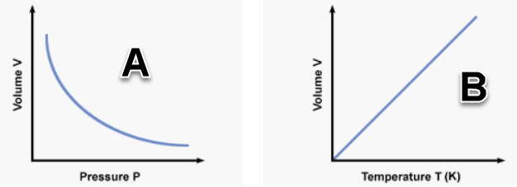

For graph "A", if pressure increases from 1.0 to 1.8 atmospheres, what volume makes most sense if volume began at 20 ml?

a. 10 ml

b. 20 ml

c. 30 ml

For graph "B", if temperature increases from 100 to 300 K, what volume makes most sense if volume began at 20 ml?

a. 10 ml

b. 20 ml

c. 30 ml

Hydrogen bonding between water molecules accounts for what property or properties?

a. water's high boiling point

b. water's solid state is less dense than its liquid (unlike most substances)

c. water's high surface tension and high specific heat

d. all of the choices

What is the energy required to start a chemical reaction?

A student mixes two aqueous solutions, whose masses are 30.0 g and 35.0 g, together. Each solution is initially at a temperature of 25.0°C. Upon mixing the solutions, a chemical reaction occurs. The final solution has a temperature of 30.0°C. What is the heat change, in kJ, for this reaction?

What is the expression for *Keq* for this reaction? 2H2O(g) ↔ 2H2(g) + O2(g)

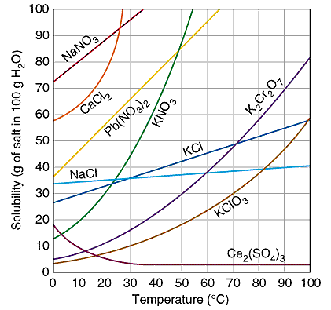

The solubility of most salts in water

a. is inversely related: the higher the temperature, the greater the solubility

b. is inversely related: the lower the temperature, the greater the solubility

c. is directly related: the lower the temperature, the lower the solubility

d. is directly related: the higher the temperature, the lower the solubility

At 10 C how much NaNO3 can dissolve in 1.0 L of water?

At 60 C, 20 g of KClO3 dissolve in 100 g of water. How would you describe this solution?

a. unsaturated

b. saturated

c. supersaturated

d. pure

Given the equation 2Mg(s) + O2(g) → 2MgO(s) + 72.3 kJ, which of the following is TRUE?

a. The reaction is isothermic.

b. ΔH = –72.3 kJ and is exothermic.

c. ΔH = +72.3 kJ and is endothermic.

d. The PE of the reactants is less than the PE of the products.

A hot metal cylinder is placed in water at room temperature in a closed system. Which statement is NOT true concerning heat flow?

a. Heat flows from the metal to the water.

b. The final temperature of the metal and the water will be the same.

c. Water exhibits an endothermic change.

d. The metal exhibits an endothermic change.

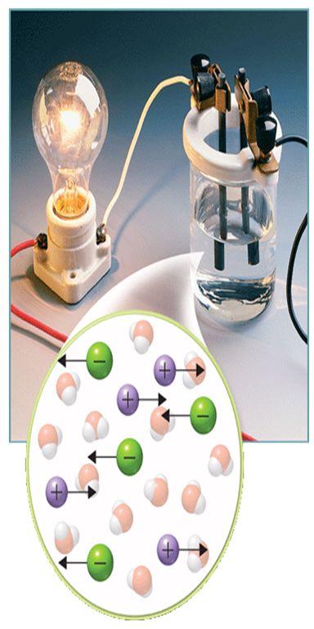

Based on the image, one can say that the solution is most likely

a. an electrolyte

b. a non-electrolyte

c. a saturated solution

d. an unsaturated solution

Calculate the boiling-point elevation for 2.0 kg of water containing 300. g of the salt CaCl2 (Kb = 0.512 C/m).

In an equilibrium reaction with a *Keq* of 1 × 108

a. reactants are greatly favored.

b. the reaction is definitely nonspontaneous.

c. products are greatly favored.

d. the reaction is definitely exothermic.

Based on the reaction: 2POCl3(g) + heat ↔ 2PCl3(g) + O2(g) if temperature is decreased

a. equilibrium shifts left to restore the heat that was lost

b. equilibrium shifts right to restore the heat that was lost

c. equilibrium favors the products so more heat is produced

d. equilibrium will be unaffected

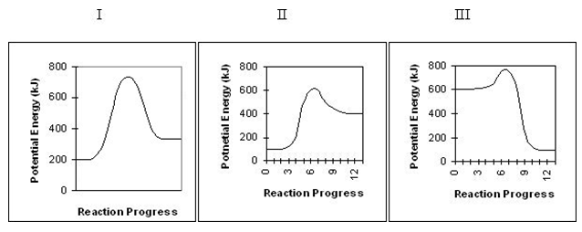

Which diagram shows an exothermic reaction?

a. I

b. II

c. III

Which diagram shows a heat of reaction closest to +300 kJ?

a. I

b. II

c. III

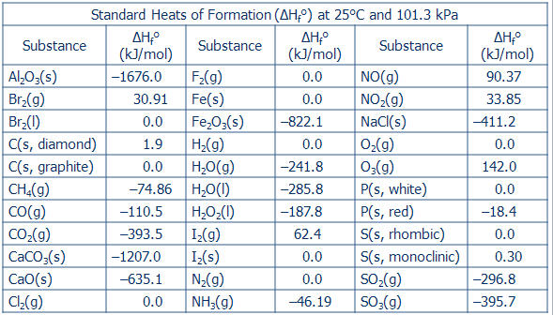

What is ΔH for the following chemical reaction: 4Al(s) + 6O2(g) → 2Al2O3(s) ?

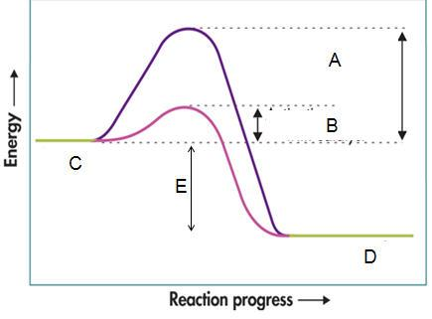

The activation energy of the uncatalyzed reverse reaction is

What is most affected when a catalyst is used in a reaction?

a. reaction rate

b. concentration of reactants

c. heat of reaction of the forward reaction

d. temperature

Which phrase best describes the reaction: 2NO (g) + O2(g) → 2 NO2(g) + 114 kJ

a. exothermic with an increase in entropy

b. endothermic with an increase in entropy

c. exothermic with an decrease in entropy

d. endothermic with an decrease in entropy

Which of the following best insures a spontaneous reaction?

a. free energy is positive

b. exothermic reaction and a liquid going to a gas.

c. endothermic reaction with a gas going to a liquid.

d. high temperature system with an enthalpy increase

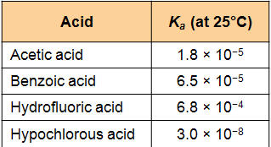

Which acid produces the LEAST amount of ions in solution?

What is the pOH of a solution in which the [H*+*] = 1 × 10*-12 M*?

HCO3-(aq)

a. is amphoteric.

b. can only act as an acid.

c. can only act as a base.

d. would act neither as an acid or a base.

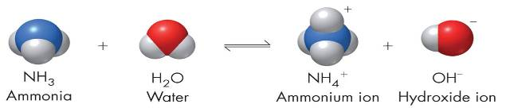

According to the Brønsted-Lowry concept and based on the equation shown in the image,

a. only the forward reaction is an acid-base reaction.

b. ammonia acting as a base and ammonium as an acid are a conjugate pair.

c. ammonia acting as an acid and ammonium as a base are a conjugate pair.

d. this is a typical neutralization reaction.

Identify the oxidizing agent in the following reaction: Mg(s) + S(s) → MgS(s)

Which of the following is TRUE for an electrolytic cell?

a. It changes electrical energy into chemical energy.

b. It is the type of cell used in electroplating.

c. It uses an electric current from an outside power source to make a nonspontaneous reaction go.

d. All of the above are true.

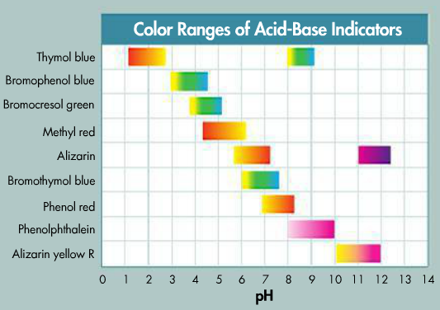

Phenolphthalein

a. works best at low pH

b. turns pink in an acid

c. turns pink in a base

d. works best around pH 13-14

If 50.0 milliliters of a 1.0 M NaOH solution are needed to exactly neutralize 10. milliliters of an H2SO4 solution, the molarity of the H2SO4 solution is:

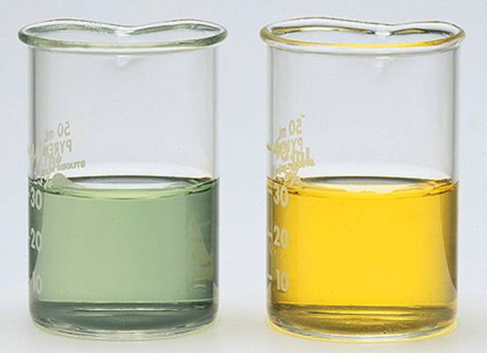

The beakers originally contained solutions that were basic (pH of about 8). 1.0 mL of 0.10 M HCl solution was added to both beakers. The beaker on the left showed no change in color, while the beaker on the right changed as shown.

a. The beaker on the left probably had a buffer.

b. The beaker on the left became acidic.

c. The beaker on the right became more basic.

d. Both beakers contained more H+ ions than (OH)- ions prior to adding the HCl solution.

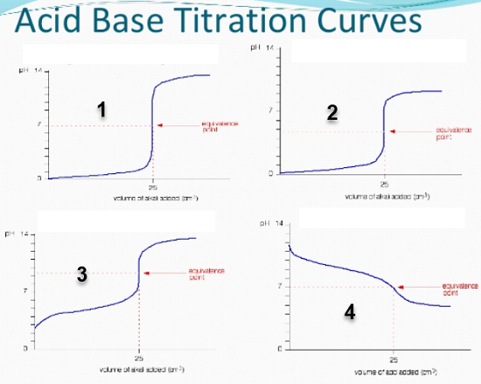

Which graph best represents the titration of a weak base added to a strong acid?

Which metal will react spontaneously with Cu2+(aq) at 25°C?

a. Ag

b. Au

c. Mg

d. Hg

Which is a redox reaction?

a. CaCO3 → CaO + CO2

b. NaOH + HCl → NaCl + H2O

c. 2NH4Cl + Ca(OH)2 → 2NH3 + 2H2O + CaCl2

d. 2H2O → 2H2 + O2

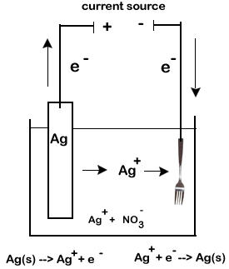

Which specific type of electrochemical cell is shown in the image?

a. voltaic cell

b. electroplating

c. electrolysis to split a compound into its elements

d. alkaline battery

What half-reaction is occuring on the "fork" side of the cell?

a. oxidation of Ag

b. reduction of Ag

c. oxidation of Ag+

d. reduction of Ag+

Nitrogen has the same oxidation number in all of the following except

a. NO3-

b. N2O5

c. NH4Cl

d. Ca(NO3)2

Determine what happens in this reaction: S(s) + Cl2(g) → SCl2(s) (Hint: Chlorine is the more electronegative element.)

a. Sulfur is reduced.

b. Chlorine is reduced.

c. Chlorine is oxidized.

d. Sulfur is the oxidizing agent.

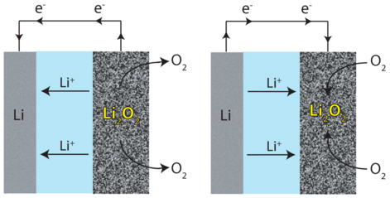

The image shows a reversible electrochemical reaction. Which specific electrochemical process is operating?

a. discharging and recharging battery

b. electrolysis to split a compound into its elements

c. half cell reactions of a typical voltaic cell

d. electroplating

All of the following describe a salt bridge or porous barrier in an electrochemical cell EXCEPT that it:

a. contains electrolyte solution.

b. allows ions to flow between half-cells.

c. prevents buildup of charge on the electrodes.

d. recharges the voltaic cell after extended usage.

Fe(OH)2(s) + O2(g) + H2O(l) → Fe(OH)3(s) represents a corrosion reaction of iron. Which statement is NOT true?

a. Salts, acids, temperature, exposure all accelerate corrosion.

b. Coating the metal, reducing exposure, and replacing metal with plastic or alloys decreases corrosion.

c. The metal gets reduced and the oxidizing agent (often oxygen) is oxidized.

d. The metal gets oxidized and the oxidizing agent (often oxygen) is reduced.

Assuming that electrochemical cells are categorized into TWO groups, which of the following represents a different type of electrochemical cell than the others?

a. A dry cell that uses a paste, but has a short shelf life.

b. Fuel cells that do not need recharging.

c. Alkaline battery that shows no significant drop in voltage when used.

d. A lead storage battery that contains multiple cells.

e. Electroplating silver onto a piece of jewelry.

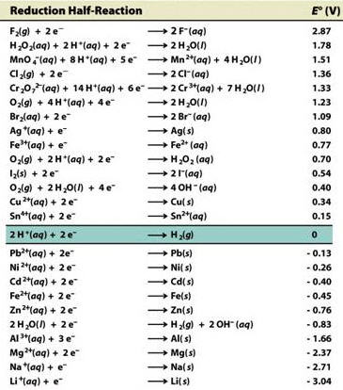

According to the SRP chart, which element will oxidize the others?

a. F2

b. Li

c. Zn

d. Mg

Does aluminum react with copper? What is the E0cell potential of these two metals?

Which of the following elements is the strongest reducing agent?

a. Fe

b. Na

c. Cl2

d. Ag

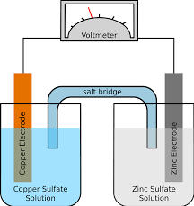

What kind of electrochemical cell is shown in the image? Is it spontaneous or not?

Which electrode represents the anode and what is its sign?

a. copper, -

b. zinc, -

c. copper, +

d. zinc, +

Which way do the electrons flow in this redox reaction?

a. ... from copper to the voltmeter to zinc.

b. ... from zinc to the voltmeter to copper.

c. ... from zinc through the salt bridge to copper.

d. There is no way of knowing without further information.

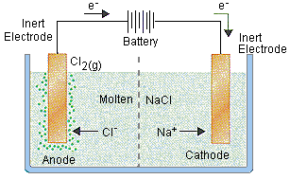

What type of electrochemical cell is shown in the image?

What is the half reaction at the anode?

a. 2Cl- → Cl2 + 2 e-

b. Cl2 + 2 e- → 2Cl-

c. Na+ + e- → Na

d. Na → Na+ + e-

REDOX reactions

a. involve neutralization of one metal with another.

b. do not require activation energy.

c. do not involve the change in oxidation number of the elements involved.

d. involve the loss of electrons by one metal and the gain of electrons by another.

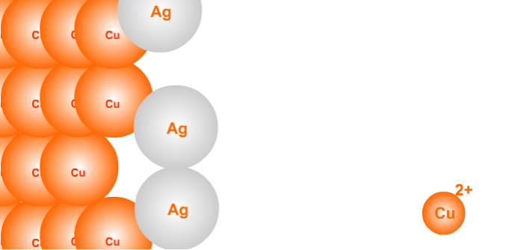

Based on the image, which statements is NOT true?

a. Copper gained electrons in the reaction.

b. Copper lost electrons in the reaction.

c. Silver metal is plating the copper metal.

d. Copper metal is more active than the silver metal.

Based on the diagram, determine the total voltage potential of this redox reaction.

