**Energy Overview**

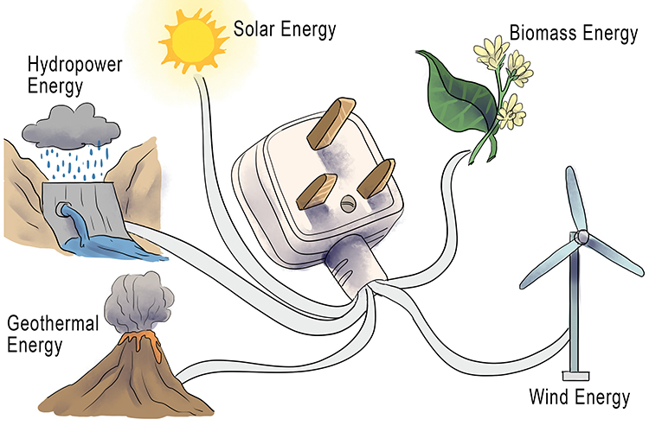

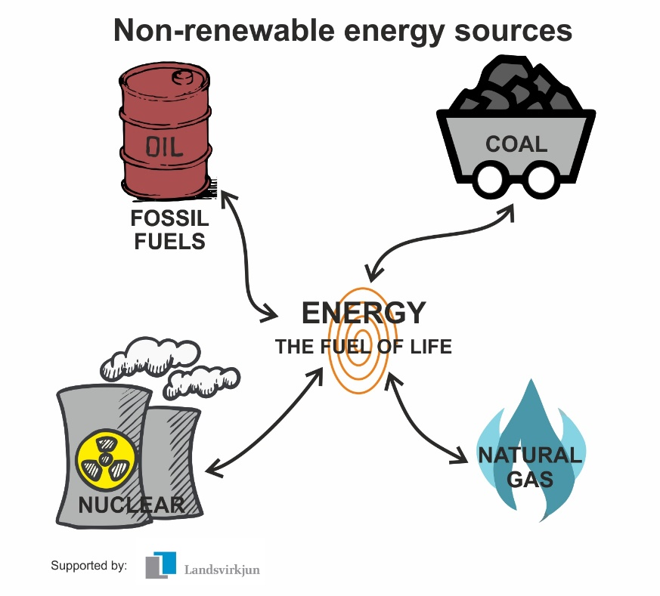

**See** [**https://www.learningctronline.com/courses**](https://www.learningctronline.com/courses) **for Materials and Resources.**

**Topics:**

1. Energy Overview

**Objectives:**

* + Distinguish between renewable and non-renewable energy resources.
  + Identify and explain major renewable and non-renewable resources.
  + Understand how much energy is derived from various resources.
  + Calculate the cost of energy.
  + Recognize ways to conserve energy.
  + Read an electric meter in your home.

TAKE NOTE [1 week]

1. Energy Sources Notes Worksheet from PowerPoint
2. Reference Material Worksheet: Energy Overview
3. Lab: Applications of Energy PowerPoint Worksheet
4. Film Review “Alexander Graham Bell” [1938] (Don Ameche, Henry Fonda, Loretta Young)
5. Quiz Energy Overview
6. Week 20 Devotional (<https://www.learningctronline.com/devotional>)

**Text**:

**Reference Material: Energy Sources PowerPoint & Energy Overview Notes**

**Homework**:

* Energy Sources Notes Worksheet from PowerPoint
* Energy Overview Reference Material Worksheet

**Lab**: Lab: Applications of Energy PowerPoint Worksheet

* Complete the worksheet provided using the PowerPoint provided.
* You will read your electric meter and calculate the cost of the energy.
* Save the document into your LAB folder in the Projects in Science folder on your desktop.

**Lab**: Film Review

* Obtain the movie “Alexander Graham Bell” [1938, Don Ameche, Henry Fonda, Loretta Young] [1h 38m]. YouTube.com.
  + Complete the **Alexander Graham Bell** film review provided.
* Save the document into your LAB folder in the Projects in Science folder on your desktop.

**TEST:** Energy Overview Quiz

1) the academic integrity policy

* Tests must be completed **WITHOUT** referring to books, notes, the internet, people, or any outside resources.
* Students **MAY** use the approved Periodic Tables, approved Reference Tables, or approved equation (formula) sheet (provided by the teacher) along with calculators and scratch paper.
* A guardian should be proctoring the test. Proctoring means to monitor the following:

2) Take the **"in one sitting"**, meaning that once you start the test, you must complete it without interruption.

3) There is a **30-minute time limit** on this test. Please have the proctor write the time taken at the top of your answer sheet with their signature or initials.

4) Proctors should NOT be reading the test or engaging students during the test.

5) Do NOT use RED font. Black font is best.

Supplemental Resources (Optional)

1. Applications of Energy Graphic Organizer