**Water Quality**



**See** [**https://www.learningctronline.com/courses**](https://www.learningctronline.com/courses) **for Materials and Resources.**

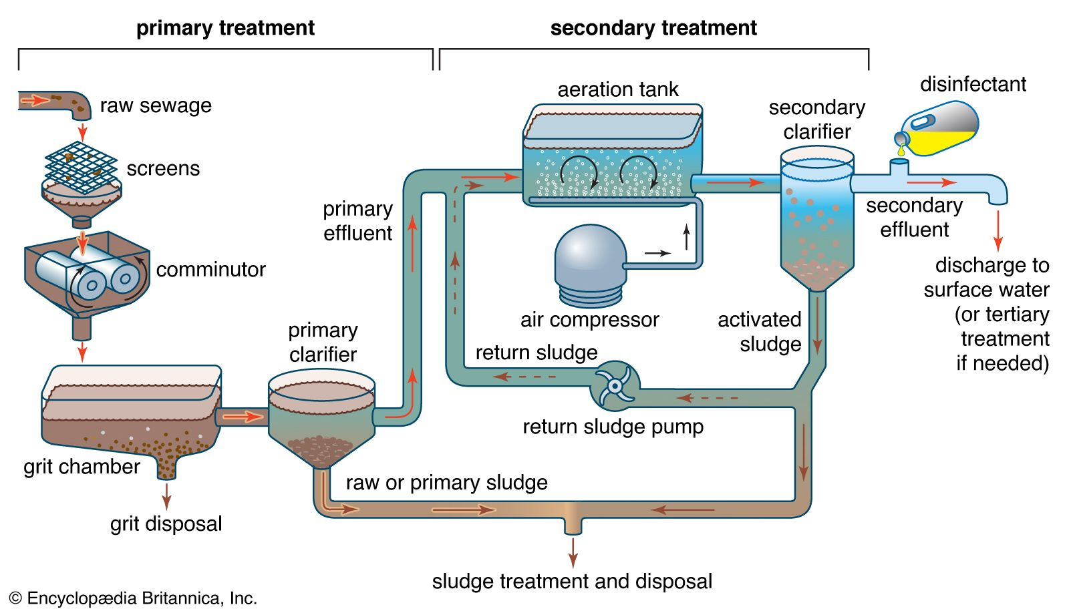

**Topics:**

1. Water Quality

**Objectives:**

* + Describe that the water cycle includes evaporation, transpiration, condensation, precipitation, infiltration, surface runoff, groundwater, and absorption.
  + Analyze the flow of water between the elements of a watershed, including surface features (lakes, streams, rivers, wetlands) and groundwater.
  + Describe the river and stream types, features, and process including cycles of flooding, erosion, and deposition as they occur naturally and as they are impacted by land use decisions.
  + Explain the types, process, and beneficial functions of wetlands.
  + Compare and contrast surface water systems (lakes, rivers, streams, wetlands) and groundwater in regard to their relative sizes as Earth’s freshwater reservoirs and the dynamics of water movement (inputs and outputs, residence times, sustainability).
  + Explain the features and processes of groundwater systems and how the sustainability of North American aquifers has changed in recent history (e.g., the past 100 years) qualitatively using the concepts of recharge, residence time, inputs, and outputs.
  + Explain how water quality in both groundwater and surface systems is impacted by land use decisions.

TAKE NOTE (All assignments are due by next week’s class.)

1. Reference Material Worksheet: Water Treatment
2. Notes / Study Guide Water Quality
3. Worksheet: Ice Mountain Discussion
4. Lab: Watch Waste Water Treatment Video
5. Crossword Review: Water Quality
6. Quiz Water Quality
7. Week 30 Devotional (<https://www.learningctronline.com/devotional>)

**Text**:

**Reference Material: Water Quality**

**Homework**:

* Reference Material Worksheet: Water Treatment
* Notes / Study Guide Water Quality
* Worksheet Ice Mountain Discussion
* Crossword Water Quality

**Lab**: Waste Water Treatment Video

* + Watch the video: <http://somup.com/c0lXqCgSfi> (9:39)
* Watch during class.

**TEST:** Test Water Quality

1) the academic integrity policy

* Tests must be completed **WITHOUT** referring to books, notes, the internet, people, or any outside resources.
* Students **MAY** use the approved Periodic Tables, approved Reference Tables, or approved equation (formula) sheet (provided by the teacher) along with calculators and scratch paper.
* A guardian should be proctoring the test. Proctoring means to monitor the following:

2) Take the **"in one sitting"**, meaning that once you start the test, you must complete it without interruption.

3) There is a **40-minute time limit** on this test. Please have the proctor write the time taken at the top of your answer sheet with their signature or initials.

4) Proctors should NOT be reading the test or engaging students during the test.

5) Do NOT use RED font. Black font is best.

Supplemental Resources (Optional)

1. Water Review Sheet
2. Nestle Article.

Water Cycle Animation <http://somup.com/cZf0ooCWJt> (3:00)

Watershed <http://somup.com/cZf0oqCWJK> (2:51)

Combined Sewer Overflow <http://somup.com/cZf0oTCWdt> (7:40)

Waste Water Treatment <http://somup.com/c0lXqCgSfi> (9:39)