Aquatic Ecology

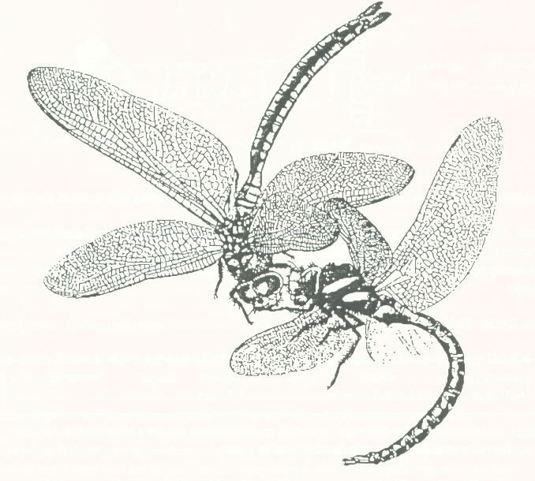

**Introduction**

The study of ecology benefits anglers in several important ways. Anglers can increase their fishing enjoyment and success by understanding the ecological relationships between the organisms in lakes, ponds, rivers, streams, and the ocean. By learning some ecology, anglers can also satisfy their curiosity about things they’ve seen outdoors. Anglers must also understand ecological concepts to understand the reasoning behind modern fisheries management decisions.

This document provides an introduction to the ecological concepts of niche, habitat, food chains, populations, and carrying capacity. The application of these concepts to angling and fisheries management is covered in future reference materials.

**Niche**

An organism’s **niche** is its unique role or “way of making a living” in the environment. It includes such things as habits, spawning behavior, and seasonal migrations. For example, alewives and ciscoes both “make a living” by schooling and feeding on zooplankton in the Great Lakes.

When exotic fish species are introduced into New York waters, they may compete for a “way of making a living,” or niche, with native species. If the exotic species has some competitive advantage, it may push out the native species. In the Great Lakes, exotic alewives and smelt displaced the native whitefish, ciscoes, and shiners. On the other hand, species may be introduced which fill a niche previously not occupied. For example, Pacific salmon were introduced into the Great Lakes to fill the niche that was created when the alewife and smelt populations exploded unchecked by native predators.

**Habitat**

**Habitat** is defined as the immediate physical and biological environment in which an organism lives. It includes such components as cover, food, and spawning sites. For an individual fish to survive, it must have adequate food and cover to escape predators. In order for the species to survive, it must have suitable spawning sites.

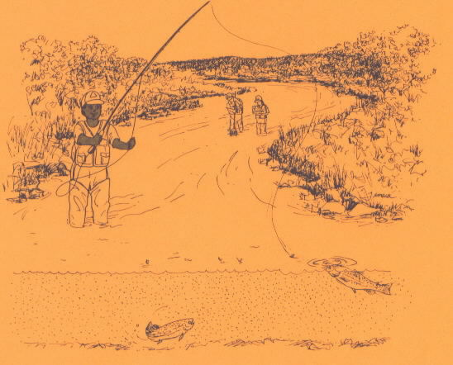

Fish may have different habitat requirements at different times of the year. For example, in small ponds, there may be ample food and cover for fish to survive in the spring, summer, and fall. But if the pond is not deep enough the fish may die from “winter kill” (due to a lack of oxygen). Therefore, the pond would not have adequate winter habitat.

In addition, fish may have different habitat requirements at different times during their life cycle. For example, lake populations of rainbow trout run up tributaries in the spring to spawn. The juvenile rainbow trout may stay in the stream for two or three years until they are mature before running down into the lake.

Unfortunately, many human activities have an adverse effect on fish habitat. Because substrate and water quality must be within narrow limits for eggs to develop properly, spawning habitat has been most affected. Declining habitat quality is caused by pollution and land use practices, such as filling in wetlands that increase erosion and cause *siltation (a build up of silt, filling in the area*) of spawning sites. Fish habitat is now recognized as being crucial to the preservation of fish populations. We must preserve aquatic habitats to ensure a healthy fisheries resource for future generations.

**Food Chains**

In an aquatic ecosystem, such as a pond or lake, phytoplankton are fed upon by zooplankton, which are then eaten by yellow perch. The yellow perch, in turn, are eaten by walleyes, bass, pike, and muskies. The game fish may then be caught and eaten by a lucky angler. A meal of fresh fish provides both energy and nutrients for the angler. That energy was produced by the photosynthetic phytoplankton and cycled through the zooplankton, yellow perch, and gamefish to the angler.

The **food chain** is used to describe the movement of energy and nutrients through a series of plants and animals in an ecosystem. All food chains begin with a photosynthetic green plant or **producer**. Animals feeding on green plants are called **primary consumers**. The next level of the food chain is **secondary consumers**, which feed on the primary consumers. There may be third, fourth, or fifth level consumers as well. Finally, at the end of every food chain are **decomposers** (such as bacteria and fungi), that return the nutrients to the environment. These nutrients are absorbed by other green plants and cycled through another food chain.

## A typical Freshwater Food Web

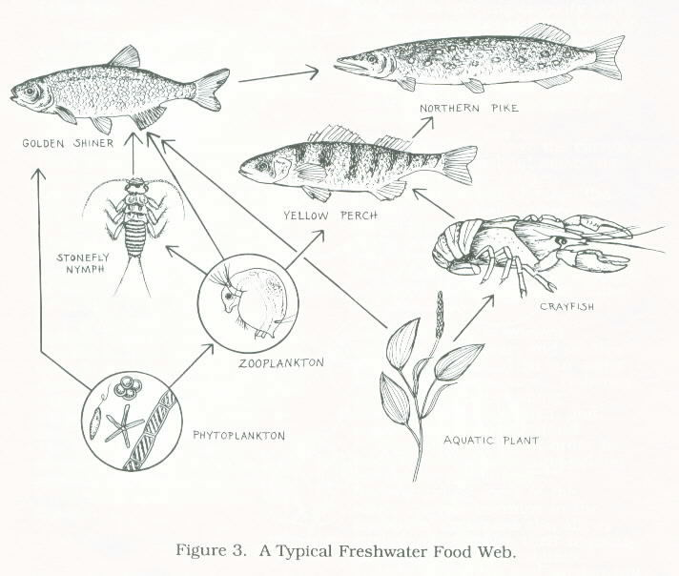

Most organisms feed on a wide variety of plants and animals. Thus, food chains become immensely complicated and interweave to form a **food web**. All living organisms in a food web are interconnected and interdependent on one another. If human activities adversely affect one member of the aquatic ecosystem, the effect often ripples down through the food web to other organisms.

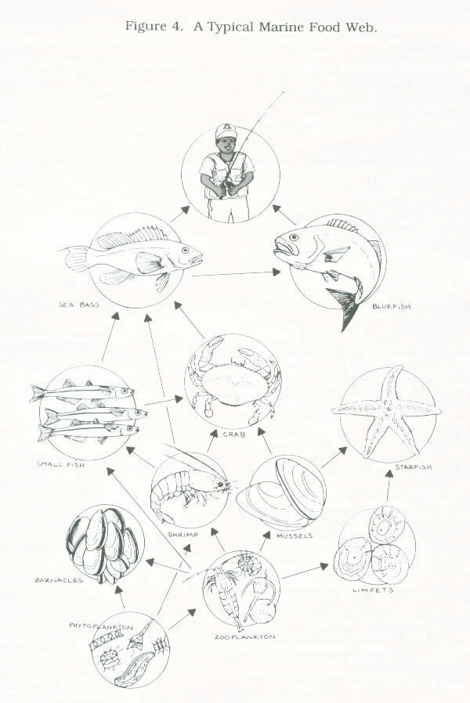

Often toxic chemicals accumulate in animals at the top of the food web. This happens in the following way. First, contaminants in the water are taken up by small plants and animals. Next, the larger animals, such as fish, eat many contaminated smaller organisms. The contaminants become concentrated in the fatty tissues of the fish, and are not excreted. Therefore, we find that the top predators of the Hudson River in New York food webs, such as striped bass, contain a level of PCB’s many thousands of times more concentrated than in the environment. When predators at the next level of the food web, such as humans, consume these contaminated fish, the toxins accumulate in their bodies as well. Due to the presence of toxins in some New York waters and the accumulation of toxins by high level consumers, we now have health advisories warning people to limit the amount of some kinds of fish in their diets.

A Typical Marine Water Food Web

## A typical Freshwater Food Web

**Populations, and Threatened and Endangered Species**

**Limiting Factors and Carrying Capacity**

A **population** is a group of organisms of the same species that lives in a given habitat and may interbreed. For example, the largemouth bass in Cayuga Lake form a population. The largemouths in Lake Erie comprise a separate population, since fish do not travel between Cayuga Lake and Lake Erie.

When populations get so small that they cannot reproduce enough individuals to replace the ones that die, they begin to decline and are called **threatened**. Severely threatened, or **endangered**, populations are in imminent danger of going extinct. For example, if there were only ten individuals of a deep-water sculpin species left in Lake Ontario, it would be nearly impossible for a male and a female to find one another and mate. Limited populations of threatened species, such as a particular fish species that only inhabits one body of water, are more subject to extinction than if there were several different populations in various waters. Some endangered species in New York State waters include the short-nosed sturgeon, round white fish, pug nose shiner, eastern sand darter, blue breast darter, gilt darter, spoonhead sculpin, and Deepwater sculpin. The DEC lists lake sturgeon, mooneye, lake chubsucker, mud sunfish, and long ear sunfish as threatened species in New York State.

**Limiting Factors and Carrying Capacity**

The number of individuals in a given population, such as the largemouth bass in Cayuga Lake, is limited by some factor of the habitat. This **limiting factor** could be food, cover/shelter, or spawning sites. The maximum number of individuals in a population that can be sustained by the habitat is called the **carrying capacity**. Simply stated, the carrying capacity is the maximum number of fish a body of water can maintain over a long period of time. When human activity such as boating, fishing, chemical dumping, etc. destroys fish habitat, the carrying capacity is reduced; the water can no longer support as many fish.

Stocking fish above the carrying capacity of the habitat makes no ecological sense. In fact, overpopulation will damage the habitat and actually reduce the carrying capacity. For example, too many predators stocked into a lake may wipe out the entire stock of forage fish. Once the food supply is damaged, the predator population will crash as well.

The number of anglers increases every year, and so does the pressure placed on our water and fisheries resources. Fisheries management is becoming increasingly complicated, and anglers need to understand ecological principles in order to understand the reasoning behind our fishing regulations. Understanding some of the ecological relationships in the aquatic environment also allows anglers to minimize their impacts on the fish and fish habitats. Today’s sportsmen and women will determine the quality of the resources for generations to come.