**Media: The Teacher**

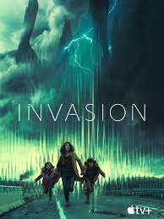 

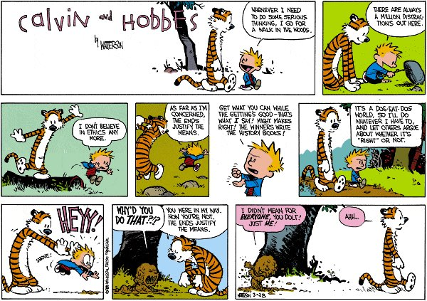

**See** [**https://www.learningctronline.com/courses**](https://www.learningctronline.com/courses) **for Materials and Resources.**

**Topics:**

1. Media: The Teacher

**Objectives:**

* + Understand the influence of media on our lives
    - Fast food mentality
    - Alien invasion
    - Deceit
    - Advertisement (e.g., cigarettes, cars, clothing, etc.)
    - Violence & vengeance
    - Winning at all costs
    - Sex is cheap and defiled
    - Ends justify the means
  + Scientifically analyze some samples of media … truth versus fiction.

TAKE NOTE

1. Media Survey
2. Reference Material Worksheet: Media, the Teacher
3. Project: Media (due before 1st semester ends)
4. Film Review “Conspiracy Theory: Did we land on the Moon?” [2001] (John Moffet, Mitch Pileggi).
5. Film Review “Hoosiers” [1986] (Gene Hackman, Barbara Hershey).
6. Quiz Media, the Teacher
7. Upcoming: Semester Exam due 10 days after week 16 class
8. Week 14 Devotional (<https://www.learningctronline.com/devotional>)

**Text**:

**Reference Material: Media, the Teacher**

**Homework**:

* Media Survey
* Reference Material Worksheet: Media, the Teacher
* Consider Media Project

**Lab**: Film Review

* Obtain the documentary “Conspiracy Theory: Did we Land on the Moon?” [2001, John Moffet, Mitch Pileggi]
  + Complete the **Conspiracy Theory** film review provided.
* Save the document into your LAB folder in the Projects in Science folder on your desktop.

**Lab**: Film Review

* Obtain the movie “Hoosiers” [1986, Gene Hackman, Barbara Hershey]
  + Complete the **Hoosiers** film review provided.
* Save the document into your LAB folder in the Projects in Science folder on your desktop.

**TEST:** Quiz Media, the Teacher

1) the academic integrity policy

* Tests must be completed **WITHOUT** referring to books, notes, the internet, people, or any outside resources.
* Students **MAY** use the approved Periodic Tables, approved Reference Tables, or approved equation (formula) sheet (provided by the teacher) along with calculators and scratch paper.
* A guardian should be proctoring the test. Proctoring means to monitor the following:

2) Take the **"in one sitting"**, meaning that once you start the test, you must complete it without interruption.

3) There is a **30-minute time limit** on this test. Please have the proctor write the time taken at the top of your answer sheet with their signature or initials.

4) Proctors should NOT be reading the test or engaging students during the test.

5) Do NOT use RED font. Black font is best.

Supplemental Resources (Optional)

1. Project X Film Review
2. Watch “American Underdog” in the “Media Bias in Movies” … to get ahead. We can do the film review in class.