**Simple Maps**

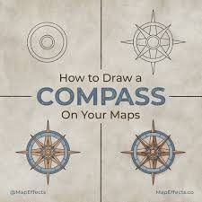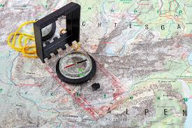

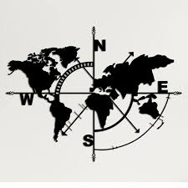

**See** [**https://www.learningctronline.com/courses**](https://www.learningctronline.com/courses) **for Materials and Resources.**

**Topics:**

1. Compass Bearings

**Objectives:**

* + Learn the components of and how to make a simple map.
    - Finding field bearings and distances (compass work)
    - Starting the map
    - Drawing the map
    - Protractor use.
  + Understand the concept of a contour (topographical) map and be able to draw one or decipher one.

TAKE NOTE

1. Film Review of “Cast Away” or “Alone in the Wilderness”.
2. Simple Maps Worksheet
3. Quiz 1 Simple Maps
4. Lab: Contour Mapping
5. Survival Essay OR Mapping Project
6. Quiz 2 Compass Mapping
7. Week 9 Devotional (<https://www.learningctronline.com/devotional>)

**Text**:

**Reference Material:** Simple Maps

**Homework**:

* Simple Maps Worksheet using the reference material.
* Survival Essay or Mapping Project [Complete the worksheet provided].

**Lab**: Film Review

* Obtain the movie “Cast Away” with Tom Hanks [2000 2h 24m] OR “Alone in the Wilderness” [2004 57 m Dick Proenneke]
  + <https://www.mondo.tube/watch/alone-in-the-wilderness-2004/> [57:28] Alone in the Wilderness
  + Complete the **generic** film review in the course Resources folder for ONE of the two movies.
* Save the document into your LAB folder in the Projects in Science folder on your desktop.

**Lab**: Contour Mapping

* Complete the worksheet provided.
* Save the document into your LAB folder in the Projects in Science folder on your desktop.

**TEST: Quiz 1 Simple Mapping**

1. Complete the quiz and email it to [LearningCTROnline@gmail.com](mailto:LearningCTROnline@gmail.com)

**TEST: Quiz 2 Compass Mapping**

1. The quiz is open notes.
2. Complete the quiz and email it to LearningCTROnline@gmail.com

Supplemental Resources (Optional)

1. Use the internet to watch videos of making a simple compass map.
2. Crossword Review Compass Orienteering.