Fishing Reference Material

# Basics of the Sport

#### Natural Baits

The various types of natural baits commonly used by fishermen were presented earlier. They include worms, minnows, crayfish, salamanders, grubs, frogs, insects, and insect larvae (*for example, grasshopper, hellgrammite*), eggs, cut baits, and dough balls.

**Worms and night crawlers** can be dug up with a potato fork or shovel. They also can be forced to the ground’s surface by pushing a potato fork into the ground, pulling back on the handle and then quickly releasing it. The vibration will cause worms in the upper soil layers to come to the surface where they are easily picked up. Night crawlers can be collected after dark with the aid of a light. A red filter is often helpful in catching them. These critters come out and crawl on the ground, especially after a rain, making them easy to collect. Both worms and night crawlers can be stored in a container partially filled with sphagnum moss, leaf mulch, or commercial worm bedding materials. Worms are effective bait for nearly every species of freshwater fish. They are usually hooked lightly through the head or the breeding ring allowing the ends to trail freely.

**Minnows** can be caught using a seine, dip net, or minnow trap. Stale bread, broken into tiny crumbs, makes good bait to attract them. Minnows can be stored for a short time in a typical bait fish pail filled with water. They are good bait for large trout and salmon, largemouth and small mouth bass, northern pike, pickerel, muskellunge, rock bass, perch, and crappies. Minnows are usually hooked through the lips or just behind the dorsal fin using light wire hooks.

**Crayfish** can be caught in a modified minnow trap using chunks of scrap meat. The entrance to the trap should be level with the stream bottom to facilitate their entry. A more straightforward method is to catch them by hand. This is actually quite fun; and since you are usually wading in streams or along lake shores in the summer to get them, it can be very refreshing too. Crayfish can be stored for a short time in a typical bait pail filled with water. They are particularly good bait for largemouth, small mouth, and rock bass. Crayfish are usually hooked through the tail when they are used as live bait.

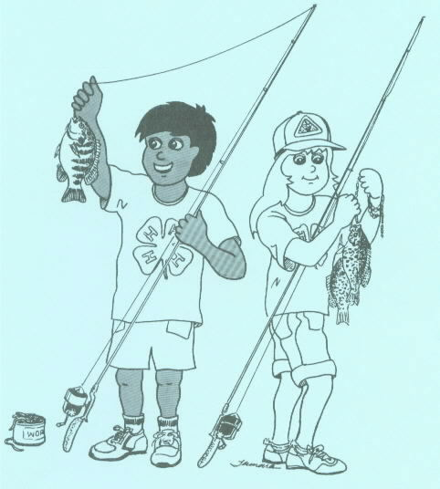

**Salamanders** can be gathered along the edges of shallow spring brooks or in moist, shaded spring seeps. They are usually found under small rocks and can be easily caught by hand. Be careful not to grab them by the tail because the tails will often break off. Salamanders can also be stored in a bait pail for short periods of time, but only one or two centimeters of water or damp moss should be added. Trout, largemouth bass, small mouth bass, rock bass, sunfish, and bluegills all readily take salamanders for food. Like minnows, salamanders may be hooked through the lips. Some fishermen prefer to hook them lightly through the skin just in front of their hind legs.

**Frogs** can be caught along the banks of any stream or standing body of water. While many people prefer to catch them by hand, a more efficient method is to use a tightly meshed net of some type. Bait fish pails fill with about five centimeters (*two inches*) of water make good temporary storage containers for frogs. Largemouth and small mouth bass, northern pike, pickerel, and muskellunge include an occasional frog in their diet. Frogs are usually lip hooked; harnessed in special rigs, or hooked lightly through t the sin of a hind leg.

**Insects and insect larvae** require different methods for capture. The grasshopper and cricket are commonly caught by hand or with nets. Aquatic insect larvae can usually be found by overturning stones in streams. Often the larvae are attached to the underside of he stones. Aquatic insect larvae can be temporarily kept in bait fish pails also. In many states it is illegal to remove insects or insect larvae from waters inhabited by trout. Terrestrial insect larvae such as grubs are commonly found under rotting logs or other wood and in rotting leaf litter. They can also be found in freshly turned sod. These can be stored in almost any type of convenient container. Whatever is used should have a layer of leaf mulch on its bottom. Insects and their larvae are good bait for bluegills, sunfish, rock bass, perch, crappies, trout a, and largemouth and small mouth bass. Use light wire hooks to keep injury to a minimum when using insect larvae for bait.

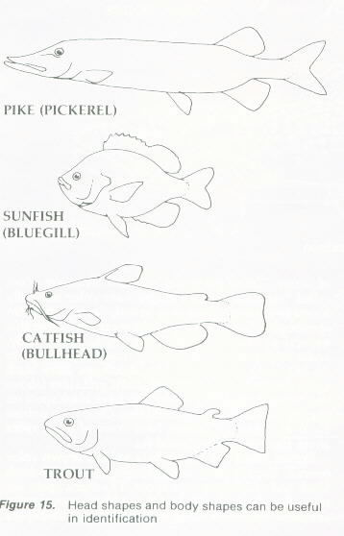

**Fish eggs** are acquired from fish that were full of roe (*eggs*). These can be used on a hook singly, as with large salmon and trout eggs, or tied in a small sack made of pieces of nylon, cheesecloth, veil, or similar materials when using smaller eggs.

**Cut baits** are chunks of fish, scrap meat, or liver which are used when still-fishing. They are cut into one-to-two-centimeter (*half to three-quarters inch*) cubes.

**Dough balls** can be made in several ways. They are usually made according to some “secret” recipe, but any bread dough recipe will do. Sometimes ingredients such as fruit Jello powder or oil of anise are added for variety. The size of these balls can vary in diameter from the size of a dime to the size of a nickel.

Eggs, cut baits, and dough balls can be carried and kept in just about any type of container. The eggs and cut baits can deteriorate if exposed to warm temperatures for any length of time. Fish eggs, cut baits, and dough balls are effective baits for suckers, carp, and bullheads. Fish eggs are also good for trout and salmon.

Regardless of what type of bait and container you use, one rule applies—keep them *cool*. For bait kept in water, frequently replenish or replace the water to keep it cool and oxygen rich. As mentioned earlier, this section on natural baits is given only superficial treatment. We hope it has been adequate in introducing the beginner to some basic considerations on the various types, uses, collection, and storage of natural baits.

## To Catch a Fish

Although important, knowing only how to cast and what bait to use is not sufficient to ensure a successful fishing trip. What do you do after a fish takes the bait you’ve offered? We’ve termed these subsequent steps, “To Catch a Fish.” The discussion below describes the main points, but only through actual experience will their importance be realized. Catching a few fish will develop these skills rapidly.

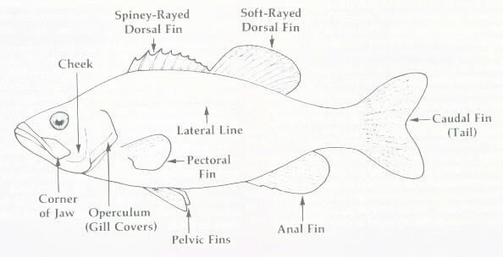

### Hooking a fish

After you’ve made a cast to a likely looking spot with nearly irresistible bait, what should you expect? More often than not the answer will be nothing. Sometimes you’ll be fortunate and your line will come to life. You may feel some short, jerky actions or a heavy steady tug. A fish has taken your bait. Slowly retrieve your slack line, not too much though. You don’t want the fish to know that you’re on the other end of the line!

With the slack line drawn up, wait for the next hint of activity on the fish’s part. Holding the rod and reel in your left hand and the reel handles in your right hand, keep the rod at about a forty-five-degree angle with the water surface. Feel a little tug? Raise the rod tip upward, very slowly. Feel a harder tug? Jerk the rod up and back swiftly. If the fish is not on, retrieve your hook and re-bait, if necessary. If the fish is on, hurry up and read the next section.

### Playing a fish

Playing a fish consists of a contest between fisherman and fish. In effect, the fish does everything it can to throw the hook and the fisherman does everything possible to prevent or counteract the fish’s maneuvers. The fisherman must keep tension on the line until the fish becomes tired so it can be brought to net. He or she must try to prevent the fish from throwing the hook or getting tangled among logs, roots, or rocks and breaking the line.

When playing a fish, the rod tip should be held in a nearly vertical position. This allows you to have the best control of the fish, keeping its head up and making it work against as much rod action as possible. If the fish makes a powerful headlong rush away from the fisherman, the drag will allow the line to be stripped from the reel. When a large fish makes such a move it is advisable to lower the rod tip and “give it the butt,” taking the strain at a heavier section of the rod. This keeps the rod from coming under severe strain, which could cause it to break. No fish can break a rod by itself. It needs help from the fisherman. If the fish rushes toward the fisherman, the line must be wound up quickly enough to maintain tension. No slack should be allowed in the line. If a fish does head for a snag, the pressure placed on the line must be increased to turn it back into the open water. If it jumps, the rod must be pulled back to keep the line taut. The amount of pressure required for these maneuvers is learned only through experience. As the fish tires more line can be retrieved. Eventually, the fish will become exhausted and you will be able to land it.

### Landing a fish

After a fish has been sufficiently tired to allow you to bring it in you must “land” it. Methods of doing this include beaching, grasping with the hands, or netting. The latter method is best for several reasons and is the one preferred for the beginner.

To net your fish, lead it toward the net with the rod. Net the fish headfirst. To do this it is obvious that you don’t reel the fish right up to the end of your rod. Leaving about ten feet of line allows you to hold the rod high and keep things under control. If the fish is not adequately tired it may make a sudden rush as it nears the net. Having the extra line out and the rod held high will increase your chances to control such a last-ditch effort. Before the fish is close enough to see you, submerge the net. Lead the fish over it, head first, and lift smoothly. Do not chase the fish with the net since this would frighten it further and increase the difficulty in netting.

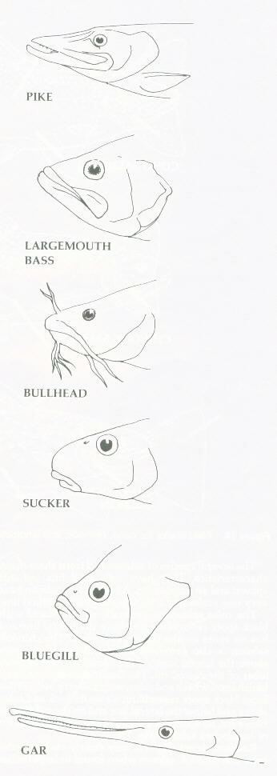

### Unhooking a fish

All fish are slippery; therefore, they are more easily handled in a net. If you are going to keep a fish, but want to kill it rather than keeping it on a stringer, kill it first and then remove the hook. To kill a fish cleanly, hold it by the body and give it a sharp blow to the base of its head with a hard object. If you are going to release a fish, be especially careful to avoid handling or injuring its gills. You must also be careful not to squeeze a fish to hard since this can cause injury.

To remove a hook from a fish you would like to return or place on a stringer, hold it in the net, being careful that all the spines on its fins are depressed. Using your fingers, if it is hooked in the lip, or forceps, if it is hooked deeper in the mouth, push the point of the hook rearward (*away from the eye of the hook*) and up. This should cause the hole to enlarge slightly, allowing the barb of the hook to pass through without unduly ripping the flesh. Never attempt to remove a hook by yanking it straight out. This will only result in embedding the hook more firmly and cause further injury to the fish.

If the fish is to be returned, carefully place it in the water. Don’t just give it a heave. If you are in a swift flowing stream, release the fish in a calm pool or near shore. This will give it time to recover before it must swim against a current. If the fish does not recover put it on your stringer. It’s better to eat it than to let it be wasted.

A fish that is to be placed on a stringer should be attached by its lower jaw, not by its gills. Putting a stringer snap through a fish’s gills will cause it to die rapidly. The reason for using a stringer is to keep your catch alive and “fresh” for as long as possible, so care in attaching the fish to the stringer is very important.

## Casting Techniques

### Introduction to spin-casting

As mentioned earlier, spin-casting is relatively easy to learn. Like many “easy” things though, it may seem difficult at first. Once the basics are mastered, increased skill develops rapidly with practice.

A beginner should become familiar with the spin-cast reel and its operation. Attach the reel to the rod. If there is no line on the reel, remove the front cap (*housing*), pass the end of the line from a supply spool through the hole in the cap and tie the line to the reel spool with a slip knot. Replace the cap, and holding the line taut with the thumb and forefinger about seven to eight centimeters (*three inches*) in front of the reel (*this insures proper line feeding*), wind on the mono-filament. Ideally a spin-cast reel should be filled with line to within about half a centimeter (*eighth of an inch*) of the lip of the spool. Press and release the release button permitting the line to feed freely. Pass the free end through each guide, being careful not to mistakenly wrap it around the rod. Using the improved clinch knot, tie a rubber practice plug onto the line.

To get a feel for how the reel works, hold the rod out in front of you, reel up the line until the practice plug is hanging about ten centimeters (*four inches*) from the rod tip. Quickly, fully depress the button. Now remove your thumb from the button. The plug should fall to the ground. Holding the line taut with your thumb and forefinger, start winding in the plug. With the first revolution of the reel handle you will hear a “click.” This is the sound of the pick-up pin being activated within the reel. Now the line is rewound onto the spool. These are the basics of operating the spin-cast reel.

The next step is to learn basic overhand casting technique. One bit of advice is important – let the *rod* do the casting. It is important to make the cast in one smooth motion. As the diagram on the next page illustrates, the rod is put under a great deal of tension with this type of cast. The bend and action of the rod created by the plug moving backward, while you have started the rod in a forward motion, greatly increases the power, and thus the distance, of the cast.

As the diagram illustrates, the cast begins with the rod in front of you, point toward the “target” of your cast. You should adopt a firm, but natural stance. The rod should be held with the reel facing up. Using wrist and forearm action, bring the rod swiftly to an upright position, then bring your forearm down and forward without pausing, snapping the wrist for added acceleration.

When the rod is held in the beginning position, the thumb button should be fully depressed and held there until the rod is nearly straight in font of you at the end of the cast. When the rod is at about a forty-five-degree angle with the ground, the button should be released allowing the line to leave the reel freely. If the button is released too soon, the plug will go high rather than far. If it is released too late, the plug will strike the ground immediately in front of you.

### The sidearm cast and casting practice

The overhand cast introduced last time is the easiest cast to learn, but often other casting techniques are useful. Occasionally overhead obstructions prevent the use of the overhand cast. Other times your target may have an obstruction (*such as tree limbs*) effectively blocking your line and lure from above. Under these types of conditions, a side-arm cast may be used to better advantage.

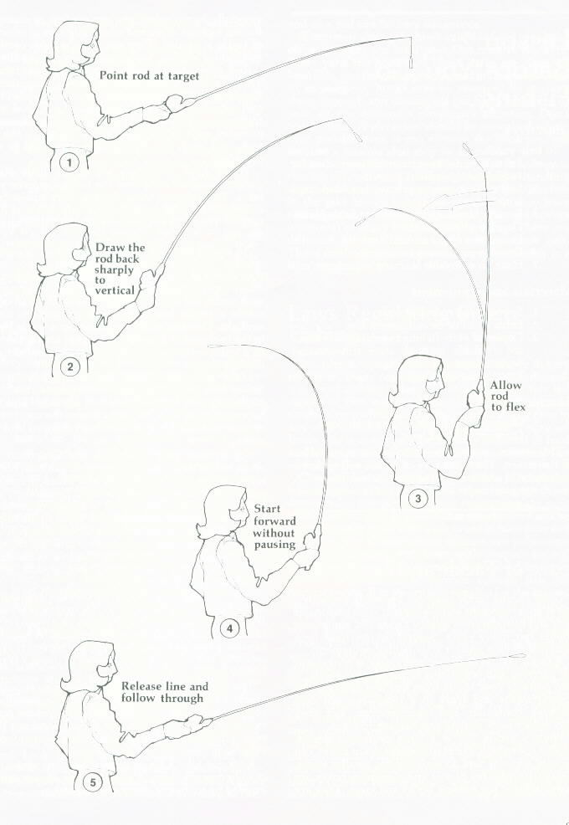

The side-arm cast begins with your casting hand at belt level (*fig*. *13*). The rod should be parallel with the water surface (*or lawn surface*) and aiming directly at your target. For a right-handed caster the left foot should be slightly in front of the right foot, the body orientated with the left side angled toward the target. The rod and reel should be held with the right hand. Fully depress the release button with your thumb and hold it there. The plug should be hanging about ten centimeters (*four inches*) from the tip of the rod. With a swift movement, bring the rod to your right, keeping it parallel to the water surface. When the rod is about a ninety-degree *angle (right angle*) from its original position, top the rearward movement. As the momentum of the casting plug forces the rod into a deep bend, sharply move the rod forward with both your forearm and wrist for maximum power. Release the thumb button just an instant before the time when your control thumb is pointing at the intended target. When the plug goes to the right of the target, the button was released too early. When the plug goes to the left, it was released too late.

Demonstrate this cast to your group. Since the rod is held to the side rater than overhead, more room is needed per individual when practicing.

