# Chapter 24 Kingdom Plantae

# GENERAL Biology students are only responsible for the notes in BLACK font type on this study guide.

# HONORS students are responsible for ALL the class notes (including yellow highlighted notes on this study guide).

1. Overview
   1. What is a plant? (from “warm up” slides)
      1. Plants are members of the Kingdom _____.
      2. All plants are _____ and are composed of _____ cells.
      3. All plants have cell walls composed of _____.
      4. All plants carry out _____ (Autotrophs) using the green pigment, _____.
      5. Life Cycle exhibits _____.
      6. Plant Embryo is _____.
   2. _____: Study of Plants
   3. Life could not exist on earth without plants
      1. Plants are the _____ in every food chain.
      2. Plants carry out _____ producing _____ from ___ and ____.
      3. The plant uses this glucose as a source of energy, but much of this glucose is passed up the _____.
         1. Herbivores eat the _____ and carnivores eat the _____.
         2. As a result, an amount of the glucose produced by the plant is passed to the next step in the food chain.
      4. Not only do plants provide the base for food chains, they provide _____ for animals as well as shelter and nesting sites.
   4. _____ of Generations
      1. All plants exhibit Alternation of Generations
         1. They have two different forms which they exist
            1. S_____ (_____; diploid (2n))
            2. G_____ (gamete-producing) (_____-n)

Diploid (2n) sporophyte stage produces haploid spores by _____.

Haploid spores undergo _____ to produce gametophyte stage.

1. Gametophyte makes gametes (egg and sperm) by _____.
2. Fertilization: zygote (2n) produces a new _____ (n)

**Sporophyte plant produces spores by meiosis**

**Fertilization of gametes**

**The zygote develops into the sporophyte plant.**

1. Plant Diversity
   1. Genesis 1:11-13
   2. “Ancestral” Green (photosynthetic) Algae are thought to have led to the evolution of four major groups of living land plants
      1. _____ and Liverworts
      2. F_____
      3. G_____ (cone bearing plants)
      4. A_____ (flower bearing plants)
2. Classification of Plants
   1. All plants are either _____ plants or _____ plants.
      1. Vascular plants have vascular tissue and nonvascular plants do not have vascular tissue.
         1. Vascular tissue is tissue that conducts _____ and _____ throughout the plant.
         2. _____: carries food down the plant from the leaves.
         3. _____: carries water up the plant from the roots.
      2. Vascular Plants are Classified as _____.
      3. Nonvascular Plants are Classified as _____.
   2. Tracheophytes (Vascular Plants) are further subdivided into "Seed Plants" and "Seedless Plants".
      * + 1. The _____ Plants do not produce seeds. Example: _____.
          2. Seed Plants do produce seeds.
          3. The Seed Plants are divided into: _____ and _____.

Angiosperm (flowering plants)

M_____

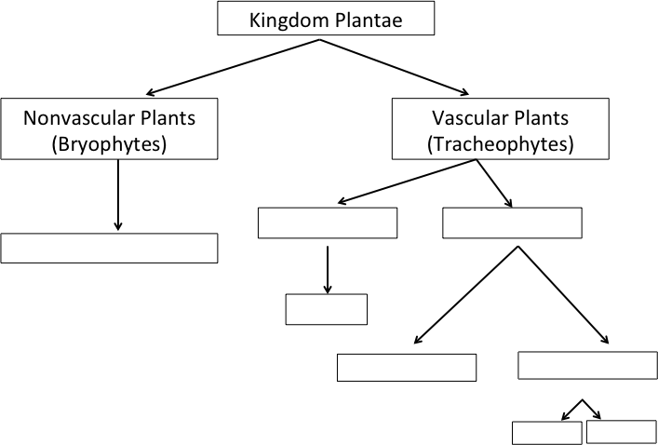D_____

Gymnosperm (Cone-bearing plants)

* 1. Nonvascular Plants
     + 1. Bryophytes are _____, meaning they have __ vascular tissue (xylem and phloem)

1. These plants can draw up water by _____ on a few centimeters above the ground.
2. This prevents them from growing very big.
3. Bryophytes have life cycles dominated by _____.
   * 1. Bryophytes include _____, _____, and _____.
     2. Bryophytes produce _____ gametes and must have water to _____.
4. During part of their life cycle, the produce _____ that must _____ through water to reach the egg.
5. They must live in places where there is rainfall or dew for at least part of the year.
   * 1. Bryophytes have ___ true roots, stems, or leaves
   1. Although bryophytes do not have true roots, they do possess _____.
6. Rhizoids are root-like structures that ______ the plant to the ground.
7. Water moves from cell to cell through the _____ and into the rest of the plant.
8. Rhizoids are capable of absorbing _____ and _____ from the soil.
   1. Bryophytes are small and grow close to the ground because they have no way to transport water large distances.
   2. This _____ the growth of the plant.
      1. Bryophytes show Alteration of Generations
9. In bryophytes, the _____ is the dominant, recognizable stage of the life cycle and is the stage that carries out most of the plant’s photosynthesis.
10. As members of the plant kingdom, they do possess _____ and carry out _____.
    1. Vascular Plants (Tracheophytes)
       * 1. Vascular tissue is specialized to conduct _____ and _____ throughout the plant.
         2. Two types of Vascular Tissue: X_____ and P_____.
         3. Vascular tissue enables plants to grow upward, away from the surface of the ground
    2. Seedless Vascular (tracheophytes) plants – _____
11. Ferns have _____, _____ and _____.
12. The _____ generation is dominant
13. Ferns have _____ tissue (xylem and phloem).
14. Just like the nonvascular plants, the Ferns have motile, _____.
15. Water must be present for the _____.
    1. Seeded Vascular (Tracheophytes) Plant Properties
16. Have _____ or _____.
17. The transfer of sperm by _____.
18. The protection of _____ within _____.
    * + 1. Like bryophytes and ferns, all seed plants show alternation of generations, alternating between the _____ stages.
        2. Unlike the bryophytes and ferns, the seed plants do not require _____ for the fertilization of the gametes.
        3. This allows the seed plants to occupy many more types of _____ than the bryophytes and ferns.
        4. In the seed plant, the _____ generation is the dominant, recognizable stage of the life cycle and is the stage that carries out most of the plant’s _____.
        5. Cones and flowers are _____ structures.
        6. The gametophytes grow and mature within these _____.
    1. Seed Plants
       1. Classified in two groups: Angiosperm and Gymnosperm
19. Cones are the seed-bearing structures of _____.
20. Flowers are the seed-bearing structures of the _____.
21. The Gametophyte generations of seed plants live _____ Cones and Flowers.
    * 1. P_____
22. The entire male gametophyte is contained within the _____.
23. Pollen grains contain _____.
24. Rather than the sperm swimming through water, the pollen (sperm) is carried to the female gametophyte by _____, _____, or small animals.
25. _____ is the transfer of pollen from the male reproductive structures to the female reproductive structures.
    * 1. Seeds
    1. A seed consists of an _____ and a _____ that is enclosed inside of a protective outer covering.
    2. The plant embryo is _____ and is in the early developmental stage of the _____ plant.
    3. The seed contains a _____ that nourishes the embryo.
    4. This food supply _____ the embryo until the seed has sprouted and has grown enough to become fully photosynthetic.
    5. The outer _____ surrounds and protects the embryo and keeps the contents of the seed from drying out.
    6. The _____ remains in a dormant stage within the seed for weeks, months, or even years.
    7. The seed can survive long periods of bitter cold, extreme heat or drought. When growing conditions become favorable, the seed germinates and begins to grow.
26. G_____
27. Bear their seeds directly on the surfaces of _____.
28. Includes the conifer such as _____ and _____.
29. The term “Gymnosperm” means “Naked Seed”.
30. The Cone is the seed-bearing structure and all seeds are _____.
31. Cycads, ginkgoes, spruce, pine, cypress, fir, cedar, redwood.
32. A_____
33. General Properties
34. Also called _____ plants.
35. Bear their seeds within a _____ that protects the seed.
36. Angiosperms include grasses, flowering trees, and shrubs.
37. According to evolutionists, angiosperms appeared in the fossil record “only” 135 million years ago, making them the most “recent” of all plants.
38. _____ plants are thought to be the dominating form of plant life on earth.
39. They have a method of reproduction and development that involves _____.
40. Flowers and Fruit
41. Unique to angiosperms is the development of the _____ as the _____.
42. Flowers are an advantage to plants because they _____ insects and other small animals to the flower.
43. These insects and animals then transport _____ from one flower to another.
44. This means of pollination is much more efficient than the _____.

The _____ is also a structure found only in angiosperms.

The fruit is a wall of tissue surrounding the seed.

The fruit _____ the seed, but also aids in _____ by attracting animals to the fruit.

1. Angiosperm Diversity
2. The phylum containing angiosperms is divided into two classes: _____ and _____
3. Monocots and dicots are named for the number of _____ their seeds contain.
4. Monocots: have _____ cotyledon
5. Dicots: have _____ cotyledons
6. A _____ is the first leaf or the first pair of leaves produced by the embryo of a seed plant.

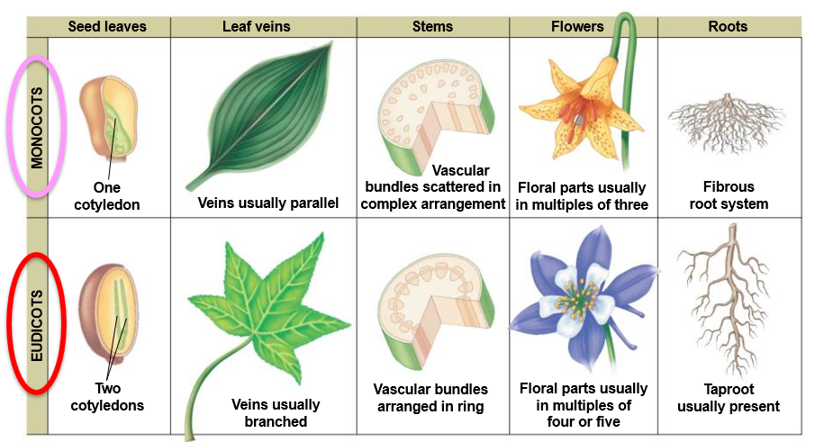

1. M_____ – corn, grass, coconut, orchid, banana, onion, wheat
2. D_____ – beans, coffee, tomato, daisy, mint, rose, pea, apple, maple
3. Most _____ trees are dicots.

|  |  |  |  |  |
| --- | --- | --- | --- | --- |
|  | Kingdom Plantae | | | |
| Characteristics | Mosses | Ferns | Gymnosperms | Angiosperms |
| Vascular Tissue Present? | No | Yes | Yes | Yes |
| True roots, stems, leaves? | No | Yes | Yes | Yes |
| Dominant Generation? | Gametophyte | Sporophyte | Sporophyte | Sporophyte |
| Water required for Fertilization |  |  |  |  |
| Seeds? |  |  |  |  |
| Flowers? |  |  |  |  |
| Motile or non-motile gametes? |  |  |  |  |
| Flowers or Cones? |  |  |  |  |

1. Basic Plant Tissue Types
2. Each plant organ (roots, stems, leaves) contains all three types.

|  |  |  |
| --- | --- | --- |
| Tissue | Components | Function |
| ? | Epidermis | * Protective outer covering * Prevent loss of water |
| ? | Parenchyma  Collenchyma  Sclerenchyma | * Bulk of plant body * Metabolism (Photosynthesis, Cell Respiration, etc.) * Storage of Sugars * Physical Support |
| ? | Xylem  Phloem | * Transport water and nutrients * Supports the plant body |

1. _____
2. Carries _____ and _____ from the roots to the rest of the plant.
3. Composed of _____ Cells (Cell Walls remain).
4. Cell Walls are lignified, which provide _____ for the plant (helps it grow tall).
5. In Trees it is the _____.
6. _____:
7. Carries the _____ made in the leaves during photosynthesis, to other plant structures.
8. _____ Tissue, but arranged in tubes.
9. Xylem and Phloem form a continuous network from the tip of the _____, through the _____, all the way to the _____, and vice versa.
10. _____ Tissue
11. Lies between dermal and vascular tissue.
12. Divided into: _____ and _____.
13. Leaf Ground Tissue is called _____.
14. Includes _____ (photosynthesis in the leaves, and storage in the roots).
15. _____ (shoot support in areas of active growth).
16. _____ (shoot support in areas where growth has ceased).
17. Plant Growth [chart below is for HONORS only]
18. Most plants have indeterminate growth, continuing to grow throughout a plant’s life.
19. Plants are categorized based on the length of their life cycle:
20. _____ complete their life cycle in one year.
21. _____ complete their life cycle in two years.
22. _____ live for many years.
23. Occurs in specialized tissues called _____, consisting of undifferentiated cells that divide when conditions permit.
24. _____ Meristems are found at the tips of roots and in the buds of shoots.
25. Primary Growth
26. occurs at apical _____.
27. allows roots to push downward through the soil.
28. 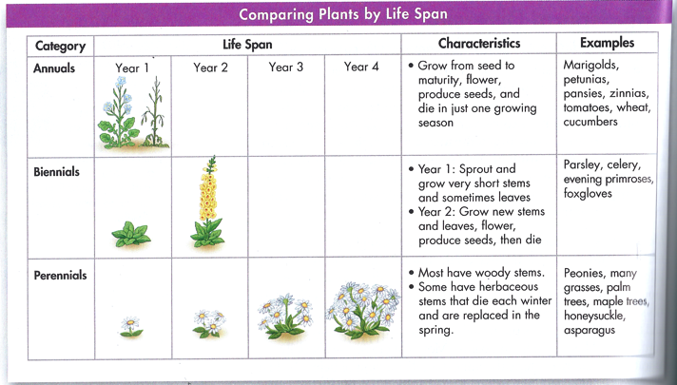allows shoots to grow upward, increasing exposure to _____ and CO2.