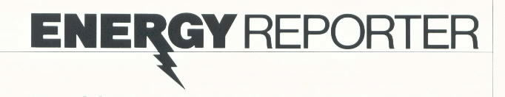

# Electricity from Nuclear Fission: Splitting the Atom

Enormous energy is released when neutrons strike the nucleus of an atom of uranium-235. In nuclear power plants, this nuclear reaction is initiated and controlled, and the energy is used to generate electricity.



One of the smallest identifiable particles of matter, the atom, is capable of providing a tremendous amount of energy. According to Einstein’s famous formula, *E = mc2*, when atoms are split, some of their mass is converted to energy. Some elements have variations in the number of neutrons they contain, which are called isotopes. **(1)** Further, the nuclei of some isotopes can be split, a process called nuclear fission. When nuclear fission occurs, vast quantities of energy are released.

**(3)** Atomic energy, which is the energy that comes from splitting the atom, was first used to generate electricity in an experimental reactor in the Idaho desert in 1951. This energy arises from a chain of events. Nuclear fission of the isotope uranium-235 is initiated and controlled in a device called a nuclear reactor. As the nuclear fission process occurs, kinetic, or moving, energy and radiation energy are released by the dividing atoms. The fragments and radiation collide with some of the surrounding atoms, and most of the fission energy is converted to heat energy. The heat energy is transferred to water. Then, the same principles that are used in generating electricity from coal, oil, or gas are employed: heating the water produces steam, steam turns the rotors of a turbine that spins a generator, and the generator converts the energy from the whirling turbine shaft into electric power.

## The Fuel and the Reactor

**(2)** The element uranium is the fuel source for nuclear power (although nuclear energy from other elements such as thorium and plutonium is also possible). It occurs in nature as a mixture of two isotopes, uranium-238, which is difficult to fission, and uranium-235, which is easy to fission. Uranium-238 accounts for 99.3% of natural uranium, uranium-235 for 0.7%. Uranium is present in much of the earth’s crust, and relatively abundant, accessible deposits of it have been identified in the United States.

After it is mined, uranium ore is taken to a mill where it is crushed, ground, and chemically treated. The initial processing of each ton of ore yields only about three pounds of a uranium oxide. This concentrate is called yellow cake because of its color. To increase the proportion of uranium-235 to about 3%, the yellow cake is chemically treated to produce a gas, uranium hexafluoride, which, in turn, is processed in a diffusion plant in a process called enriching. The enriched fuel is next converted to a powder, uranium dioxide, which is pressed into tiny pellets. Each pellet, about the size of a fingertip, has a fuel potential equal to nearly a ton of coal or three barrels of crude oil.

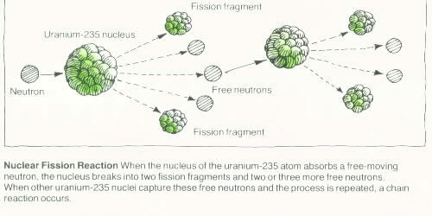

In the next fuel fabrication stage, about 200 pellets are stacked end on end in a long, slender fuel rod made of stainless steel or Zircaloy, a special alloy of the metal zirconium. The fuel rods are collected into bundles that are called fuel assemblies.

In the nuclear reactor itself, many fuel assemblies-containing around a million pellets-make up the nuclear reactor core or center. This reactor core is surrounded by water and housed in a reactor vessel, which is made of carbon steel that has been lined with stainless steel. The reactor vessel wall can be as thick as 10.5 inches. It, in turn, is housed inside a special large structure of metal and reinforced concrete that is called the containment building.

**(4)** The nuclear reaction begins when the nucleus of uranium-235 atom absorbs a fee-moving neutron. This causes it to become unstable and split into two main pieces, which are called fission fragments, and two (sometimes three) free neutrons. If one of the free neutrons released during fission shoots off and strikes the nucleus of another uranium-235 atom, that nucleus also splits and shoots off neutrons, which in turn strike other nuclei. The reaction thus becomes a self-perpetuation or chain reaction. The water surrounding the reactor core helps to maintain the reaction by acting as a moderator and slowing down the neutrons so they are more easily absorbed.

The chain reaction is controlled by restricting the number of free neutrons available for interacting with other nuclei. **(5)** Control rods, which contain substances that easily absorb neutrons, are lowered into the reactor to control the chain reaction. The substances in the control rods “grab” free neutrons before they are absorbed by fissionable material.

About half of the freed neutrons do not cause new fissions. Instead, many of them are absorbed by the nuclei of the non-fissionable uranium-238 atoms. Although these atoms do not split, they change into atoms of plutonium-239, which are fissionable and therefore become part of the fuel source for the reaction. The plutonium-239 can fission. When it does so, two fragments and neutrons that help sustain the chain reaction result, just like in uranium. The plutonium-239 can also be used, like uranium-235, as fuel for another reactor.

## Reaction Variations

The radiation and fragments from the fission process heat the fuel rods, which, in turn, heat the surrounding water. In the most common type of reactor, called a pressurized water reactor (PWR), the circulating water is kept under high pressure. The high pressure allows the water to absorb a great deal of heat without boiling. From the reactor vessel the heated water is pumped to steam generators. There the heat from the water is transferred to water inside the steam generator. This water is under lower pressure, so it boils and produces steam. The steam is piped through a secondary system to a turbine where it drives the turbine rotor and turns a shaft that powers a generator to produce electricity.

In another common type of reactor, called a boiling water reactor (BWR), the pressure in the reactor vessel is low enough so that the circulating water boils. The steam is piped directly from the top of the reactor vessel to a steam turbine where it spins a shaft to generate electricity.

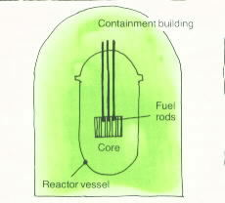

**Nuclear Reactor** *radioactive fuel pellets are isolated from the atmosphere by three successive barriers: stainless steel or Zircaloy rods that encase the pellets in the reactor core, a steel reactor vessel, and an airtight containment building of metal and reinforced concrete.*

In both reactors, after the steam delivers its energy to the turbine rotor it passes over coils filled with cool water and condenses (turns back into liquid). This increases the thermal efficiency of the process. The water from the condensed steam is pumped back into the steam generators to be used again.

Although plutonium forms in all reactors, another type of reactor, the breeder reactor, is especially designed to use it as a fuel and to produce it in larger quantities. These breeder reactors encourage the production of plutonium by increasing the number of neutrons absorbed by uranium-238 nuclei. (This reactor is called the breeder because it can produce more fuel than it uses). Because there is no moderator, fewer neutrons are absorbed unproductively. Currently, the breeder reactor program in the United States has been deferred and is being reevaluated. Should public energy policy decide in its favor, the breeder reactor would theoretically be capable of extracting 60 times as much energy from uranium as is possible with conventional reactors.

Regardless of the type of reactor being used to produce atomic energy, uranium-235 atoms continue to split, producing more and more fission fragments in the fuel rods (like cessium-137 and strontium-90). These absorb neutrons but do not split, interrupting the chin reaction. After about three years, so many non-fissionable waste products accumulate in the fuel that the chain reaction stops. At this time the fuel rods must be replaced even though nearly one third of the uranium-235 has not been used.

Unspent fuel contained in the rods could be reprocessed and used as fuel again. But the used fuel also contains highly radioactive wastes, as well as the reusable uranium and plutonium. These wastes have to be separated from the reusable fuel before it can be put back into a reactor. Methods of isolating and storing the wastes have been devised. The wastes are presently being stored in temporary storage sites. However, the government has not sanctioned permanent storage locations. This is a barrier to reprocessing, and no reprocessing plants are yet in operation in the United States.

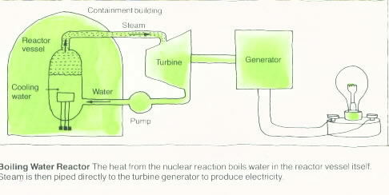

**Safety and Nuclear Power**

**(6)** Nuclear power plants currently provide 12% of the electricity used in the United States. Whether that percentage will increase, stay the same, or decrease in the future is a question. In many respects producing electricity from fission is highly attractive: it is cheaper than electricity from fossil fuels; it does not pollute the air; it uses available fuel and produces enormous **(7)** amounts of electricity from it; and it is well tested and has a good performance record.

But no method of making electricity is without hazard or negative environmental effect. **(8)** Many people fear a nuclear reactor accident in which the escape of radioactive fission products would threaten public health and the environment. Because nuclear reactors are designed, built, and operated according to the most stringent safety requirements, such an accident is very unlikely. To date, no one has been killed as a result of a radiation accident at a commercial reactor. Safety is further ensured by the fact that all nuclear power plants are stringently regulated from the design stage throughout all operations by the federal government.

Although temporary solutions are in effect, the problem of dealing with the radioactive wastes produced during normal reactor operation needs permanent resolution. **(8)** Highly concentrated materials such as strontium-90 and cesium-137 are dangerously radioactive for several centuries. Many experts feel that technology exists for safe disposal of wastes. Various plans for permanent disposal include burying wastes in deep granite deposits or in stable salt formations thousands of feet under the ground. But, so far, no permanent systems have been set up in the United States. (The French use vitrification techniques, in which the radioactive wastes are incorporated in hard glass, followed by deep burial methods).Radioactive wastes are currently being held in pools or buried in trenches, awaiting public policy decisions and government directions for permanent disposal.

In recent years, construction of many nuclear power plants has been delayed or cancelled. The lengthy licensing process greatly increases utility costs for both construction and financing. Lower growth projections for electricity demand are also a factor in the slowdown. And the benefits and risks of generating nuclear power are subjects of public discussion and debate. Until such debate is resolved, future growth in nuclear power generation remains uncertain.

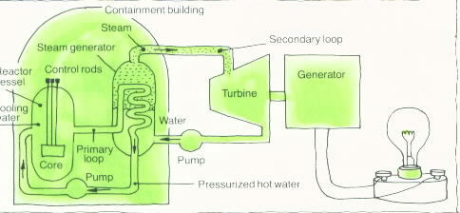

**Pressurized Water Reactor** *The heat generated by nuclear fission in the reactor core transfers to the cooling water, which is then pumped in a closed primary loop through the steam generator. High pressure allows this water to carry a great deal of heat without boiling. But the water inside the steam generator vessel, kept at lower pressure, does boil, and the resulting steam in the secondary loop powers the turbine generator.*

## Vocabulary

### Breeder reactor

A reactor in which fissionable plutonium-239 is “bred” from non-fissionable uranium-238 by causing the uranium nuclei to absorb neutrons.

### Fission fragment

A new, smaller nucleus that results from fission.

### Generator

A machine that produces electricity by rotating a magnet inside a stationary ring that is wrapped with conductive electric wire, thereby producing electric current.

### Isotope

One of two or more atoms of the same element having different numbers of neutrons in their nuclei, different weights, and different radioactive behaviors.

### Kinetic energy

The energy of a body or fluid resulting from its motion.

### Moderator

A material used in a reactor to slow down neutrons so that they are more easily absorbed by nuclei.

### Neutron

An electrically neutral particle in an atom’s nucleus.

### Nuclear fission

Splitting of the nucleus of an atom resulting in the release of energy.

### Nuclear reactor

A device for producing a controlled nuclear fission reaction and capturing the energy that is released.

### Nucleus/nuclei

The central part of the atom containing the positively charged protons and electrically neutral neutrons.

### Plutonium

A highly radioactive element produced in fission when uranium-238 absorbs free neutrons.

### Radioactive waste

By-products of nuclear fission; includes spent fuel, elements formed during fission t hat emit high-energy radiation, and lower-level waste, such as contaminated clothing, equipment, etc.

### Turbine generator

An electric generator driven by a turbine; the turbine has blades that are made to rotate by the force of a fluid (water, gas, or steam) or by wind; as the turbine rotates, it turns the shaft of a generator; at the end of the shaft is a magnet that rotates in a ring wrapped with a long piece of wire, which generates an electric current.

### Uranium

A metallic element that is used as a fuel source for nuclear power.

### Vitrification

Conversion of a material into glass or a glassy substance.

### Zirconium

A metal