Measuring _______ Pressure

Torricelli developed the “_______” from *baro*, meaning *weight* and *meter* meaning *measure*.

He also coined the unit “Torr” which is equal to _______ .

What is pressure & its units?

What is STP and its units?

The Nature of Gases

_______ 🡪 the gradual mixing of molecules of different gases from _______ to _______ concentration.

_______ 🡪 the movement of molecules through a small _______ into an empty container.

_______ Gas Law: _______

*P* = _______ in atm, mm Hg, or kPa *V* = _______ in liters

*n* = _______ *R* = ideal gas _______ based on units

*T* = _______ in Kelvins

Boyle’s Law

Boyle’s Law describes the relationship between the _______ of a gas and its _______ at a _______ temperature and number of moles.

A gas can be compressed to take up less space: the _______ the pressure applied to the gas, the _______ the volume it will occupy. (e.g. piston chamber in engines)

Bubbles in a fish tank _______ in size as they move toward the surface of the water experiencing _______ pressure. Bubbles at the bottom of the tank are _______, experiencing _______ pressure than bubbles up higher in the water.

Robert Boyle (1627-1691) decided to experiment with only _______ and _______ of a gas, so he held the _______ and number of _______ of the gas constant.

PV = nRT 🡪 ___ = k

Mathematically: P ∞ 1/V (*take away the constants*)

At the same conditions of temperature and moles: P1V1 = k, P2V2 = k

Thus: __1__1 = __2__2

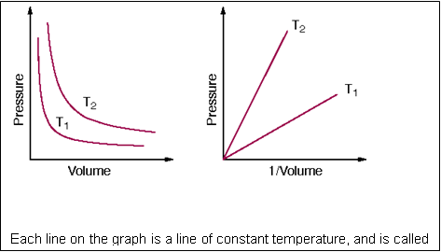

What relationship is shown by the graph?

Give some examples of Boyle’s Law:

Charles’ Law

Jacques Charles (1746-1823) experimented with only _______ and _______ of a gas, so he held the _______ and number of _______ of the gas constant.

PV = nRT 🡪 _____ = k

Mathematically: V ∞ T (*take away the constants*)

At the same conditions of pressure and moles: V1 = kT1, V2 = kT2

Thus: __1/__1 = __2/__2

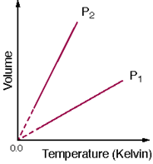

In the plot of V-vs-T, the _______ relationship is _______, with an intercept of _______ zero on the _______ scale.

The slope depends on the pressure and the amount of gas.

The dashed lines on the graph are to represent the fact that you _______ achieve absolute zero.

Kelvin includes avg ___ & _______.

Give some examples of Charles’ Law:

Gay-Lussac’s Law

Gay-Lussac (1746-1823) experimented with only _______ and _______ of a gas, so he held the _______ and number of _______ of the gas constant.

PV = nRT 🡪 P/T = k

Mathematically: P ∞ T (*take away the constants*)

At the same conditions of volume and moles: P1 = kT1, P2 = kT2

Thus: __1/__1 = __2/__2

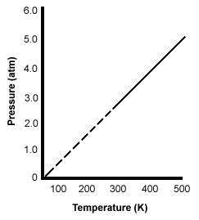

In the plot of P-vs-T, the _______ relationship is linear.

The slope depends on the volume and the amount of gas.

The dashed lines on the graph are to represent the fact that you cannot achieve _______ _______.

_______ includes avg KE & volume.

Give some examples of Gay-Lussac’s Law:

Avogadro’s Law

Amedeo Avogadro (1776-1856) experimented with only _______ and _______ of a gas, so he held the _______ and _______ of the gas constant.

PV = nRT 🡪 V = kn 🡪 k = V/n

Mathematically: V ∞ n (*take away the constants*)

At the same conditions of pressure and temperature: V1 = kn1, V2 = kn2

Thus: __1/__1 = __2/__2

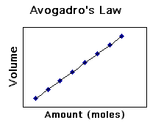

In the plot of V-vs-n, the _______ relationship is linear.

For a gas:

1 mol = # molecules / 22.4 L

_______ volume = _______

NA = 6.02 x 1023 particles, etc.

Combined gas law

For a fixed quantity of gas, pressure & volume vary inversely while temperature varies directly with pressure & volume. Fill in the names in the chart:

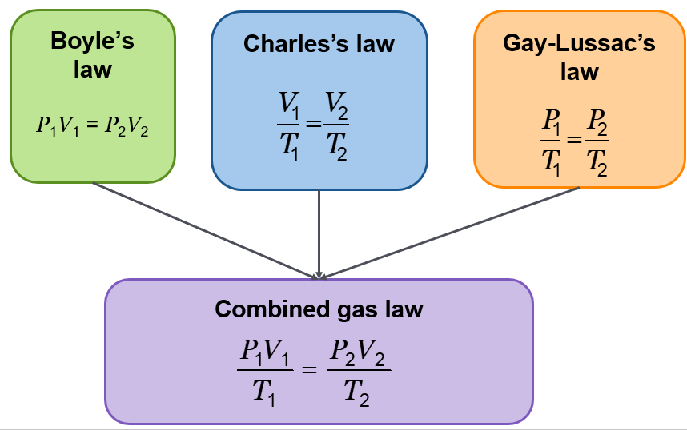

Real World Application of the Combined Gas Law

Internal combustion _______ operate on the principle of taking a _______ (___) of gas in, compressing it (___), igniting it (___), then pushing the exhaust out.

Spraying a gas from an aerosol can … _______ (___) of gas decreases as it goes from being compressed in the container to being released into the atmosphere. _______ (___) increases substantially. Kinetic energies of gas molecules decrease. Gas _______ (___) therefore decreases as it is sprayed

Ideal Gases

Ideal gases are _______ gases that perfectly fit all of the _______ of the kinetic molecular theory; i.e.,

* Gases consist of _______ particles that are _______ apart relative to their size.
* There are ___ forces of attraction or repulsion _______ the gas particles.
* Collisions between gas particles and between particles and the walls of the container are _______ collisions, so no _______ energy is lost in those collisions.

There is ___ gas for which these assumptions are true.

Ideal Gases & Real Gases

A gas will behave in an ideal fashion (PV = nRT) if its temperature is at or greater than _______ K (0⁰ C), and its pressure is near or less than ___ atm (____ kPa).

_______ _______ (273 K or higher) and _______ (101.3 kPa or lower)

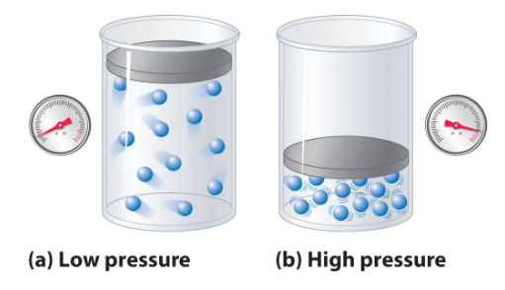

When pressure is _______ as in image (b), the _______ that the gas molecules occupy is _______ compared to the region in which they are contained.

Particles in such _______ gases have _______ and there are _______ between the particles.

Because of these attractions, a gas can condense, or even solidify, when it is compressed or cooled. Therefore _______ temperatures also cause deviations from the ideal gas law.

Ideal gas behavior exists at _______ . _______ temperatures (molecules move _______ … more attractions) and _______ pressures (more _______ in less volume) show significant deviations from the ideal gas law.

_______ pressure

When two or more ideal gases are _______ together, the _______ pressure of the mixture is equal to the _______ of the pressures of each individual gas.

Partial pressure:

* + refers to pressure of ____ gas in a mixture of gases
  + the pressure of a single gas as if it occupied the container by _______
  + the sum of all _______ pressures equals _______ pressure of the mixture

Gases exhibit:

Diffusion 🡪 the gradual mixing of molecules of different gases from _______ to _______ concentration.

Effusion 🡪 the movement of molecules through a small _______ into an empty container.

Effusion 🡪 A gas _______ through a tiny _______ in its container.

Gases of _______ molar mass diffuse and effuse _______ than gases of higher molar mass.

Graham’s law of effusion **🡪** the rate of effusion of a gas is _______ proportional to the square root of the gas’s _______ _______.

Helium gas (_______ massive) effuses much _______ than ethylene oxide gas (_______ massive).

Which of the following gas particles will diffuse fastest if all of these gases are at the same temperature and pressure? (give molecular masses)

SO2 N2O Hg Cl2