Biochemistry

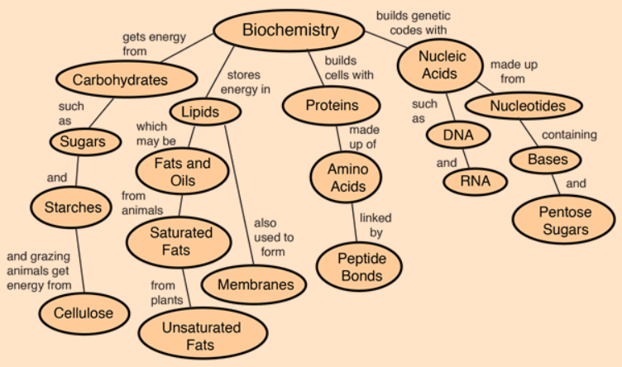

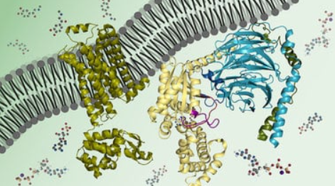

**See** [**https://www.learningctronline.com/courses**](https://www.learningctronline.com/courses) **for Materials and Resources.**

**Topics:**

1. Biochemistry

**Objectives:**

1. Describe the structures and functions of each of the four groups of Macromolecules of Life: Carbohydrates, Lipids, Proteins, and Nucleic Acids.
2. Investigate how the four groups of Macromolecules of Life are metabolized by cells.

TAKE NOTE

1. Notes/Study Guide (1 week)
2. Homework from Text (1 week)
3. Lab Biomolecules
4. Chapter 2-3 Test Chemistry of Life, Biochemistry
5. Week 4 Devotional (<https://www.learningctronline.com/devotional>)

**Text**: Chapter 3: Biochemistry pp. 40-59

Read the assigned pages in the text.

**Class Notes: PowerPoint or PDF**

**Notes/Study Guide:** Fill in the Chapter 3 Study Guide worksheet to understand the class notes.

**Homework**: (1 week)

* Study Questions (at the end of the chapter in the text) #1, 7-8, 10-15, 18-20, 22-23
* Use a Word document format as follows:
  + Start on a new page of your document
  + Heading: Your name, Chapter in Text, Study Questions
  + Number the appropriate questions you are to answer
  + Write the answer in a complete sentence use the question as the template (do not copy the question, but reword it into a statement that answers the question).
* Use the same document each week by starting a new “Study Question” for a different chapter on the next page.
* Assignments will be “spot checked” during class or submitted via email.

**Lab**: Biomolecules

* Complete the " Biomolecules Lab" using the lab worksheet provided.
* After completing the Lab worksheet, email it to [learningctronline@gmail.com](mailto:learningctronline@gmail.com) for grading.
* Save document into your LAB folder in the Biology folder on your desktop.

**TEST:** Chemistry of Life, Biochemistry

1) the academic integrity policy

* Tests must be completed **WITHOUT** referring to books, notes, the internet, people, or any outside resources.
* A guardian should be proctoring the test as per Learning CTR Online policy: <https://www.learningctronline.com/test-proctor-policy>

2) This test is composed of 20 multiple choice and 4 essay questions.

* The **test must be taken "in one sitting"**, meaning that once you start the test, you must complete it without interruption.
* Take a short break (5 minutes) during the test.

3) There is a **50-minute time limit** on this test. Please have the proctor write the time taken at the top of your answer sheet with their signature or initials.

4) Honors students have an additional 20 minutes to answer the additional questions.

5) Proctors should NOT be reading the test or engaging students during the test.

6) Do NOT use RED font. Black font is best.

Supplemental Resources (Optional)

1. Chemistry of Life / Biochemistry Vocabulary Crossword

<https://youtu.be/YO244P1e9QM> The Amoeba Sisters Channel – **Biomolecules** (8:12)