**Astronomy Earth & Moon**

 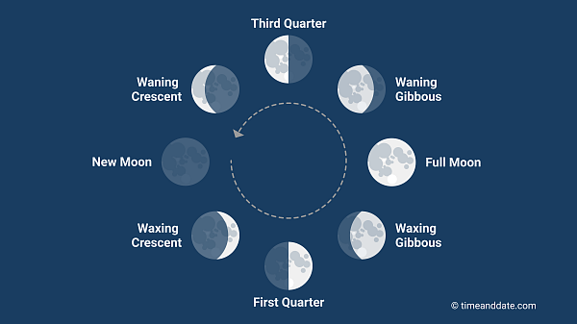

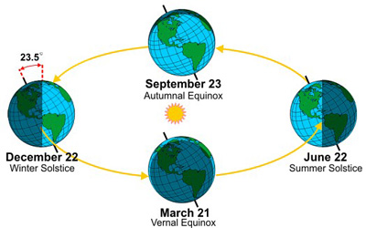

**See** [**https://www.learningctronline.com/courses**](https://www.learningctronline.com/courses) **for Materials and Resources.**

**Topics:**

1. Astronomy Earth & Moon

**Objectives:**

* What are Earth’s major movements, distance from the sun, and axial tilt?
* What are two main pieces of evidence for the Earth’s revolution (orbit) around the sun?
* Define and explain earth’s seasons related to axial tilt & sun’s rays.
* Explain why the seasons are designated as they are (sun’s path).
* Identify and describe Moon phases.
* Understand aspects of Earth’s tides and what causes them.
* Distinguish the types of tides (high, low, spring, neap).

TAKE NOTE (All assignments are due by next week’s class.)

1. Astronomy Earth & Moon PowerPoint (class notes)
2. Class notes study guide (Astronomy Earth & Moon)
3. Labs: Seasons & Tides
4. Review Worksheet Earth & Moon
5. Film Review: Apollo 13
6. QUIZ Seasons, Tides, Moon
7. Week 18 Devotional (<https://www.learningctronline.com/devotional>)

**Text**:

**Reference Material: Astronomy Earth & Moon PowerPoint**

**Homework**:

* Class Notes Study Guide
* Review Worksheet Earth & Moon

**Lab**: Seasons & Tides

* Perform the lab using the link and worksheet provided.
* Save the document into your LAB folder in the Projects in Science folder on your desktop.

**Lab**: Film Review

* Open the worksheet for the film review: “Apollo 13”. Obtain the movie.
  + Complete the film review worksheet.
* Save the document into your LAB folder in the Projects in Science folder on your desktop.

**TEST:** Lab Quiz

1) the academic integrity policy

* Tests must be completed **WITHOUT** referring to books, notes, the internet, people, or any outside resources.
* Students **MAY** use the approved Periodic Tables, approved Reference Tables, or approved equation (formula) sheet (provided by the teacher) along with calculators and scratch paper.

2) Take the **"in one sitting"**, meaning that once you start the test, you must complete it without interruption.

3) There is a **15-minute time limit** on this test.

4) Do NOT use RED font. Black font is best.

Supplemental Resources (Optional)

<https://astro.unl.edu/classaction/animations/coordsmotion/eclipticsimulator.html> Earth & Moon Animation

<https://science.nasa.gov/moon/tides/> Tides Animations