**Energy Chapter 15**

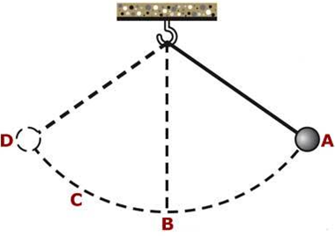 

**See** [**https://www.learningctronline.com/courses**](https://www.learningctronline.com/courses) **for Materials and Resources.**

**Topics:**

1. Energy

**Objectives:**

* Define and calculate Potential Energy (PE) in terms of gravitational PE, and explain elastic PE.
* Define and calculate Kinetic Energy (KE) related to the motion of object.
* Recognize maximum PE, maximum KE, maximum velocity, rest position, and when PE = KE for moving objects.
* Identify specific forms of energy and how they can be transformed into other forms.

TAKE NOTE

1. Guided Reading Note-Taking Worksheet (Pearson Text) (1 week)
2. Pearson Concepts in Action Worksheets
3. Lab Energy (PE & KE) (1 week)
4. Class Song: It’s Time for Class (Hi Ho Hi Ho)
5. Week 21 Devotional (<https://www.learningctronline.com/devotional>)

**Text**: Chapter 15: Energy pp. 444-471

**Guided Reading Note-Taking Worksheet:**

Complete the worksheet for Chapter 15: Energy (15.1 – 15.3).

**Class Notes: PowerPoint or PDF**

**Homework**:

* 15.1 Energy Worksheet (Pearson Concepts in Action)
* 15.2 Energy Conversion & Conservation Worksheet (Pearson Concepts in Action)
* Assignments will be “spot checked” during class or submitted via email.

**Lab**: Energy Lab (PE & KE)

* Complete the activities using the worksheet provided.
* Save the documents into your LAB folder in the Physical Science folder on your desktop.
* *Assignments will be “spot checked” during class or submitted via email.*

**TEST:** The test will be given after next week’s lesson.

Supplemental Resources (Optional)

1. Energy Problem Set
2. Vocabulary Review (Crossword) & Key

[**http://somup.com/cFX2bVniRL**](http://somup.com/cFX2bVniRL) **Pendulum Swing (1:17)**

<http://somup.com/cYhFD1jyDA> Be Humbled 1 Peter 5:5b-6; Blessings (5:30)