**SHOW EQUATIONS AND WORK FOR EACH PROBLEM**

PE = mgh KE = ½ mv2

1. A 2 kg mass has 40 joules of potential energy with respect to the ground. Approximately how far is it located above the ground?

2. How much kinetic energy (joules) does a 0.5 kg motion cart have when moving 2 m/s?

3. A large 50 kg stone is wedged on top of a cliff 100 m high ready to fall. What is the stone’s potential energy?

4. A 1 kg ball dropped from a height of 2 m rebounds only 1.5 m after hitting the ground. What is the amount of energy (joules) lost to heat?

5. How much does a 100 kg person weigh?

6. It is said that Galileo dropped objects off the Leaning Tower of Pisa to determine whether heavy or light objects fall faster. If Galileo had dropped a 5.0 kg cannon ball to the ground from a height of 12 m, what would have been the change in PE of the cannon ball?

7. The 2000 Belmont Stakes winner, Commendable, ran the horse race at an average speed of 15.98 m/s. If Commendable and jockey Pat Day had a combined mass of 550.0 kg, what was their KE as they crossed the finish line?

8. A flea gains 1.0 x 10-7 J of PE jumping up to height of 0.030 m from a dog’s back. What is the mass of the flea?

9. A Mexican jumping bean jumps with the aid of a small worm that lives inside the bean. If a bean of mass 2.0 g jumps 1.0 cm from your hand into the air, how much potential energy has it gained in reaching its highest point?

10. A 35.0 kg bowling bowl is released from the top of a 100.0 m long hill with a vertical drop of 30.0 m. What is the ball’s kinetic energy at the bottom of the hill if it’s velocity is 24.5 m/s when it reaches that point? Compare maximum PE to maximum KE.

11. The KE and PE of a block freely sliding down a ramp are shown in only one place in the sketch. Fill in the missing values.

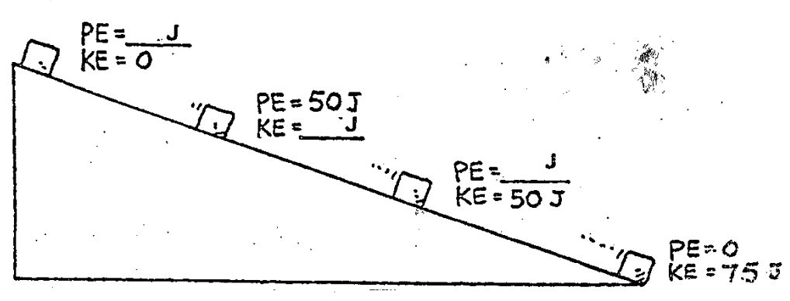

**PE = 0 J**

**KE = 75 J**

12. Block A and B have the same mass. Describe the potential energy of each block at the top of the incline and describe the velocity of each block at the moment the blocks reach the bottom of the incline. Assume no friction. Explain your answer.

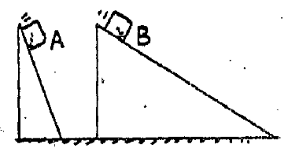

13. A big metal bead slides due to gravity along an upright friction-free wire. It starts from rest at the top of the wire as shown in the sketch below. Where will the bead’s PE and KE be the greatest? How does the PE for point B, D and E compare?

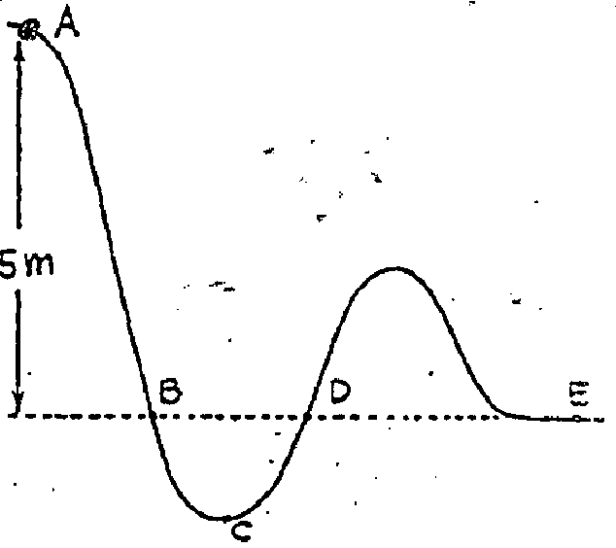

At what point does it have the maximum speed?

14. A 1000 kg lead anvil is thrown off a 45 meter cliff to the ground. Air resistance is negligible. Determine the PE & KE at each time frame shown. Assume conservation of energy. Determine the velocity of the anvil when it hits the ground (v = gt) if it takes 3 s to fall.

45 m

22.5 m

Falling Distance 0 m

33.75 m

11.25 m



PE _________ KE _________



PE _________ KE _________

45 m



PE _________ KE _________



PE _________ KE _________



PE _________ KE _________ velocity _________

PE = mgh KE = ½ mv2

1. A 2 kg mass has 40 joules of potential energy with respect to the ground. Approximately how far is it located above the ground?

**PE = mgh h = PE / mg = 40 J / (2 kg)(10 m/s/s) = 2 m**

2. How much kinetic energy (joules) does a 0.5 kg motion cart have when moving 2 m/s?

**KE = ½ mv2 = ½ (0.5 kg)(2 m/s)2 = 1 joule**

3. A large 50 kg stone is wedged on top of a cliff 100 m high ready to fall. What is the stone’s potential energy?

**PE = mgh = (50 kg)(10 m/s2)(100 m) = 50,000 joules or 5.0 x 104 J**

4. A 1 kg ball dropped from a height of 2 m rebounds only 1.5 m after hitting the ground. What is the amount of energy (joules) lost to heat?

**PEtotal = mgh = (1 kg)(10 m/s2)(2 m) = 20 joules**

**PErebound = mgh = (1 kg)(10 m/s2)(1.5 m) = 15 joules**

**PEtotal - PErebound = 20 J - 15 J = 5 Joules lost to heat**

5. How much does a 100 kg person weigh?

**W = m x g = (100 kg)(10 m/s/s) = 1000 N**

6. It is said that Galileo dropped objects off the Leaning Tower of Pisa to determine whether heavy or light objects fall faster. If Galileo had dropped a 5.0 kg cannon ball to the ground from a height of 12 m, what would have been the change in PE of the cannon ball?

***PE = mgh = (5.0 kg)(10 m/s2)(12 m) = 600 J***

7. The 2000 Belmont Stakes winner, Commendable, ran the horse race at an average speed of 15.98 m/s. If Commendable and jockey Pat Day had a combined mass of 550.0 kg, what was their KE as they crossed the finish line?

***KE = 1/2 mv2 = 1/2 (550.0 kg)(15.98 m/s2) = 70,224 J***

8. A flea gains 1.0 x 10-7 J of PE jumping up to height of 0.030 m from a dog’s back. What is the mass of the flea?

***PE = mgh m = PE / gh = 1 x 10-7 J / (10 m/s2)(0.030 m) = 0.00000033 kg***

***= 3.3 x 10-7 kg … (That’s 0.00033 grams).***

9. A Mexican jumping bean jumps with the aid of a small worm that lives inside the bean. If a bean of mass 2.0 g jumps 1.0 cm from your hand into the air, how much potential energy has it gained in reaching its highest point?

***PE = mgh = (0.002 kg)(10 m/s2)(0.01 m) = 0.0002 J***

What is its speed as the bean lands back in the palm of your hand?

***Assume conservation of energy and that no energy is lost to friction, air resistance, etc.***

***KE = 1/2 mv2 Therefore, v = √(2KE / m) = √(2[0.0002 J] / [0.002 kg) = 0.45 m/s***

10. A 35.0 kg bowling bowl is released from the top of a 100.0 m long hill with a vertical drop of 30.0 m. What is the ball’s kinetic energy at the bottom of the hill if it’s velocity is 24.5 m/s when it reaches that point? Compare maximum PE to maximum KE.

***PE = mgh = (35.0 kg)(10 m/s2)(30.0 m) = 10,500 J***

100 m



***KE = ½ mv2 = ½ (35.0 kg)(24.5 m/s) 2***

***KE = 10,504 J***

***max PE = max KE***

11. The KE and PE of a block freely sliding down a ramp are shown in only one place in the sketch. Fill in the missing values.

**PE = 75 J**

**KE = 0 J**

**75**



**PE = 0 J**

**KE = 75 J**

**PE = 25 J**

**KE = 50 J**

**PE = 50 J**

**KE = 25 J**

**Total Energy = PE + KE**

12. Block A and B have the same mass. Describe the potential energy of each block at the top of the incline and describe the velocity of each block at the moment the blocks reach the bottom of the incline. Assume no friction. Explain your answer.



***The total energy in the system is conserved: total E = PE + KE. At the top of the incline, KE = 0 (the blocks are not moving). At the bottom of the incline, PE = 0 (no more height to fall). PE (mgh) is based on the height of the ramp (how high the blocks***

***fall), so both blocks have the same PE (the mass is the same, gravity is the same and the height is the same). Assuming no friction, the maximum PE = maximum KE. Since both blocks have the same maximum PE, they also have the same maximum KE (½ mv2). Since the mass of both blocks is the same, both blocks will also have the same velocity at the end of the incline.***

13. A big metal bead slides due to gravity along an upright friction-free wire. It starts from rest at the top of the wire as shown in the sketch below. Where will the bead’s PE and KE be the greatest? How does the PE for point B, D and E compare?

At what point does it have the maximum speed?



***The total energy in the system is conserved. Therefore, maximum PE = maximum KE for the system. PE (mgh) is based on the initial height of the ramp and since that does not change, the maximum PE remains constant for points B, D & E, meaning the PE at B, D & E are all the same because the bead falls from the same height and will rise to the same height. Since point C is the lowest point, this represents the greatest distance to fall from A. Therefore, the maximum PE from A to C will be greatest. Once the bead falls from***

***A to C, it will continue to increase in velocity throughout the fall, and therefore, its maximum KE will also be greatest and it will******have the maximum speed at C.***

14. A 1000 kg lead anvil is thrown off a 45 meter cliff to the ground. Air resistance is negligible. Determine the PE & KE at each time frame shown. Assume conservation of energy. Determine the velocity of the anvil when it hits the ground (v = gt) if it takes 3 s to fall.



0 m

Falling Distance

PE 4.5 x 10*5* J KE 0 J

**PE = mgh = (1000 kg)(*10 m/s2*)(45 m) = 4.5 x 10*5* J**

**KE = 0 J … no velocity**



11.25 m

PE 3.4 x 10*5* J KE 1.1 x 10*5* J

**¾ PE + ¼ KE = total energy**

22.5 m



PE 2.25 x 10*5* J KE 2.25 x 10*5* J

**½ PE + ½ KE = total energy**



33.75 m

PE 1.1 x 10*5* J KE 3.4 x 10*5* J

**¼ PE + ¾ KE = total energy**



PE 0 J KE 4.5 x 10*5* J velocity 30 m/s

45 m

**KE is maximum v = gt**