**Properties of Matter Chapter 2**

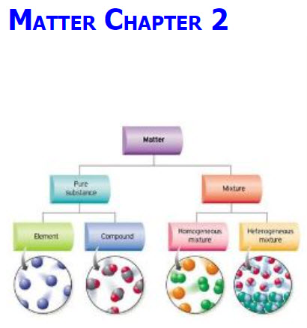

**See** [**https://www.learningctronline.com/courses**](https://www.learningctronline.com/courses) **for Materials and Resources.**

**Topics:**

1. Matter & Change

**Objectives:**

* Classify Matter as pure substances versus mixtures and explain the main difference among solutions, suspension, and colloids.
* Distinguish extensive and intensive Physical properties. Give examples of physical properties.
* Explain how mixtures can be separate.
* Distinguish chemical versus physical properties and how this can be observed.
* Evaluate Accuracy & Precision in Measurements (significant figures).
* Identify the states of Matter (s, l, g) using kinetic theory.
* Define phases changes of all states of matter and the energy involved for each.
* Understand what happens to a substance’s temperature and a system’s energy (heat) during a phase change.
* Describe the arrangement of molecules and how they change from solid to liquid to gas.
* Distinguish between evaporation and boiling. How are they the same? How are they different?

TAKE NOTE

1. Guided Reading Note-Taking Worksheet (Pearson Text)
2. Pearson Concepts in Action Worksheets
3. Lab: Classifying Matter
4. Lab: Density (Formal Lab Report)
5. Week 3 Devotional (<https://www.learningctronline.com/devotional>)

**Text**: Chapter 2: Properties of Matter pp. 36-65

**Guided Reading Note-Taking Worksheet:**

Complete the worksheet for Chapter 2: Properties of Matter (2.1 - 2.4).

**Class Notes: PowerPoint or PDF**

**Homework**:

* 2.1 Solid, Liquid, Gas Worksheet from Pearson Concepts in Action
* 2.3 Phase Changes Worksheet from Pearson Concepts in Action
* Assignments will be “spot checked” during class or submitted via email.

**Lab**: Classifying Matter

* Perform the lab as directed using the worksheet provided.
* Complete all calculations and data, showing work whenever appropriate.
* Conclusions should be answered in complete sentences that convey a complete thought.
* Save the documents into your LAB folder in the Physical Science folder on your desktop.
* When ready, take the Lab Quiz.
* You may **NOT** use the worksheets on this lab.

**Lab**: Density Lab (Formal Lab Report)

Perform the "Density" lab using the Density Lab Worksheet provided.

* This week do the Procedures and Calculations and Data sections.

* You will submit a Formal Lab Report (following the guidelines in the Lab Report Format Document) within 16 days.

**TEST:** The test will be given after next week’s lesson.

Supplemental Resources (Optional)

[**http://somup.com/cF660DnnJb**](http://somup.com/cF660DnnJb) **Extensive & Intensive Properties ctr (1:53) ... used to classify matter**

[**http://somup.com/cF6eq5nVpn**](http://somup.com/cF6eq5nVpn) **Electrical Conductivity (Properties) ctr (1:13) ... solids & water**

[**http://somup.com/cF6eq8nVpq**](http://somup.com/cF6eq8nVpq) **Electrical Conductivity (Properties) ctr (1:31) ... solutions**

<http://somup.com/cFQi2FVRK8>  **Samples of Classifying Matter ctr (6:10) ... Non-uniform mixtures/suspensions/colloids are all heterogeneous.**

<http://somup.com/cF6XFbnn8Q> Classifying Matter Notes ctr (1:52) ... Graphic Organizer ... Pure substances versus mixtures.

[**http://somup.com/cqjhonebqd**](http://somup.com/cqjhonebqd) **Dancing Raisins (1:06)**

<http://somup.com/cYfT28iytc> Classifying Matter: What's Opera Doc (5:47)

Look for homogeneous matter (elements, compounds) and heterogeneous matter (non-uniform, suspensions, colloids).

<http://somup.com/cFQi2CVR7o> Density: An Intensive Property ctr (1:12) ... Beware of Whacky Scientists!

[**https://screencast-o-matic.com/watch/cFfnDFDGtZ**](https://screencast-o-matic.com/watch/cFfnDFDGtZ) **Separating Mixtures: Distillation ctr (2:32)**

[**http://somup.com/cFQilMVRKj**](http://somup.com/cFQilMVRKj)**] Physical Versus Chemical Changes LAB ctr (5:01) ... demonstrations (part 1)**

[**http://somup.com/cFQiI3VRKY**](http://somup.com/cFQiI3VRKY) **Physical Versus Chemical Changes LAB ctr (5:04) ... demonstrations (part 2)**

<http://somup.com/cYhlqkjqUU> Study 2 Timothy 2:15; Thy Word is Pure (3:11)