Energy Levels

The electron in a Hydrogen atom can only have certain energies. Because the electron can only exist at discrete energy levels, they are said to be quantized. The word quantum comes from a Latin word meaning “how much.” The branch of physics that provides the current model of the Hydrogen atom is called quantum mechanics.

<http://somup.com/cr1olCqkPR> Emission Spectra (0:49)

<http://somup.com/cr1DD5qCSV> Probability of Finding an Electron (1:40)

The different energy levels of Hydrogen are denoted by the quantum number **n** where n varies from 1 for the ground state (*the lowest energy level*) to ∞, corresponding to unbound electrons. To determine the energy of an electron at any given energy level of the hydrogen atom:

En = -13.6 eV(1/n2)

## 

|  |  |
| --- | --- |
| n | E (eV) |
| 1 | -13.6 |
| 2 | -3.40 |
| 3 | -1.51 |
| 4 | -0.850 |
| 5 | -0.544 |

What would happen if the electron gained enough energy to make it all the way to 0 eV? The electron would then be free of the hydrogen atom. The atom would be missing an electron, and would become a hydrogen ion.

From the previous page, one can see that the actual energies of an electron in the hydrogen atom depends on what energy level that electron exists. The ground state electron (n = 1) of the hydrogen atom would have -13.6 eV of energy. This also implies that it would require 13.6 eV to ionize the atom (*the electron* *leaves the atom*). If the electron existed at the n = 2 energy level due to excitation (see below), it would possess -3.40 eV, and therefore, need 3.40 eV to ionize. [at n = 3 … -1.51 eV, n = 4 … -0.85 eV, n = 5 … -0.544 eV].

## Excitation

Electrons can jump from one energy level to another, but they can never have orbits with energies other than the allowed energy levels. A hydrogen atom with excess energy is said to be “excited“. The two primary ways to excite an atom are through absorbing light and through collisions. When two atoms collide, energy is exchanged. Sometimes, some of that energy is used to excite an electron from a lower energy level to a higher energy level. The amount and energy of collisions will depend on how tightly the hydrogen atoms are spaced and their average temperature. Another way to excite an atom is to absorb electromagnetic energy, or in the terminology of quantum mechanics, “absorb a **photon**”.

**The Excited State of an Atom**

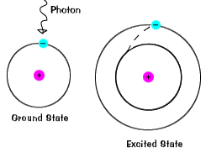

* An atom in the ground state is at equilibrium in terms of energy and particles.
* When heat or light (photons) strike an atom and bring it to the “excited state” equilibrium is disturbed as electrons jump to higher energy levels.
* The electron will return to the “ground state” to restore equilibrium … it must, therefore, give off the excess energy it gained. The excess energy is given off as colors of light (wavelengths)

One can calculate the energy gained or released as an electron changes energy levels. For instance, an electron being excited from n = 1 (*ground state*) to n= 3 would require 12.1 eV of energy [(-13.6 eV) – (-1.51 eV)].

## Energy of a Photon

Photons are “bundles” of electromagnetic radiation with definite frequencies (or wavelengths). To understand the energetic, we refer to the electromagnetic spectrum:

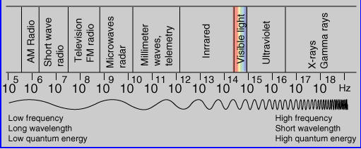

We can simplify the EM spectrum as follows:

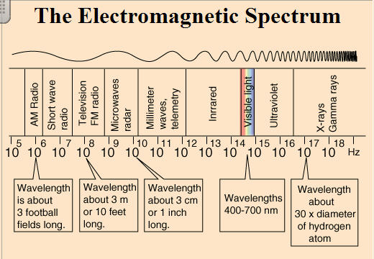

700 nm

400 nm

3 dm

3 mm

3 μm

0.3 nm

300 m

3 m

λ

f

λ

f

The relationship of the EM spectrum can be written as:

c = f λ where c = 3 x 108 m/s

When electrons make a jump from one **energy level** (a specific value of ***n***) to another energy level, a photon is emitted or absorbed. The energy of that photon depends on its **wavelength** (*or frequency*). The energy absorbed or emitted by electrons jumping between energy levels (e.g. n = 1 🡪 n = 3) is definite. Therefore, the light absorbed or emitted must have a definite wavelength or frequency. This wavelength can be found using the equation:

Wavelength of a Photon:

∆E = hc/λ or λ = hc/∆E

where ∆E is the energy of the photon (in eV)

h is Planck’s constant (4.14 x 10-15 eV s or h = 6.626 x 10-34 Js)

c is the speed of light (3 x 108 m/s).

*One electron volt is the energy that an electron gains when it travels through a potential difference of one volt (1 eV = 1.6 x 10-19 Joules).*

As we already saw, wavelength and frequency are inversely proportional to one another via the equation: c = f λ . Therefore, one can also calculate the …

Energy of a Photon:

E = hf where h = 6.626 x 10-34 Js

The amount of energy for an electron or a photon depends on its distance from the nucleus. The greater the distance from the nucleus the more energy exists (*just as a tire produces more energy than its hub*).

Producing Emission Spectra

When electrons make a jump from one **energy level** (a specific value of ***n***) to another energy level, a photon is emitted or absorbed. The energy of that photon depends on its **wavelength** (*or frequency*). The energy absorbed or emitted by electrons jumping between energy levels (e.g. n = 1 🡪 n = 3) is definite. Therefore, the light absorbed or emitted must have a definite wavelength or frequency and this forms an emission spectra.

**Diffraction** is the major principle of light demonstrated in emission spectra. Light acts as a wave in the emission spectrum lab emitted wavelengths (colors). This is because waves interfere with each other as the light passes through a diffraction grating. The **interference** pattern is observed as a bright-line spectrum.

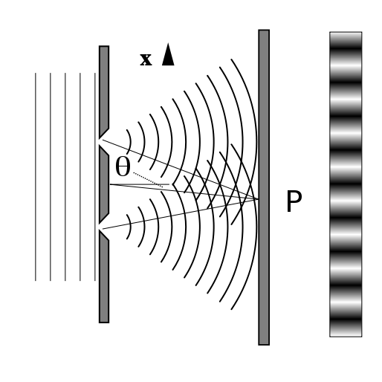

Constructive Interference

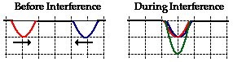

The white lines are from constructive interference.

Destructive Interference

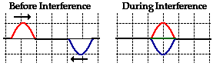

The black lines are from destructive interference.

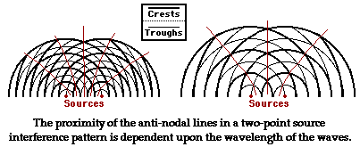

The amount of energy for an electron or a photon depends on its distance from the nucleus. The greater the distance from the nucleus the more energy exists (*just as a tire produces more energy than its hub*). One last helpful variable when considering the atom is its average orbital radius.

Average Orbital Radius:

Rn = kn2 where k = 5.3 x 10-11 m

n refers to the energy level, starting with n = 1 as the ground state

* *An expanded derivation of the orbital radius is included on the next pages [you are not responsible for this].*

In 1913, the Danish physicist Niels Bohr (1885 - 1962) managed to explain the spectrum of atomic hydrogen by an extension of Rutherford's description of the atom. In that model, the negatively charged electrons revolve about the positively charged atomic nucleus because of the attractive electrostatic force according to Coulomb's law [f = kq1q2/d2]. In quantum physics, the lowest energy orbital is called the **ground state**. Solving the Schroedinger equation (*see below*) for an electron in an attractive Coulomb potential provides the ground state properties of the hydrogen atom.

Enrichment

**Hydrogen Schrodinger Equation**

|  |  |
| --- | --- |
|  | The electron in the [hydrogen atom](http://hyperphysics.phy-astr.gsu.edu/hbase/quantum/hydsch.html#c1) sees a spherically symmetric potential, so it is logical to use [spherical polar coordinates](http://hyperphysics.phy-astr.gsu.edu/hbase/sphc.html#c1) to develop the [Schrodinger equation](http://hyperphysics.phy-astr.gsu.edu/hbase/quantum/sch3d.html#c2). The potential energy is simply that of a [point charge](http://hyperphysics.phy-astr.gsu.edu/hbase/electric/elepe.html#c1):    The expanded form of the Schrodinger equation is shown below. Solving it involves [separating the variables](http://hyperphysics.phy-astr.gsu.edu/hbase/quantum/hydsch.html#c4) into the form |

The starting point is the form of the Schrodinger equation:

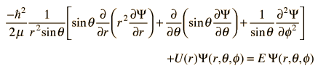

**Hydrogen Energy Levels**

The basic hydrogen energy level structure is in agreement with the [Bohr model](http://hyperphysics.phy-astr.gsu.edu/hbase/bohr.html#c4). Common pictures are those of a shell structure with each main shell associated with a value of the principal quantum number n.

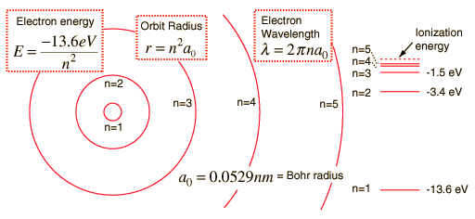

***To find the Average Orbital Radius using Bohr's atom***

*DERIVATION:*

*Consider an electron of charge* ***-e*** *in a circular orbit of radius* ***r0*** *in the presence of a Coulomb force* ***F*** *caused by a proton of equal but opposite charge. Writing* ***F*** *=* ***ma****,*

*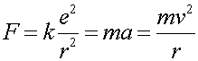    (1)*

*Using the fact that the momentum* ***p*** *=* ***mv****, and that the momentum is given in terms of the DeBroglie wavelength*

*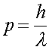    (2)*

*allows one to write the velocity in terms of the DeBroglie wavelength*

*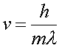    (3)*

*One can then write Eq. (1) with the DeBroglie wavelength rather than with the velocity.*

*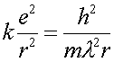    (4)*

*Then, Bohr made the jump that the wave function closed in on itself and that the circumference of the orbit was an integral number of wavelengths.*

*    (5)*

*Combining Eq.s (4) and (5) allows one to eliminate the wavelength and solve for the radius.*

*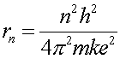    (6)*

*This actually perfectly agrees with the result from Schroedinger's equation, which is the more correct way to solve the problem.*

SIMPLIFICATION: Rn = kn2 where k = 5.3 x 10-11 m

n refers to the energy level, starting with n = 1 as the ground state