* Use the dichotomous key and / or phone app to identify 10 trees in your yard or nearby fields.
* Take a picture of the Tree and give the common name under the image of the tree.
* Example:

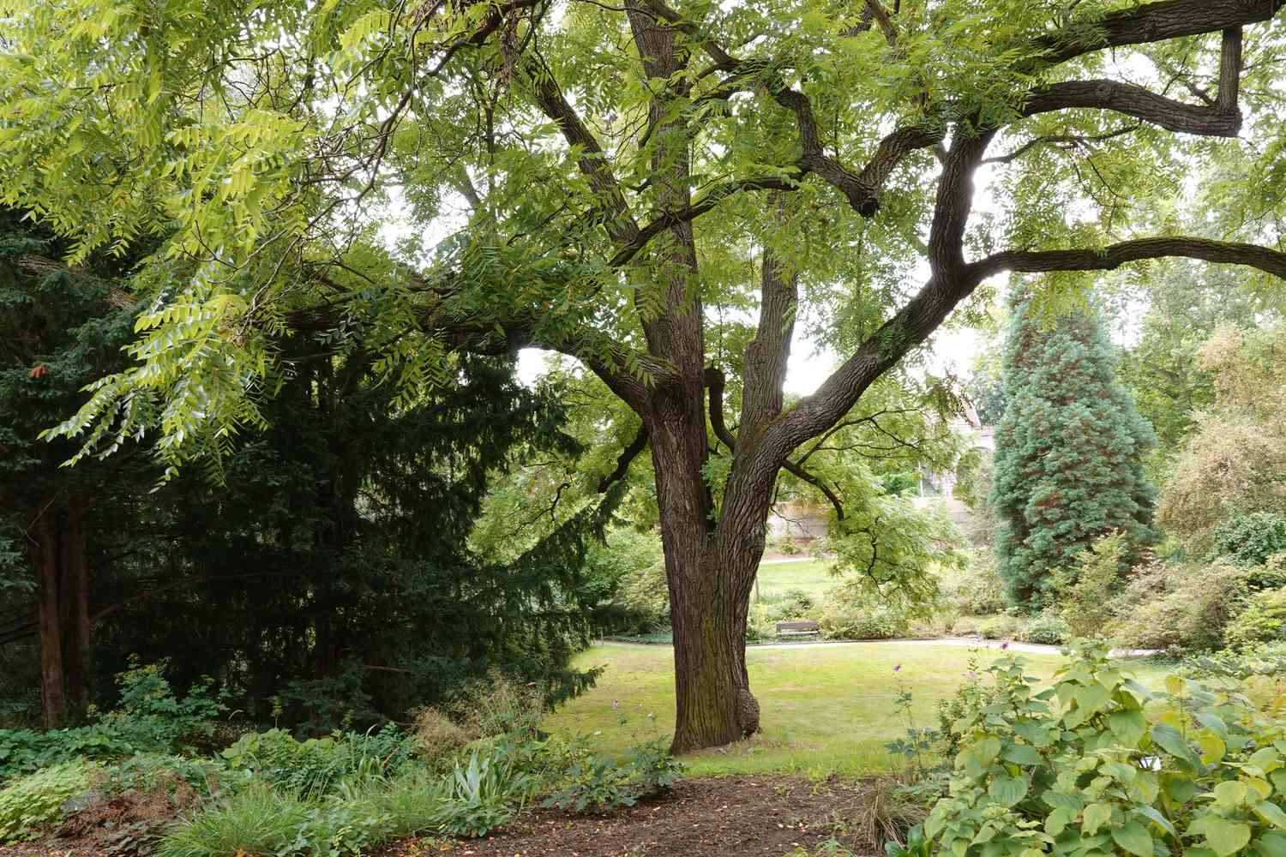 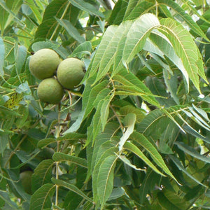

Black Walnut