Applying Concepts

1. The northern lights are the result of high energy particles coming from the sun striking atoms high in the Earth’s atmosphere. If you looked at the light through a spectrometer, would you expect to see a continuous spectrum or line spectrum? Explain.

***Looking through a spectrometer, one would see a line spectrum in which the light comes from a diluted GAS. A continuous spectrum results from fluorescent or incandescent sources.***

2. If white light were emitted from the Earth’s surface and observed by someone in space, would its spectrum be continuous, dark line or bright line? Explain.

***As white light passed through Earth’s atmosphere, certain energies would be absorbed by the GASES composing the atmosphere. Its spectrum, therefore, would have black lines in it because the energy is absorbed.***

3. Suppose you wanted to explain quantization to a younger brother or sister. Would you use money or water as an example? Explain.

***Money is a better example of quantization because of the “denominations” of the bills. They are discrete and there is no gradation between them. i.e. $1 bill, $10 bill, $100 bill, etc. … with no $3 bills, $7 bills, etc. In comparison water flows gradually.***

4. A photon with an energy of 6.2 eV enters a mercury atom in the ground state. Will the photon be absorbed by the atom? Explain.

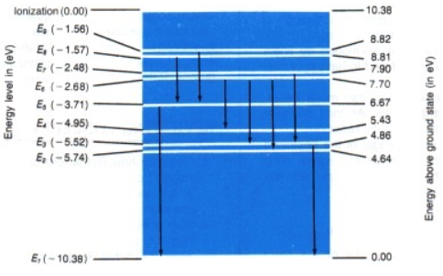

***It takes 5.43 eV to raise the electron to the E4 level, and 6.67 eV to raise the electron to the E5 energy level. The atom can absorb only photons that have exactly the right energy in order to get to a specific energy level. 6.2 eV is in-between the energy levels so nothing happens.***

5. A certain atom has 4 possible energy levels. If an electron can make transitions between any two levels, how many spectral lines can the atom emit? Which transition gives the photon the highest energy?

***Six spectral lines are possible between the E4 energy level and the E1 energy level.***

E4

E3

E2

E1

6. A photon is emitted when an electron drops through energy levels within an excited hydrogen atom. What is the maximum energy the photon can have? If this same amount of energy were given to an electron in the ground state of a hydrogen atom, what would happen?

***The maximum energy a photon can have in the hydrogen atom is 13.6 eV. This equals the ionization energy for hydrogen (the energy required to release the outermost electron). In this question, the electron would have enough energy to leave the nucleus.***

7. When electrons fall from higher energy levels to the third energy level within hydrogen atoms, are the photons emitted infrared, visible, or ultraviolet? Explain.

***All transitions from higher energy levels to the third energy level in hydrogen atoms yield photons with wavelengths greater than visible light. Therefore, the photons emitted are infrared.***

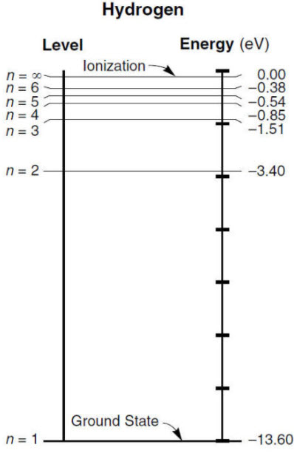

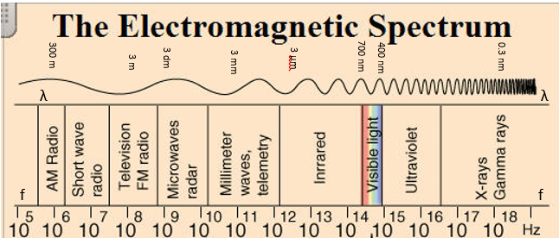

Notice that visible light has a wavelength between 400 nm (violet) to 700 nanometers (red).

∆E = hc/λ … rearrange to λ = hc/∆E

λ = (6.626 x 10-34 js)(3 x 108 m/s) / (-1.51 eV)( 1.6 x 10-19 j/eV) = 8.23 x 10-7 m = 823 nm

*since the energy given was in electron volts (eV) we need to convert to joules.*

823 nm is greater than the red (700 nm) range of visible light.

8. Compare the present quantum mechanical theory of the atom with the Bohr model.

***The Bohr model has fixed orbital radii. The present modern atomic theory (quantum model) gives a probability of finding an electron at a particular location. The Bohr model allows for calculation of only hydrogen atoms. The present model can be used for all elements.***

9. Which color laser (*red light, green light, or blue light*) emits photons with the highest energy?

***Blue light has a higher frequency and therefore, higher energy … E = hf***

### 

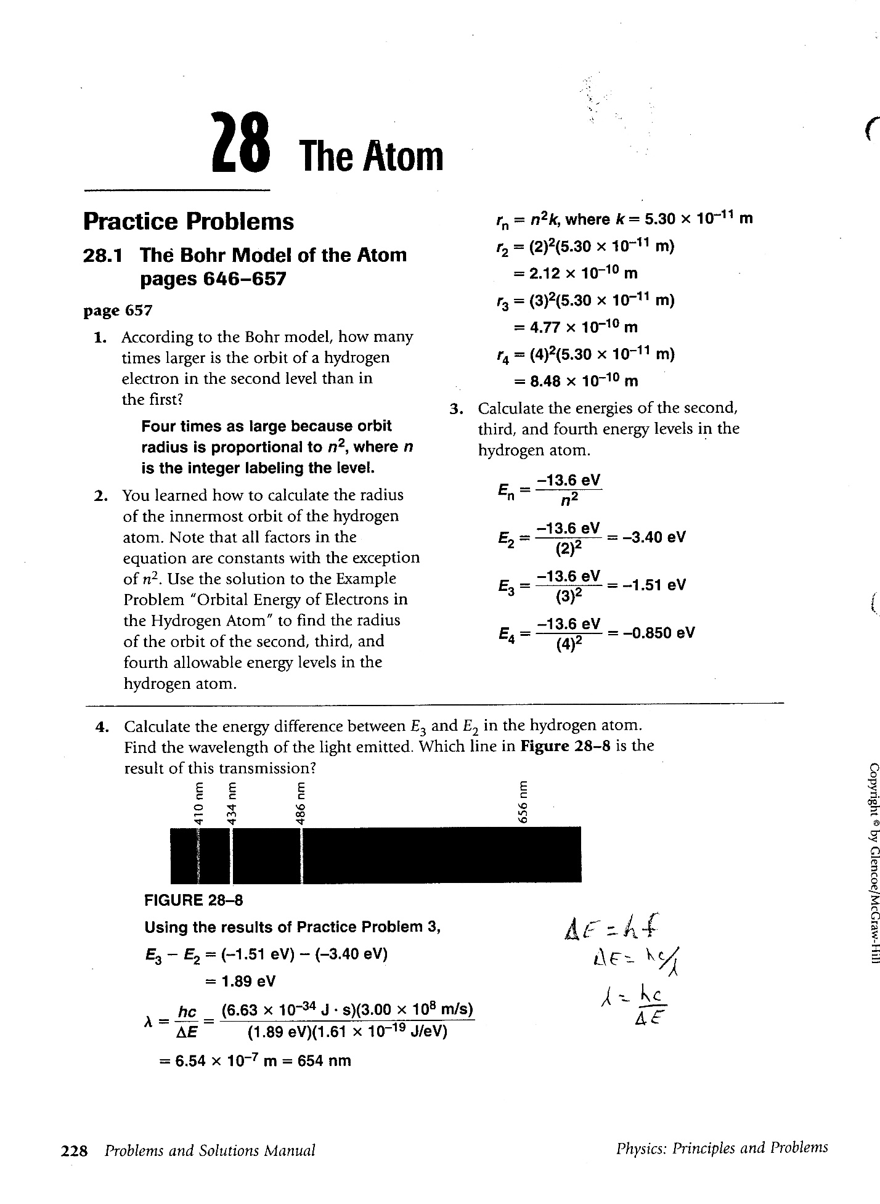

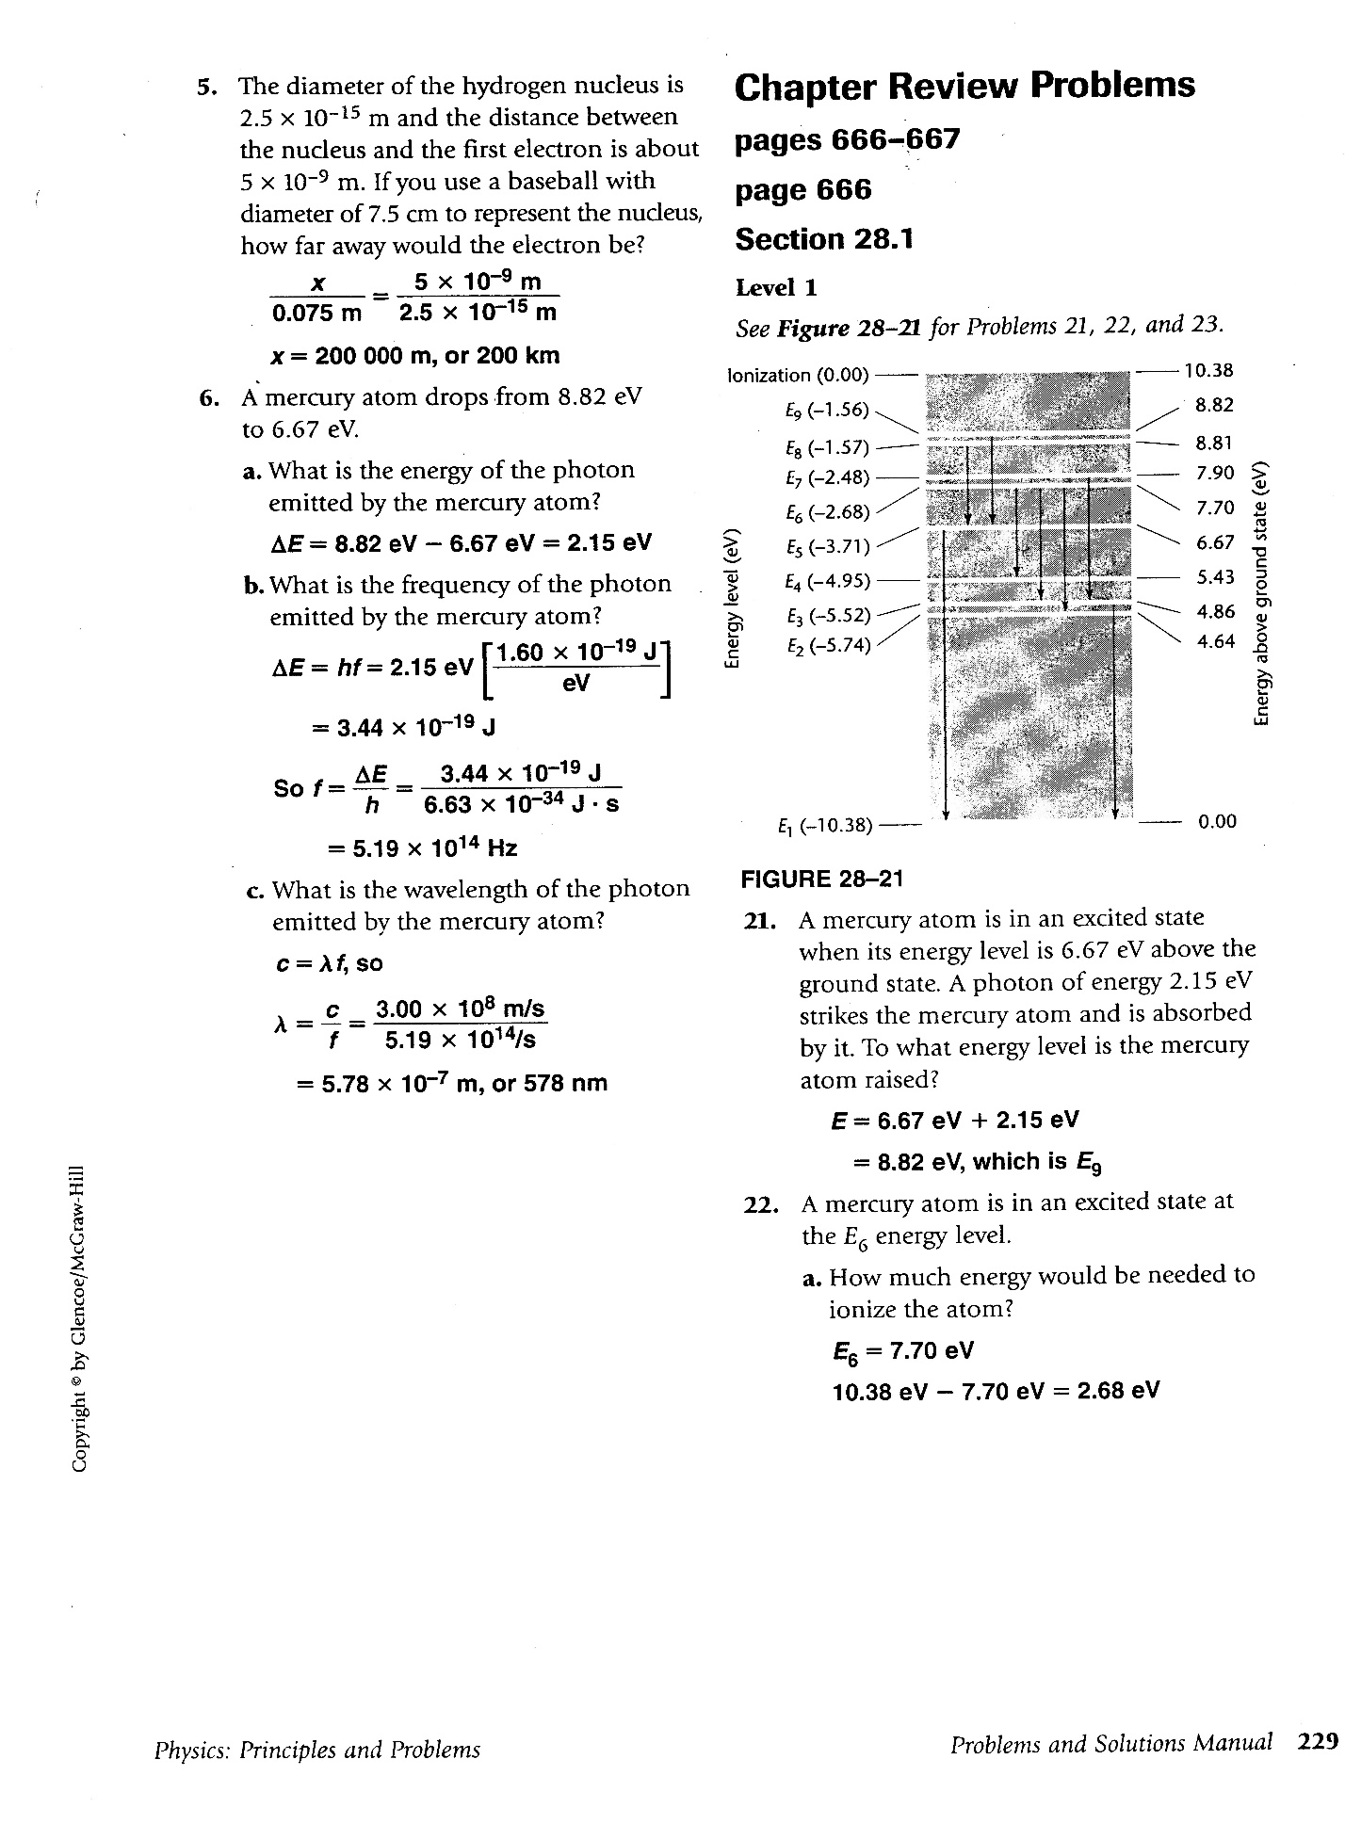

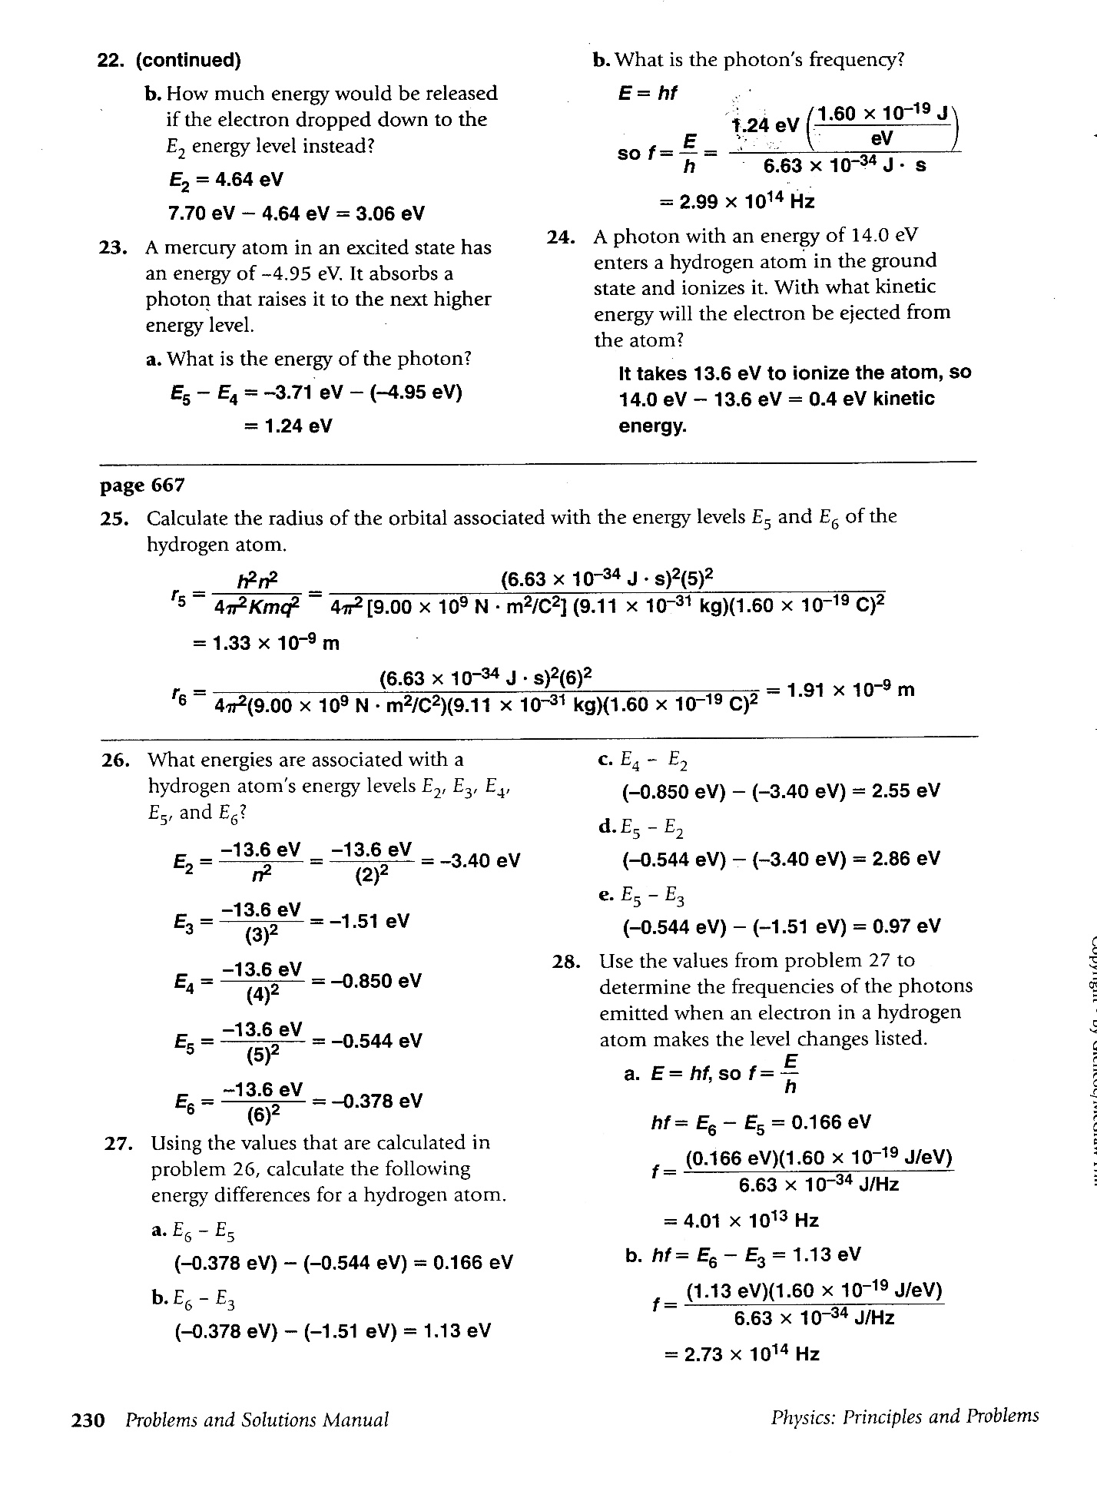

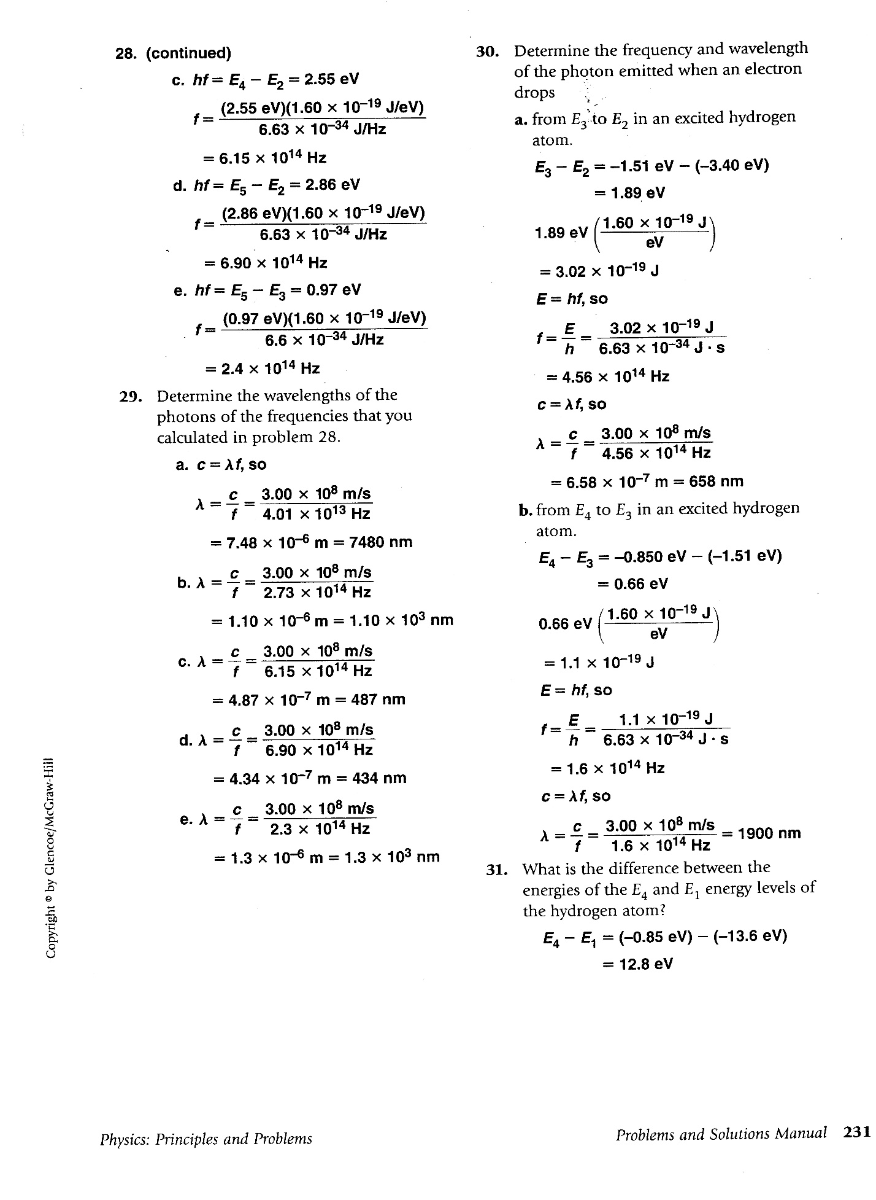

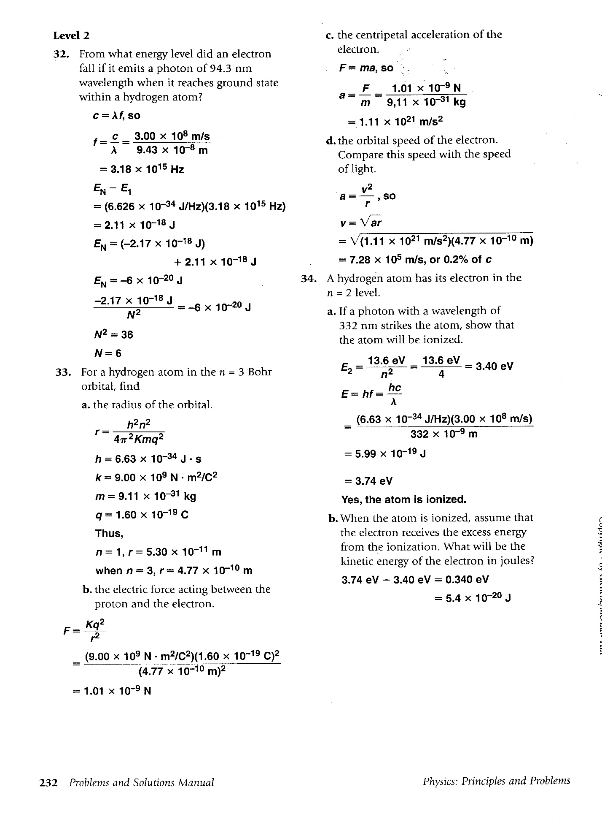

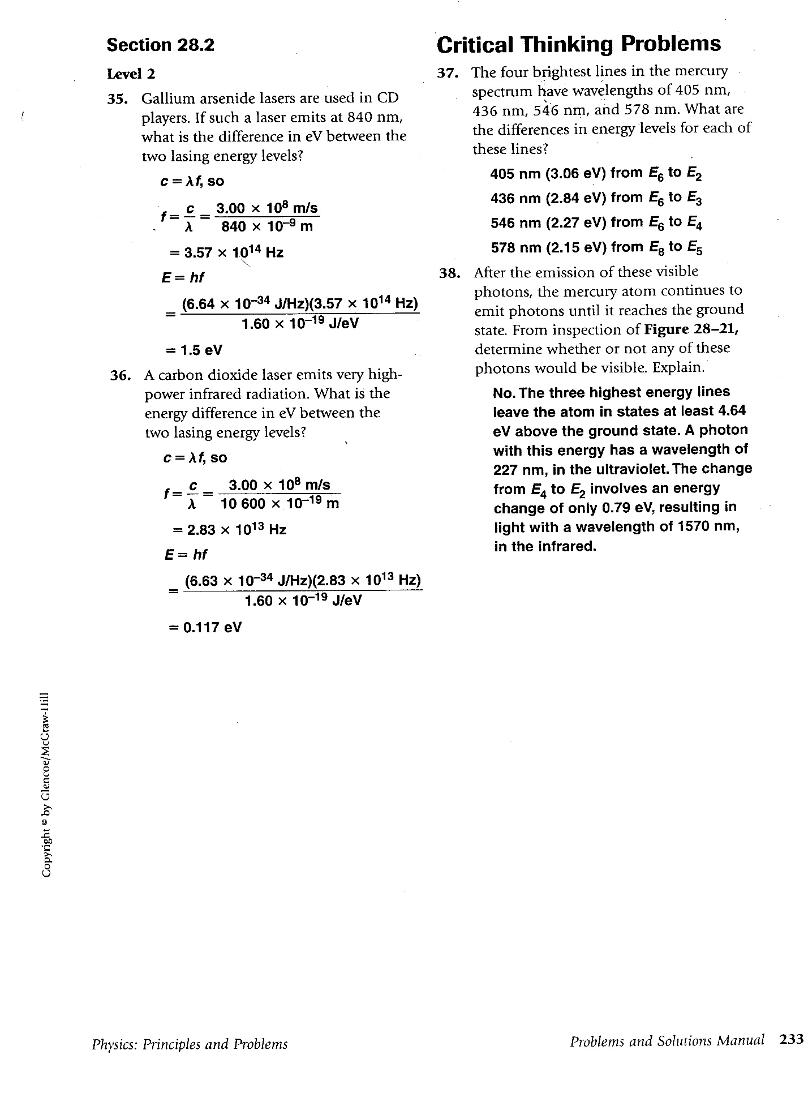

36. A carbon dioxide laser emits very high-power infrared radiation. If such a laser emits at 10,600 x 10-9 m, what is the energy difference in eV between the two lasing energy levels?

c = fλ, rearrange to solve for f

f = c/λ = 3.00 x108 m / 10,600 x 10-9 m = 2.83 x1013 Hz

E = hf = (6.63 x 10-34 j/Hz)(2.83 x 1013 Hz) / 1.60 x 10-19 j/eV) = 0.117 eV