Parallel Circuits Lab

## Introduction

## Purpose To investigate basic components of parallel circuits.

**Discussion**

In a parallel circuit there are several current paths. The circuit contains a voltage source and resistors located in two or more loops or paths. The current flows through each loop or path in the overall parallel circuit. This is similar to rapids in a wide, branching river. Some channels may have a large flow of water (*current*), others a small flow. The sum of the flows, however, is equal to the total flow of water in the river. In addition, no matter which channel the water follows, the gravitational potential (*voltage*) will be the same. All the water starts at the same level and comes together again at the same level below the rapids.

We can mathematically represent components for a parallel circuit as follows:

1/R total = 1/R1 + 1/R2 + 1/R3

I total = I1 + I2 + I3

### V = I R

**PART 1 Building a Series Circuit For Comparison OR PHET Simulation**

**Materials** 2 Strings of Bulbs 30 V battery Alligator Clips/Wires

**OR**

**PHET Simulation**: <https://phet.colorado.edu/en/simulation/legacy/circuit-construction-kit-ac>

<http://somup.com/cr1v3MqWpK> Parallel Circuit Lab (10:07)

**Procedures, Calculations and Data**

1. Obtain 2 strings of bulbs, a battery and some electric wiring and/or alligator clips.

2. Set up a simple series circuit using the battery and the 1 strings of bulbs.

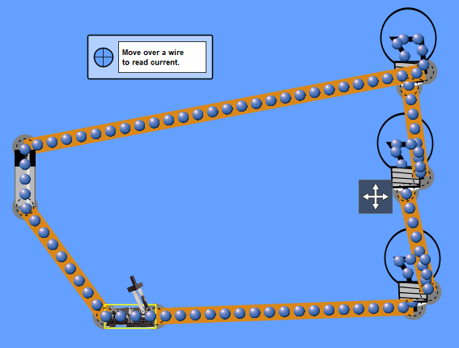

30 V Battery

Ammeter

Resistors

Switch

3. Once all the bulbs are lit, remove one bulb from one of the circuit paths. What happens to the bulbs in that same string? Record and explain your observations.

4. Replace the bulb you took out. Add a second string of bulbs to the same series circuit and observe what happens to the brightness of the bulbs. Record and explain your observations.

**PART 2 Building and Measuring in a Parallel Circuit**

**Materials** 3 Strings of Bulbs 30 V battery Alligator Clips/Wires Switch

**OR**

**PHET Simulation**: <https://phet.colorado.edu/en/simulation/legacy/circuit-construction-kit-ac>

<http://somup.com/cr1v3MqWpK> Parallel Circuit Lab (10:07)

**Procedures, Calculations and Data**

1. Obtain 3 strings of bulbs (*3 lights on each string*), a battery, some electric wiring and/or alligator clips, and a switch to the battery. (*For the PHET simulation use 3 bulbs in EACH branch*.)

2. Set up a 3-branch parallel circuit using a battery, 3 strings of bulbs, and a switch. Be sure to set up the 3 branches separately, connecting each branch to a separate wire above and below the branch:

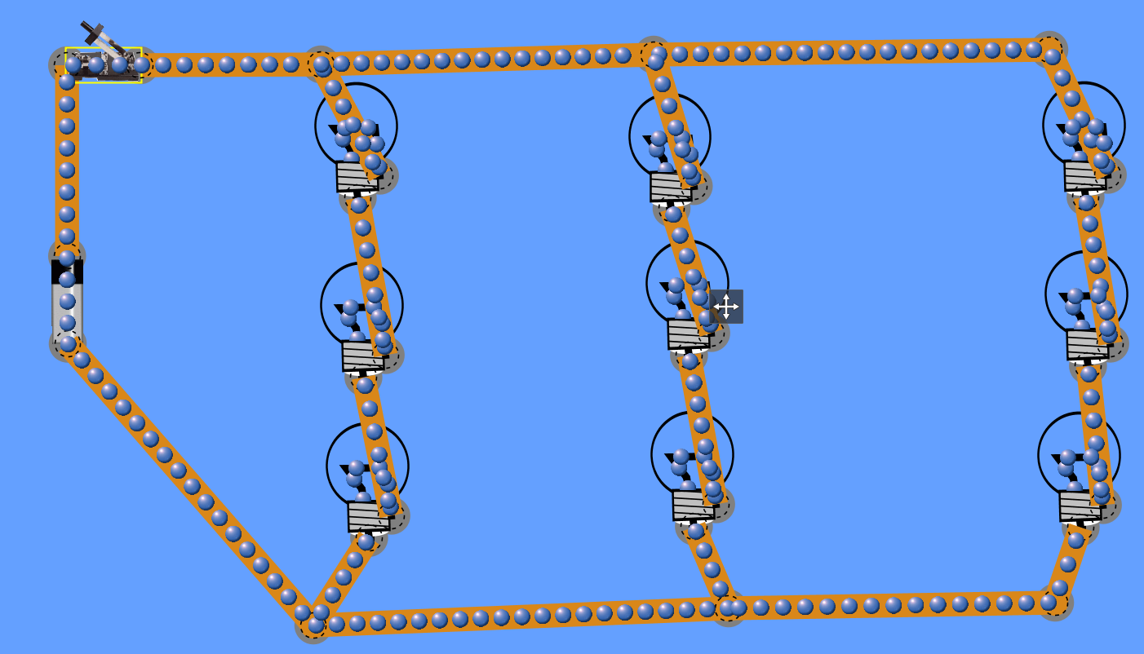

50 V Battery

10 Ω

Switch

20 Ω

30 Ω

10 Ω

20 Ω

30 Ω

10 Ω

20 Ω

30 Ω

3. Once all nine (9) bulbs are lit, remove one bulb from one of the circuit paths. What happens to the bulbs in that same string? What happens to the bulbs in the other circuit paths?

4. Replace the bulb you took out. Repeat procedure 3 with a bulb from each of the other two circuit paths to confirm your findings. Record your observations.

5. Replace the bulb you took out so that all three paths have 3 bulbs lit up. Compare the brightness of the bulbs from each loop with one another. Record your observations.

6. Use the PHET simulation and set up a 3-branch parallel circuit of 3 bulbs each. Set the voltage of the battery to 30 Volts.

7. Set up your parallel circuit so that each string of bulbs (in one path) has resistances of 10, 20, and 30 ohms respectively.

8. Use the voltmeter and non-contact ammeter in the simulation to determine the voltage and current across each resistor. Complete the chart below. The last row is the total for each column (resistance, voltage, and current in each loop/branch).

|  |  |  |  |  |  |  |  |  |
| --- | --- | --- | --- | --- | --- | --- | --- | --- |
| Resistance  Branch 1 | Voltage | Current | Resistance Branch 2 | Voltage | Current | Resistance  Branch 3 | Voltage | Current |
| 10 Ω |  |  | 10 Ω |  |  | 10 Ω |  |  |
| 20 Ω |  |  | 20 Ω |  |  | 20 Ω |  |  |
| 30 Ω |  |  | 30 Ω |  |  | 30 Ω |  |  |
|  |  |  |  |  |  |  |  |  |

9. Use the voltmeter and non-contact ammeter in the simulation to determine the voltage and current across the battery and overall circuit. Complete the chart below.

|  |  |  |  |
| --- | --- | --- | --- |
| Battery Voltage | Current  Battery to Branch 1 | Current  Battery to Branch 2 | Current  Battery to Branch 3 |
|  |  |  |  |

10. Sketch the parallel circuit you created with appropriate symbols, labeling voltage across the batteries, current, and resistance over each resistor and each loop.

**Conclusions and Questions**

1. What element(s) in a parallel circuit remains constant over every other component?

2. What element(s) in a parallel circuit could you say are variables?

3. How does the brightness of the bulbs in the parallel circuit compare with that of the series circuit? In other words, in series, when you added a second string of bulb, it effected the brightness in some way; how does adding a second string of bulbs in a second branch of the parallel circuit effect the brightness of those bulbs?

4. Use the total resistance and current in each branch to calculate the voltage expected. How does this compare with the actual voltage?

5. What is one obvious major advantage of using parallel circuits in our homes, transportation, and industry?

6. A 12.0 resistor and a 15.0 resistor are connected in parallel and placed across the terminals of a 15.0 V battery. What is the equivalent resistance of the parallel circuit? What is the current through the entire circuit? What is the current through each branch of the circuit?

**ANSWERS**

**PART 1 Building a Series Circuit For Comparison OR PHET Simulation**

3. Once all the bulbs are lit, remove one bulb from one of the circuit paths. What happens to the bulbs in that same string? Record and explain your observations.

**The circuit stops and there is no more flow of electrons. This is because only one loop exists in a series circuit and when there is a gap in the circuit, all flow stops.**

4. Replace the bulb you took out. Add a second string of bulbs to the same series circuit and observe what happens to the brightness of the bulbs. Record and explain your observations.

**The circuit with 6 bulbs connected in series works, but the lights are very dim compared to the original circuit with only 3 bulbs. This is because the same current flows through each resistor in a series circuit. The more resistors in series, the lower the current in each resistor.**

**PART 2 Building and Measuring in a Parallel Circuit**

3. Once all nine (9) bulbs are lit, remove one bulb from one of the circuit paths. What happens to the bulbs in that same string? What happens to the bulbs in the other circuit paths?

**The lights (resistors) in the branch that was disconnected go out, but the other branches continue to flow.**

4. Replace the bulb you took out. Repeat procedure 3 with a bulb from each of the other two circuit paths to confirm your findings. Record your observations.

**Same result … the lights (resistors) in the branch that was disconnected go out, but the other branches continue to flow.**

5. Replace the bulb you took out so that all three paths have 3 bulbs lit up. Compare the brightness of the bulbs from each loop with one another. Record your observations.

**The brightness of each branch is the same for all three branches.**

6. Use the voltmeter and non-contact ammeter in the simulation to determine the voltage and current across each resistor. Complete the chart below. The last row is the total for each column (resistance, voltage, and current in each loop/branch).

|  |  |  |  |  |  |  |  |  |
| --- | --- | --- | --- | --- | --- | --- | --- | --- |
| Resistance  Branch 1 | Voltage | Current | Resistance Branch 2 | Voltage | Current | Resistance  Branch 3 | Voltage | Current |
| 10 Ω | **8.3 V** | **0.83 A** | 10 Ω | **8.3 V** | **0.83 A** | 10 Ω | **8.3 V** | **0.83 A** |
| 20 Ω | **16.7 V** | **0.83 A** | 20 Ω | **16.7 V** | **0.83 A** | 20 Ω | **16.7 V** | **0.83 A** |
| 30 Ω | **25 V** | **0.83 A** | 30 Ω | **25 V** | **0.83 A** | 30 Ω | **25 V** | **0.83 A** |
| **60 Ω** | **50 V** | **2.5 A** | **60 Ω** | **50 V** | **2.5 A** | **60 Ω** | **50 V** | **2.5 A** |

9. Use the voltmeter and non-contact ammeter in the simulation to determine the voltage and current across the battery and overall circuit. Complete the chart below.

|  |  |  |  |
| --- | --- | --- | --- |
| Battery Voltage | Current  Battery to Branch 1 | Current  Battery to Branch 2 | Current  Battery to Branch 3 |
| **50 V** | **2.5 A** | **1.67 A** | **8.3 V** |

10. Sketch the parallel circuit you created with appropriate symbols, labeling voltage across the batteries, current, and resistance over each resistor and each loop.



50 V Battery

10 Ω

Switch

20 Ω

30 Ω

10 Ω

20 Ω

30 Ω

10 Ω

20 Ω

30 Ω

0.83 A

0.83 A

0.83 A

2.5 A

0.83 A

1.67 A

2.5 A

**Conclusions and Questions**

1. What element(s) in a parallel circuit remains constant over every other component?

**Voltage remains constant over every branch of the circuit (50 V in this case).**

2. What element(s) in a parallel circuit could you say are variables?

**Current, resistance, and voltage all vary throughout the parallel circuit. However, the voltage for each branch equals the power source voltage (50 V in this case). The overall current flowing in each branch is also the same for each branch.**

3. How does the brightness of the bulbs in the parallel circuit compare with that of the series circuit? In other words, in series, when you added a second string of bulb, it effected the brightness in some way; how does adding a second string of bulbs in a second branch of the parallel circuit effect the brightness of those bulbs?

**The brightness in each branch is the same. If you observe closely, the brightness of the 1st branch (closest to the power source) is slightly higher than the 2nd which is higher than the 3rd branch.**

4. Use the total resistance and current in each branch to calculate the voltage expected. How does this compare with the actual voltage?

**The resistance in each branch is the sum of the resistance for each bulb (10 Ω, 20 Ω, 30 Ω) for a total of 60 Ω. The current is 0.83 across each resistor, totaling 2.5 A.**

**V = I R = 0.83 x 60 Ω = 49.8 V which is very close to the actual 50 V.**

5. What is one obvious major advantage of using parallel circuits in our homes, transportation, and industry?

**Parallel circuits are advantageous because if one resistor or branch fails, the other branches can continue because each branch is independently connected to the power source.**

6. A 12.0 Ω resistor and a 15.0 Ω resistor are connected in parallel and placed across the terminals of a 15.0 V battery. What is the equivalent resistance of the parallel circuit? What is the current through the entire circuit? What is the current through each branch of the circuit?

**1/R total = 1 / R1 + 1 / R2 = 1 / 12.0** **Ω + 1 / 15.0 Ω = 0.083 Ω + 0.067 Ω = 0.149 Ω … therefore R total = 1/0.1497 = 6.68 Ω**

**V = I R … I total = V / R = 15.0 V / 6.68 Ω = 2.25 A**

**15.0 Ω loop 🡪 I = V / R = 15.0 V / 15.0 Ω = 1.0 A**

**12.0 Ω loop 🡪 I = V / R = 15.0 V / 12.0 Ω = 1.25 A**