Compass Orienteering: Simple Maps

# Two Step Process

1. Finding field bearings and distances (compass work)
2. Transposing the information to a flat map (mapping)

**\*Note**: One must be careful in using a compass indoors or around engines/motors and/or any strong electrical currents … the magnetic needle will be deflected by metal objects, other magnets or other electrical fields (i.e. power lines, electrical plugs)

### Compass Work

## Field Bearings and Corresponding Distances

1. Chose a starting point for the map you desire to make
2. Find a landmark in the direction you want to travel
3. Point the “direction of travel” arrow at the landmark
4. Adjust compass until compass needle surrounds the magnetic needle
5. Read and record this bearing
6. Pace off (measure) the distance toward the landmark as far as you desire

**\*You must travel in straight lines**

1. Record the distance with the previous field bearing
2. Repeat procedures 2-7, finding a new landmark, etc.
3. Record appropriate distances with the proper field bearings

**\*It is good to make a chart of bearings and distances**

Map scale: 1 cm = 10 feet

|  |  |  |
| --- | --- | --- |
| **Bearing #** | **Field Bearing** | **Distance** |
| 1 | 83◦ | 42 ft |
| 2 | 174◦ | 104 ft |
| 3 | 252◦ | 115 ft |

1. Record bearings and distances until you complete all necessary coordinates for the map

#### Map Scale

1. By definition, a map is a “graph” of a larger area placed onto a smaller area.
2. To measure distance on a map, one uses a “Map Scale.”
3. A “**map scale**” tells the reader how the distance on the map compares with the actual distance on the earth’s surface.

Example: map scale 1 cm = 10 feet

*on map on earth*

* For each “1 centimeter” on the map, this represents “10 feet” of distance on the earth’s surface.
* “2 cm” on the map would be equivalent to “20 feet” on the earth’s surface, “3 cm” would be equivalent to “30 feet” and so forth.

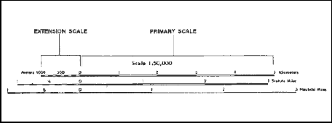

### Starting the Map

1. Materials Needed
2. Protractor
3. Metric ruler
4. Pen or pencil
5. Results of field bearings and distances
6. Labeling your map

### EE

### S

### W

### N

1. Cardinal points with symbol

This symbol must be on all maps that you draw.

North (N)

South (S)

East (E)

West (W)

1. Map scale (i.e. 1 cm = 10 m)
2. North (“N”) reference lines for all bearings (*use dotted lines*)
3. Label all field bearings at appropriate points
4. Label distances for all lines
5. Actual distance
6. Scale distance
7. Be sure to include units (meters, feet, etc.)

##### Choosing a starting point on the map

1. Starting position on a map will vary according to:
2. The shape of the map
3. The starting field bearing
4. The map scale

* In general, you can place an “X” approximately 3 inches from the top of your paper and 5 inches from the left side of your map

1. Make a “N” reference line at the starting point

X

Start

1. N reference lines travel “due” N and S
2. Use the protractor’s straight side and align it flush with the “N” edge of map paper
3. The 90 degree mark on the protractor must be exactly aligned with the starting point or pass through it
4. Make a mark at the center of the protractor straight *edge (directly opposite the 90 degree mark*)
5. Draw a DOTTED line from the start point 2-3 inches N

### Drawing the Map

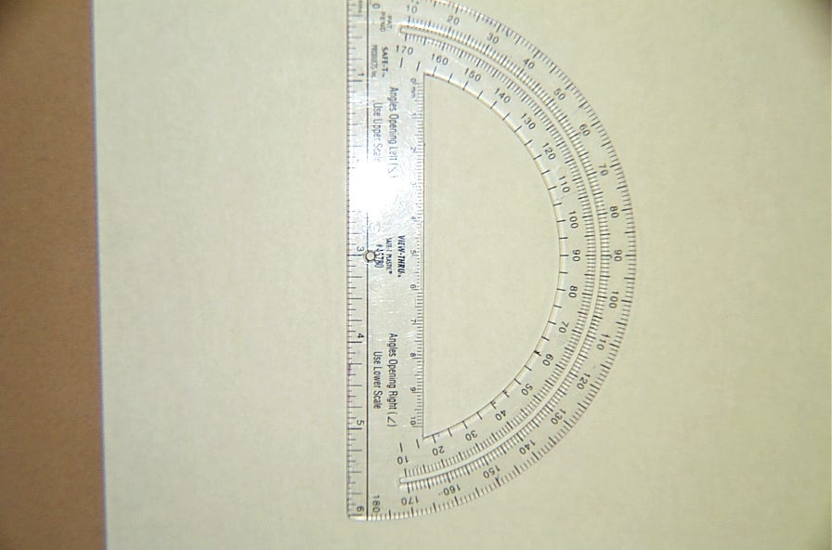

**X**

83◦

## Mapping the first field bearing

1. Place protractor on N reference line.
2. Align the protractor “center line” exactly on starting point (*as shown*)
3. Obtain the first field bearing from the chart on page 1 (83o).
4. Starting at the N end of the protractor, measure 0o to 83o.

X

1. Place a dot at the field bearing.
2. Remove protractor and obtain a metric ruler.
3. Mapping the distance of the first map line

Map scale: 1 cm = 10 feet

1. Determine the scale distance for your map
2. Based on the chart on page 1, the longest distance is 115 feet.
3. Metric rulers use centimeters (cm) as a standard unit and a 12 inch metric ruler has 30 centimeters marked off.
4. To fit the line distance on a normal sized sheet of paper we need to use a scale. The scale we chose is given in the box.
5. This scale makes the longest line 11.5 cm, which fits on the page.
6. Place the map scale on your drawing near the cardinal direction key.
7. The actual distance is 42 feet
8. The scale is 1 cm = 10 feet
9. The map distance will be 4.2 centimeters, representing 42 feet.
10. Determine the scale distance for your first map line
11. The actual distance is 42 feet
12. The map scale is 1 cm = 10 feet
13. Divide the actual distance by the scale distance (42 ft / 10 feet)
14. Therefore, the map distance will be 4.2 centimeters, representing 42 feet
15. Align the metric ruler from the starting point through the dot you just made at 83o (see IV. A. #1-3).
16. Do NOT use the end of the metric ruler to measure: start with 1 cm or more. This is because the ends are often worn or broken off.
17. Draw a **solid** line from the starting point toward the dot you made at 83o the **exact** distance (4.2 cm) to represent the distance of the line on your map.

**.**

# C. Continuing the map by drawing the second map line

83◦

**\*Be sure to only draw the scale distance for the line**

N Reference Line

Starting Point

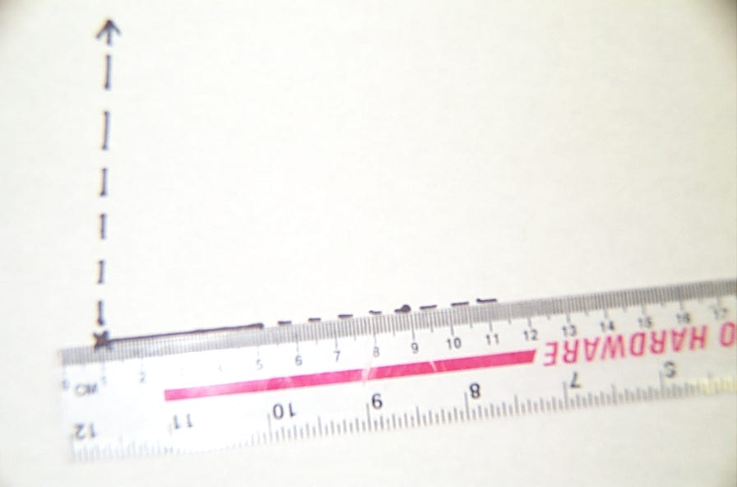

1. The end of the first map line becomes the next starting point.
2. Place an “X” or a Dot to indicate this new start position
3. To draw the second map line, go back and repeat all the field bearing and map line procedures for all your map information.

Original

Starting

Point

New

Starting

Point

X

X

### Protractor Use



A. Measuring angles over 180o

1. Make sure protractor is right side up as shown to the right.
2. For angles between 0 o and 180 o, the protractor must be positioned so that the curved side is to the right.

* Start at the top of the protractor to find the angle you need.

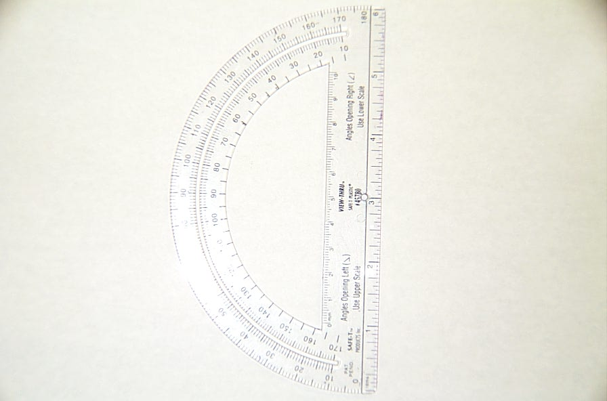

1. For angles between 180 o and 360 o or 0 o, the protractor must be positioned so that the curved side is to the left (*as shown to the left*).

* You would start at the bottom of the protractor to find the angle you need.

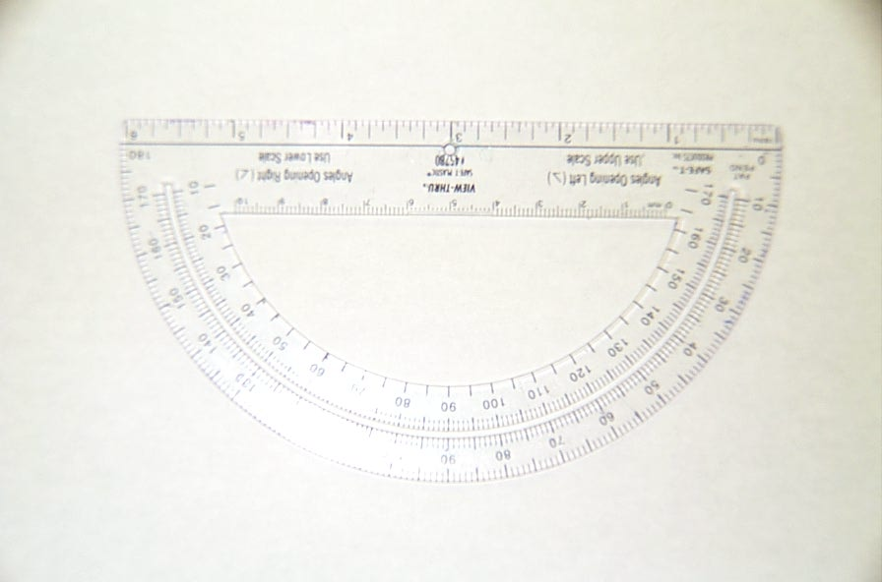

X

###### B. Aligning the protractor for North (N) Reference lines

1. Place straight edge on North edge of you map paper (*as shown above*)
2. Using a straight edge plus the protractor (*see below*)
3. Align a ruler or other straight edge at the top or bottom edge of paper depending on where you need to align your protractor

(b) Align the protractor on that straight edge (*see sketch below*)

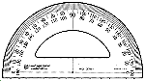

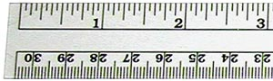

X