**Carbon Compounds**

# **Introduction**

# **Purpose** To investigate carbon compounds and their structure. (*Refer to 9.1-9.2 in text*.)

**Background Information**

Organic molecules contain BOTH the element carbon and hydrogen bonded together. All other compounds and molecules are called inorganic. Organic molecules tend to be very large, possessing characteristic properties that we will discuss later in the course. Inorganic compounds/molecules tend to be relatively small.

Organic Molecules can be broken down into two main categories:

1) hydrocarbons: composed of carbon and hydrogen atoms only,

2) organic molecules containing other elements such as oxygen, nitrogen and sulfur.

Organic molecules are more common than all other compounds combined. The most popular organic molecules include fats, proteins, carbohydrates and vitamins. Chemicals used for medicines include hormones, sulfa drugs, cortisone, tranquillizers, pain killers, etc.

Hydrocarbons are the most abundant organic molecules. They contain only the elements carbon and hydrogen. There are three categories of hydrocarbons:

1) saturated, containing all single covalent bonds between atoms,

2) unsaturated, containing at least 1 double or triple covalent bond in the molecule,

3) aromatic, containing carbon atoms bonded into “rings” or geometric shapes.

Oxygen containing organic molecules are the next most abundant organic molecules after hydrocarbons. They can be classified into several categories:

1) alcohols, used for disinfectants, beverage, solvents,

2) carboxylic acids, used in medicines, foods (vinegar),

3) ethers, used as anesthetics,

4) esters, found in foods, and scents,

5) aldehydes

6) ketones.

**Materials**: Marshmallows Toothpicks Raisins

**Procedures**:

1. Refer to the various tables of Carbon Compounds on the following pages.
2. Build each carbon compound in the tables:
3. Use marshmallows to represent carbon atoms.
4. Use raisins to represent hydrogen atoms.
5. Use a ½ marshmallow for oxygen atoms.
6. Use the toothpicks to represent bonds (you can break them in half).

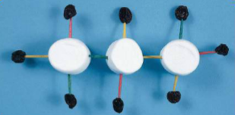

Propane C3H8

1. NOTE: All carbon atoms must have FOUR (4) bonds (toothpicks). For “double bonds” use TWO (2) toothpicks. For “triple bonds” use THREE (3) toothpicks.

## Calculations and Data

Hydrocarbon Isomers

*Compounds with the same molecular formula but different structural formulas are* ***isomers.***

|  |  |  |
| --- | --- | --- |
| Compound | Molecular Formula | Structural Formula |
| Butane | C4H10  “Linear” |  |
| Isobutane  *(put 3 carbons in a row, 4th in middle)* | C4H10  “Branched” |  |
| Cyclobutane  *(put carbons in a ring)* | C4H8  “Ring” |  |

**Saturated & Unsaturated Hydrocarbons**

|  |  |  |
| --- | --- | --- |
| Compound | Molecular Formula | Structural Formula |
| Ethane | C2H6  “Saturated” |  |
| Ethene | C2H4  “Unsaturated” |  |
| Ethyne  *(acetylene*  *Welder’s fuel)* | C2H2  “Unsaturated” |  |

**Carbon Compounds Containing Oxygen (Functional Groups)**

|  |  |  |
| --- | --- | --- |
| Compound | Molecular Formula | Structural Formula |
| Ethanol | C2H5OH  “Alcohol” |  |
| Methyl Ethanoate | CH3COOCH3  Scents / Smells / Flavorings |  |

## Conclusions and Questions

1. Define the terms “isomer” and “branched” in relation to carbon compounds

2. Define a “hydrocarbon.”

3. What is the difference between a saturated hydrocarbon and an unsaturated hydrocarbon? Give one example of each.

1. Alcohols, ethers, carboxylic acids, and esters all contain what three elements?

**Bibliography**

Wysession, M., Frank, D, and Yancopoulos, S.. Physical Science, Concepts in Action. Pearson Education, Inc., 2011. Upper Saddle River, New Jersey 07458. Print.

## ANSWERS

## Calculations and Data

**Hydrocarbon Isomers**

*Compounds with the same molecular formula but different structural formulas are* ***isomers.***

|  |  |  |
| --- | --- | --- |
| Compound | Molecular Formula | Structural Formula |
| Butane | C4H10  “Linear” |  |
| Isobutane  *(put 3 carbons in a row, 4th in middle)* | C4H10  “Branched” |  |
| Cyclobutane  *(put carbons in a ring)* | C4H8  “Ring” |  |

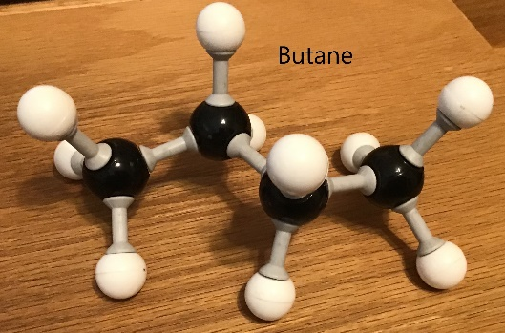 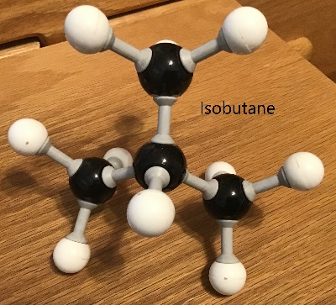 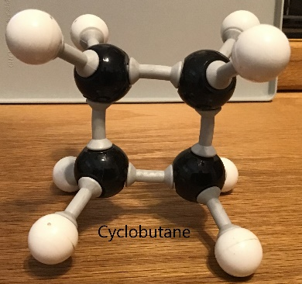

**Saturated & Unsaturated Hydrocarbons**

|  |  |  |
| --- | --- | --- |
| Compound | Molecular Formula | Structural Formula |
| Ethane | C2H6  “Saturated” |  |
| Ethene | C2H4  “Unsaturated” |  |
| Ethyne  *(acetylene*  *Welder’s fuel)* | C2H2  “Unsaturated” |  |

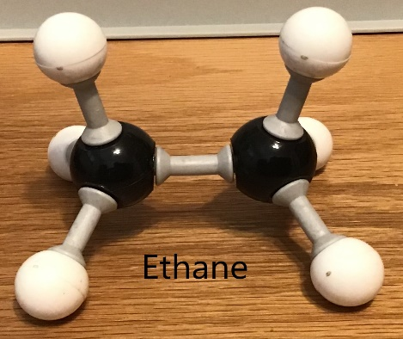 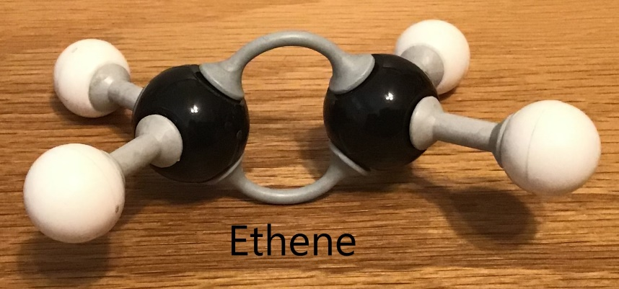

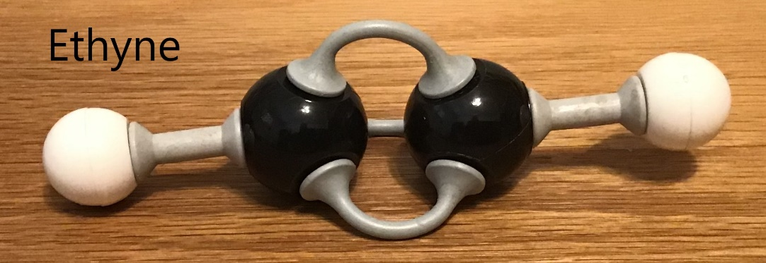

**Carbon Compounds Containing Oxygen (Functional Groups)**

|  |  |  |
| --- | --- | --- |
| Compound | Molecular Formula | Structural Formula |
| Ethanol | C2H5OH  “Alcohol” |  |
| Methyl Ethanoate | CH3COOCH3  Scents / Smells / Flavorings |  |

## 

**Conclusions and Questions**

1. Define the terms “isomer” and “branched.”

*Isomers are carbon compounds with the same molecular formula but different structural formulas. A branched carbon compound has one or more group of carbon bonded off the central, linear axis.*

2. Define a “hydrocarbon.”

*Hydrocarbons are organic molecules contain ONLY C and Hydrogen (methane, ethane, propane, butane, etc.).*

3. What is the difference between a saturated hydrocarbon and an unsaturated hydrocarbon? Give one example of each.

*Saturated hydrocarbons ONLY contain single covalent bonds between the carbon atoms. Unsaturated hydrocarbons can contain double bonds or triple bonds between the carbon atoms.*

4. Alcohols, ethers, carboxylic acids, and esters all contain what three elements?

*Alcohols, ethers, carboxylic acids and esters all contain oxygen, carbon and hydrogen.*