**Vectors**

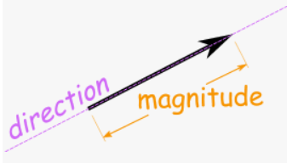

**See** [**https://www.learningctronline.com/courses**](https://www.learningctronline.com/courses) **for Materials and Resources.**

**Topics:**

1. Vectors

**Objectives:**

* Define vectors as compared to scalar quantities.
* Distinguish displacement from distance. Understand that displacement is ∆d = d2 – d1.
* Identify x and y components, cardinal directions, and conventions.
* Utilize properties (addition, subtraction, graphing), including trigonometry.

TAKE NOTE

1. Reading (Hewitt Text)

1. Test Corrections
2. Problem Set Vectors (2 weeks)
3. Lab: Discovery Lab Vectors
4. Lab: Paper River
5. Week 3 Devotional (<https://www.learningctronline.com/devotional>)

**Text**: Chapter 3: Vectors 3.1 – 3.3 (Hewitt)

**Class Notes: Vectors Document**

**Homework**:

* Problem Set Vectors (2 weeks)

**Lab**: 2L Discovery Lab Vectors

* Perform the lab as directed using the worksheet provided.
* Save the document into your LAB folder in the Physics folder on your desktop.

**Lab**: 2L Paper River

* Perform the lab as directed using the worksheet provided.
* Complete all calculations and data, showing work whenever appropriate.
* Conclusions should be answered in complete sentences that convey a complete thought.
* Save the documents into your LAB folder in the Physics folder on your desktop.

**TEST:** No Quiz this week

Supplemental Resources (Optional)

[**https://screencast-o-matic.com/watch/cYhtbQpq0c**](https://screencast-o-matic.com/watch/cYhtbQpq0c) **What is a Vector? "Despicable Me" (0:39)**

<http://somup.com/crhXogFdWr> (1:02) Paper River Lab