**Chemical Formulas Chapter 9A**

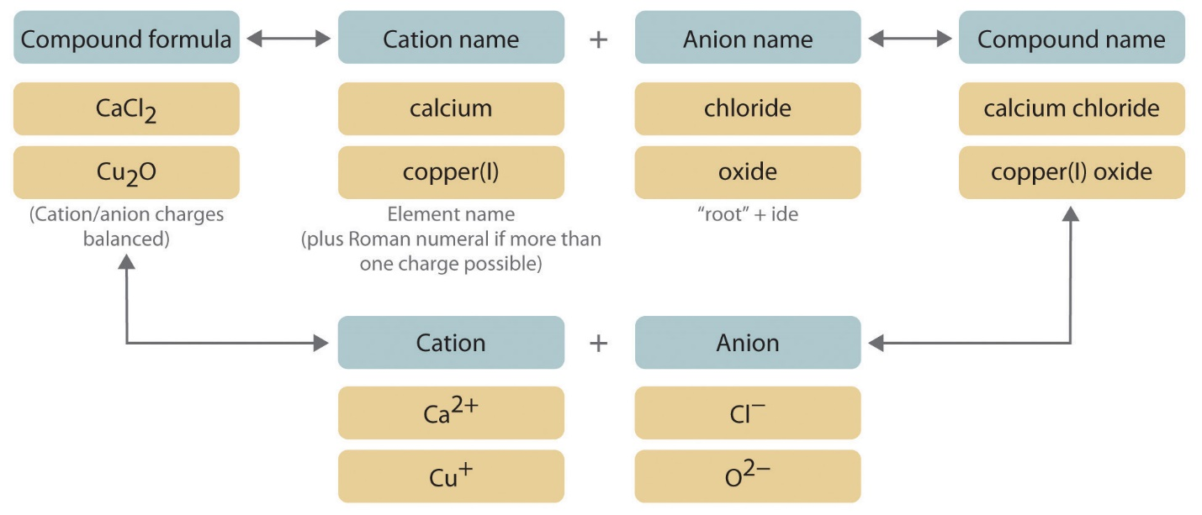

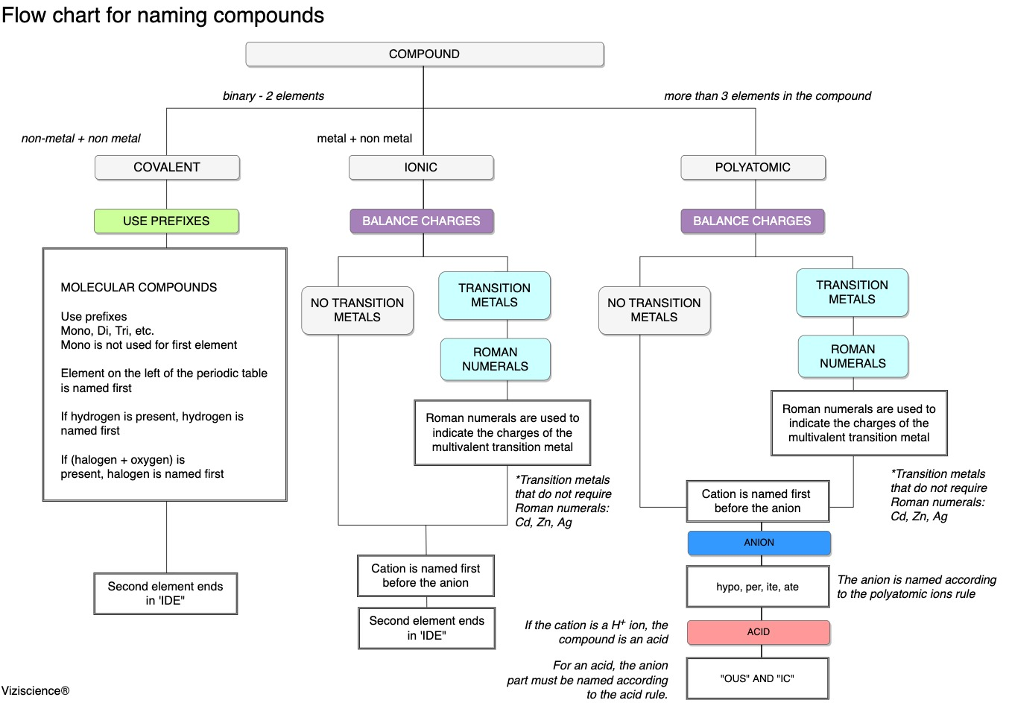

**See** [**https://www.learningctronline.com/courses**](https://www.learningctronline.com/courses) **for Materials and Resources.**

**Topics:**

1. Chemical Formulas

**Objectives:**

1. Explain how to determine the charges (oxidation numbers) of monatomic ions.
2. Apply the rules for naming and writing formulas for compounds with polyatomic ions.
3. Determine the names and formulas of ionic and covalent compounds, of acids and bases.
4. Understand Law of Definite Proportions

TAKE NOTE

1. Notes/Study Guide (2 weeks)
2. Lesson Check/Sample problems or Alternative Worksheets (2 weeks)
3. Lab Quiz: Bonding & Formulas
4. Test Corrections (Covalent Bonding)
5. Upcoming
   1. Lab Report Law of Definite Proportions
   2. (week 16): Semester Exam (Chapters 1-10, 13)
6. Week 13 Devotional (<https://www.learningctronline.com/devotional>)

**Text**: Chapter 9: Chemical Formulas pp. 262-284

Read the assigned pages in the text.

**Class Notes: PowerPoint or PDF**

**Notes/Study Guide:** Fill in the Chapter 9 worksheet to understand the class notes.

**Homework**: Text

(1) Answer the KEYED **“Lesson Check”** questions at the end of each.

(2) Answer the **“Sample problems”** found in the “Sample Problem” boxes throughout the chapter. An answer KEY is provided for you to use to self-correct your homework problems.

* Put your answers into complete thoughts in a Word document. Do NOT just put the answer, but write a phrase or sentence that you can study from for your tests. Save your work in a WORD document and SAVE into your HOMEWORK folder in the Chemistry folder on the desktop.
* Assignments will be “spot checked” during class or submitted via email.

**Alternate Homework**:

1. Formula Worksheets
2. Chapter 9 Practice Exam: Formulas

**Lab**: Bonding & Formulas

Complete the “Bonding & Formulas” activity using the worksheet provided.

* Answers are provided at the end of the document for guidance. Do NOT copy and paste these answers, but write using your own words.
* Save the document into your LAB folder in the Chemistry folder on your desktop.
* Study for understanding, and when ready, take the Lab Quiz.
* You may **NOT** use the worksheet on this lab test.

**TEST:** The test will be given after next week’s lesson.

Supplemental Resources (Optional)

1. Formulas & Naming Ionic Compounds
2. Update (check) your Reference Materials (Periodic Table, Equation Sheet, Reference Tables)

[Chemical Formulas & Oxidation Numbers ctr](http://somup.com/cF6jYFnn3G) (7:43) ... element symbols, subscripts, coefficients, oxidation states  
  
[Writing Chemical Formulas ctr](http://somup.com/cF6QITnnU5) (4:18) Oxidation & Criss-Cross Method  
  
[Naming Chemical Formulas (Introduction) ctr](http://somup.com/cF6Q2ZnnvT) (1:57) Naming elements, HOFBrINCl (diatomic) Molecules, & Ionic (Binary) Compounds.  
  
[Naming Covalently Bonded Molecules](http://somup.com/cF6Qrunnam)(6:11)  
  
[Praying the Word Ephesians 6:17-18; On My Knees](http://somup.com/cYhD2VjU1w) (4:43)