**Projectile Motion**

**Introduction**

**Purpose**

To investigate the launch angle, initial velocity, and size & shape of a projectile in order to explain how these variables affect the projectile's motion.

**Discussion**

In this activity, you will use a computer simulation to investigate the variable of projectile motion. One aspect of this activity will allow you to act as an artillery sergeant for the United States Army. Your commanding officer has assigned you the task of identifying the object being fired, angle of fire, and the initial velocity of the fired object.

**Hypothesis**

If launch angle and velocity are known, then the projectile distance and height can be accurately calculated.

**Materials** PHET Simulation Lab Sheet

<https://phet.colorado.edu/en/simulation/projectile-motion>

You can access simulations at: <https://phet.colorado.edu/en/simulations/browse>

Find the course you desire (Physics, Chemistry, Math, Earth Science, Biology). Go to the right to scroll each course for simulations.

**Procedures & Calculations and Data**

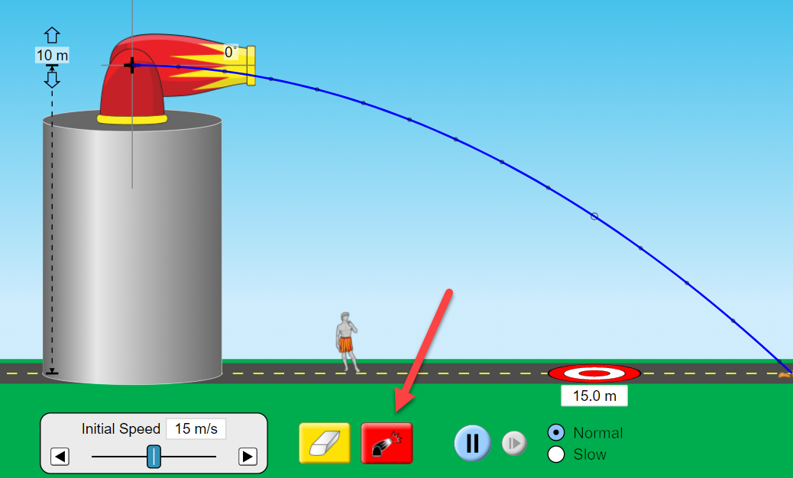

1. LIST & DESCRIBE: Think about a ball flying through the air, a cannon ball fired from a canon, or any form of projectile motion. There are many possible factors that affect the trajectory of the projectile. Go to the introduction simulation, fire the canon and list 4 variables, giving a brief description of how they may affect projectile motion [*variables are in table to the right*]:

1.

2.

3.

4.

2. At the bottom, Click on the “Vectors” icon. Move the canon to 30°. Initial speed (m/s) = 18 m/s . Air Resistance is NOT checked. Click Vectors at the right as shown.

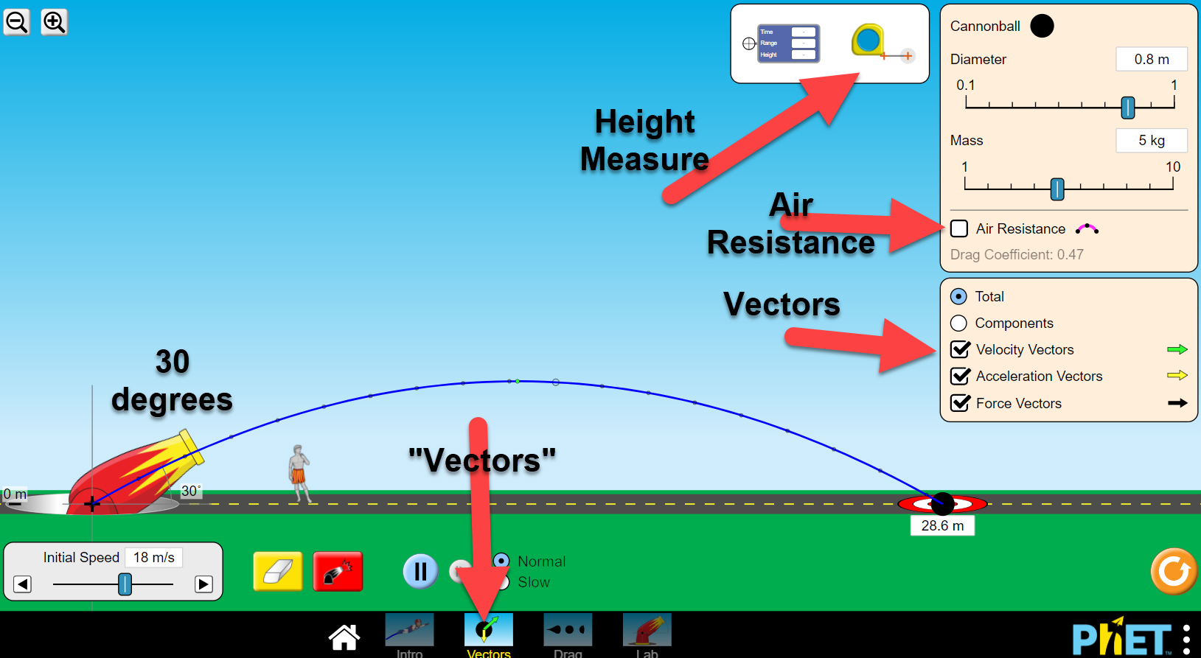

Notice the red/white target, which gives distances. There is an eraser to delete the trial. You can set “slow” for the speed of projectile motion. You can play with other factors after this lab.

a. Complete the data table below for each angle.

*To get the vertical height, use the tape measuring tool (top towards the right) to determine the height at each angle. The trajectory has a white dot which represents the highest point.*

*You may need to “zoom” to shrink the screen in order to measure the longer distances.*

|  |  |  |
| --- | --- | --- |
| Trajectory | **dx**  (Range) | **dy**  (Height) |
| 15° | m | m |
| 30° | m | m |
| 45° | m | m |
| 60° | m | m |
| 75° | m | m |

b. Once you have completed the table, make a sketch of the five projectiles below. You need to predict the trajectory of the 15° angle projectile.

c. Which set(s) of launch angles produced the same horizontal displacements (dx)?

d. Which angle(s) produced the longest horizontal displacement (dx)?

e. Which angle(s) produced the highest vertical displacement (dy)?

3. **INITIAL VELOCITY**:

a. “Erase” the motion paths.

b. Change the launch angle to 30° and change the initial velocity option to read 15 m/s and then click fire, and observe the resulting motion. Fill in the data in the chart.

c. When it finishes, adjust the initial velocity to 18 m/s, 21 m/s, 24 m/s, 27 m/s and 30 m/s. **INCLUDE UNITS**!

|  |  |  |
| --- | --- | --- |
| Initial Velocity (m/s) | **dx**  (Range) | **dy**  (Height) |
| 15 |  |  |
| 18 |  |  |
| 21 |  |  |
| 24 |  |  |
| 27 |  |  |
| 30 |  |  |

*To get the vertical height, use the tape measuring tool (top towards the right) to determine the height at each angle. The trajectory has a white dot which represents the highest point.*

*You may need to “zoom” to shrink the screen in order to measure the longer distances.*

d. Which initial velocity produced the longest horizontal displacement (dx) and time? Explain why this makes sense.

e. How do the vertical displacements (dy) compare at each initial velocity related to the previous experiment when you changed the launch angle? Explain why this makes sense.

4. **SIZE & SHAPE (no air resistance)**:

a. At the bottom, Click on the “Lab” icon.

b. “Erase” the motion paths and change the parameters as follows:

angle = 80° initial velocity = 18 m/s Air resistance is NOT checked.

c. Start with a baseball, click on fire, and observe the motion path. Repeat this with the tank shell, various balls, pumpkin, human, piano, and car.

d. Draw and describe the motion path for all the objects.

5. **SIZE & SHAPE (CHECK “air resistance”)**:

a. “Erase” the motion paths and change the parameters as follows:

angle = 80° initial velocity = 18 m/s

b. Now, check Air Resistance box.

c. Start with a tank shell, click on fire, and observe the motion path. Repeat this with the tank shell, various balls, pumpkin, human, piano, and car.

d. Make a sketch of the projectile path of each of those objects.

e. Make a statement regarding the effect of air resistance on motion.

6. **Vertical Launch (with NO air resistance)**:

a. “Erase” the motion paths and change the parameters as follows:

angle = 90° initial velocity = 15 m/s choose any object you want

b. Click fire, and observe the resulting motion. When it finishes, adjust the initial velocity to 18 m/s, 21 m/s, 24 m/s, 27 m/s and 30 m/s. **INCLUDE UNITS**.

|  |  |  |
| --- | --- | --- |
| Initial Velocity (m/s) | **dx**  (Range) | **dy**  (Height) |
| 15 |  |  |
| 18 |  |  |
| 21 |  |  |
| 24 |  |  |
| 27 |  |  |
| 30 |  |  |

c. What parameter(s) changed when the vertical launch angle was 90**°**?

d. What parameter(s) did not change when the vertical launch angle was 90**°**?

7. **US Army Sergeant**:

a. “Erase” the motion paths.

b. Move the target to 20.0 m exactly.

c. Choose the parameters you want and try to hit a bull’s eye on the target.

c. How many attempts does it take to hit the bull’s eye?

8. The curved path caused by the combination of an initial velocity and gravity (e.g. an outfielder throws the ball to home plate) is known as: ___________________.

ANSWER KEY

**Procedures & Calculations and Data**

1. LIST & DESCRIBE: Think about a ball flying through the air, a cannon ball fired from a canon, or any form of projectile motion. There are many possible factors that affect the trajectory of the projectile. Go to the simulation and list 4 variables, giving a brief description of how they may affect projectile motion [*variables are in table to the right*]:

1. *angle of launch*

*2. initial speed of launch*

*3. mass of object launched*

*4. time of launch*

2. **ANGLE**:

Initial speed (m/s) = 18 m/s Air Resistance is NOT checked

a. Change the angle option to read 15° and then click fire, and observe the resulting motion path and fill in the data below. When it finishes, adjust the angle to 30°, 45°, 60°, 75°.

|  |  |  |
| --- | --- | --- |
| Trajectory | **dx**  (Range) | **dy**  (Height) |
| 15° | 17.4 m | 1.0 m |
| 30° | 28.6 m | 4.1 m |
| 45° | 32.3 m | 8.3 m |
| 60° | 28.6 m | 12.4 m |
| 75° | 16.8 m | 15.4 m |

b. Once you have completed the table, make a sketch of the five projectiles below:

15°

30°

45°

60°

75°

c. Which set(s) of launch angles produced the same horizontal displacements (dx)?

*15*° *& 75*° *30*° *& 60*°

d. Which angles produced the longest horizontal displacement (dx)? *45°*

e. Which angles produced the highest vertical displacement (dy)? *75°*

3. **INITIAL VELOCITY**:

a. Click “Erase” the motion paths.

b. Change the launch angle to 30° and change the initial velocity option to read 15 m/s and then click fire, and observe the resulting motion. Fill in the data in the chart.

c. When it finishes, adjust the initial velocity to 18 m/s, 21 m/s, 24 m/s, 27 m/s and 30 m/s. **INCLUDE UNITS**!

|  |  |  |
| --- | --- | --- |
| Initial Velocity (m/s) | **dx**  (Range) | **dy**  (Height) |
| 15 | 19.9 m | 2.8 m |
| 18 | 28.6 m | 4.1 m |
| 21 | 38.9 m | 5.6 m |
| 24 | 50.8 m | 7.2 m |
| 27 | 64.3 m | 9.4 m |
| 30 | 79.4 m | 11.2 m |

d. Which initial velocity produced the longest horizontal displacement and time? Explain why this makes sense.

*The initial velocity of 30 m/s produced the longest horizontal displacement and time. This makes sense because the nozzle velocity was greatest, meaning the cannonball was moving the greatest distance per unit time.*

e. How do the vertical displacements (dy) compare at each initial velocity related to the previous experiment when you changed the launch angle? Explain why this makes sense.

*The vertical displacement does not change much since the initial angle of launch is low.*

4. **SIZE & SHAPE (no air resistance)**:

a. At the bottom, Click on the “Lab” icon.

b. “Erase” the motion paths and change the parameters as follows:

angle = 80 initial velocity = 18 m/s Air resistance is NOT checked.

c. Start with a baseball, click on fire, and observe the motion path. Repeat this with the tank shell, various balls, pumpkin, human, piano, and car.

d. Draw and describe the motion path for all the objects.

*All of the projectiles took the same path.*

5. **SIZE & SHAPE (CHECK “air resistance”)**:

a. “Erase” the motion paths and change the parameters as follows:

angle = 80° initial velocity = 18 m/s

b. Now, check Air Resistance box.

c. Start with a tank shell, click on fire, and observe the motion path. Repeat this with the tank shell, various balls, pumpkin, human, piano, and car.

d. Make a sketch of the projectile path of each of those objects.

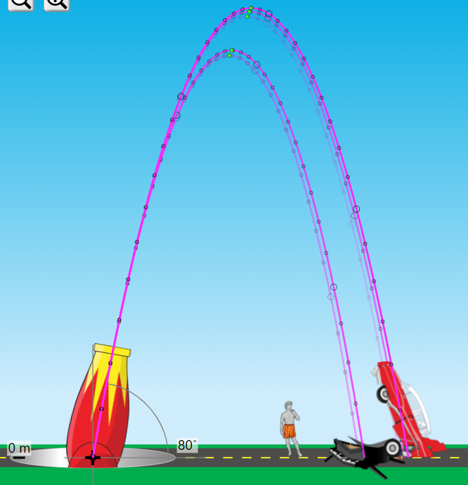

e. Make a statement regarding the effect of air resistance on motion.

*Air resistance affects the motion of the projectiles. Some of the projectiles had a lower vertical displacement.*

6. **Vertical Launch (with NO air resistance)**:

a. “Erase” the motion paths and change the parameters as follows:

angle = 90° initial velocity = 15 m/s choose any object you want

b. Click fire, and observe the resulting motion. When it finishes, adjust the initial velocity to 18 m/s, 21 m/s, 24 m/s, 27 m/s and 30 m/s. **INCLUDE UNITS**.

|  |  |  |
| --- | --- | --- |
| Initial Velocity (m/s) | **dx**  (Range) | **dy**  (Height) |
| 15 | 0 m | 10.4 m |
| 18 | 0 m | 16.4 m |
| 21 | 0 m | 22.4 m |
| 24 | 0 m | 28.4 m |
| 27 | 0 m | 36.9 m |
| 30 | 0 m | 45.9 m |

d. What parameter(s) changed when the vertical launch angle was 90**°**?

*Vertical height and time both changed*

e. What parameter(s) did not change when the vertical launch angle was 90**°**?

*Horizontal displacement did not change*

7. **US Army Sergeant**:

a. “Erase” the motion paths.

b. Move the target to 20.0 m exactly.

c. Choose the parameters you want and try to hit a bull’s eye on the target.

d. How many attempts does it take to hit the bull’s eye?

*Answers will vary*

8. The curved path caused by the combination of an initial velocity and gravity (e.g. an outfielder throws the ball to home plate) is known as: projectile motion.