Chapter 6: Metabolism Overview and Enzymes

1. Energy
   1. Cells Transform _____ as they Perform Work.
      1. Cells are miniature chemical factories, housing thousands of _____.
      2. Some of these chemical reactions _____ energy, and others _____ energy.
   2. Energy is the ability to do _____ or to cause change
   3. Two General Types of energy that exist in all forms of energy.
      1. _____ Energy: energy of _____
         1. Energy of _____ or _____ Energy
         2. _____ being done
         3. Some types
            1. Thermal energy: a type of kinetic energy associated with _____ and deals with the random _____ of atoms or molecules.

Heat flows (transfers _____ energy) from _____ to _____ (thus KE).

* + - * 1. _____ (Light) energy

kinetic energy of _____ or waves of light

Light energy is absorbed by _____.

* + 1. _____ Energy: _____ energy that matter possesses as a result of its location or structure.
       1. Stored Energy in:
* _____ bonds
* _____ gradients
* Electric potential (cell _____)
  + - 1. _____ Energy:
         1. The potential energy available for release in a chemical _____.
         2. The most important type of energy for living organisms to _____ the _____ of the cell.
  1. Energy can be _____ from one form to another.
  2. Cells _____ energy as the perform work.
     1. _____ is the study of energy _____ that occur in and between living organisms.
        1. The word _____ is used for the matter under study.
        2. The word _____ is used for everything outside the system; the rest of the universe.
        3. The two laws of thermodynamics that govern energy _____ in organisms.
           1. First Law of Thermodynamics

The law of Energy _____

Energy can be _____ and transformed

Energy _____ be created or destroyed.

* + - * 1. The Second Law of Thermodynamics

Energy conversions increase the _____ of the universe.

_____: measure of _____

II. Types of Chemical Reactions: E_____ & E_____

* 1. _____ Reactions
     1. Chemical reactions that _____ energy in the form of _____ to the surroundings.
     2. Release the energy stored in the covalent bonds of the _____.
     3. Burning wood _____ the energy in glucose as _____ and _____.
     4. Cellular _____
        1. Involves many steps
        2. _____ energy slowly
        3. Uses some of the released energy to produce _____
        4. _____ + 6O2 🡪 6 CO2 + 6H2O + _____
  2. _____ Reactions
     1. _____ energy from the surroundings
     2. Yield products rich in potential energy.
     3. Start with reactant molecules that contain relatively little _____.
     4. End with products that contain more _____.
     5. Photosynthesis
        1. Uses energy-_____ reactants (carbon dioxide and water).
        2. Energy is _____ from sunlight
        3. Energy-rich _____ molecules are produced.
        4. 6CO2 + 6H20 🡪 C6H12O6 + 6O2
        5. Plants, _____, _____ have photosynthesis and are called _____ because they can make their own food.
  3. Chemical Reactions
     1. A livi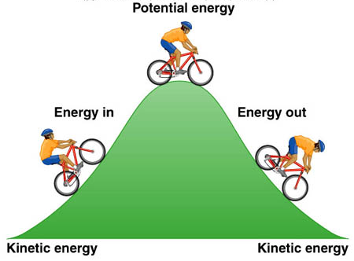ng organism carries out thousands of _____ and _____ chemical reactions
     2. The total of an organism’s chemical reactions is called _____.
     3. A metabolic pathway is a series of chemical reactions that either
        1. _____ a complex molecule or
        2. _____ _____ a complex molecule into simpler compounds.
     4. Energy is _____ - Energy Coupling
        1. Uses the energy released from _____ reactions to drive _____ reactions, typically using the energy stored in _____ molecules.
           1. _____ (Adenosine TriPhosphate) powers nearly all forms of cellular work.
           2. ATP consists of

Adenosine (a _____, adenine & a _____, ribose)

Triphosphate tail of three phosphate groups.

* + - 1. _____ of ATP releases energy by transferring its third phosphate from ATP to some other molecule in a process called _____.
      2. Most cellular work depends on _____ energizing molecules by phosphorylating them.
      3. _____ has enough stored energy to power a variety of cellular activities such as:
         1. _____ Protein synthesis
         2. Muscle contractions
         3. _____ transport across the cell membrane.
         4. _____ & repair
         5. Reproduction
      4. The _____ molecule is the basic _____ source of all living cells.
      5. In a cell, _____ is used continuously and must be regenerated continuously. In a working muscle cell, 10 million ATP are consumed and regenerated per second.
      6. A _____ uses & regenerates ATP continuously
      7. In the ATP Cycle, energy released in an _____ reaction, such as the breakdown of _____ during cellular respiration, is used in an endergonic reaction to _____ ATP from ADP.

Which pathway shows the hydrolysis of ATP ?

[ ] ATP + P + energy 🡪 ADP

[ ] ATP 🡪 ADP + P + energy

[ ] ADP 🡪 ATP + P + energy

[ ] ADP + P + energy 🡪 ADP

Label each item exergonic or endergonic.

1. Cellular Respiration
2. Phosphorylation of ATP
3. Photosynthesis
4. Hydrolysis of ATP

Label each item Potential Energy (PE) or Kinetic Energy (KE).

1. Chemical Bonds
2. Radiant Energy shining
3. Heat flowing
4. Concentration gradients
5. The Importance of _____ and how they Function
   1. Enzymes _____ _____ the cell’s chemical reactions by _____ energy barriers

Time

Energy

Activation energy

Reactants

Products

* + 1. Although biological molecules possess much _____, it is not released spontaneously.
       1. An energy _____ must be overcome before a chemical reaction can begin.
       2. This energy is called the _____ energy because it activates the reactants.
       3. Activation energy is the energy needed for a reactant molecule to move _____ to a higher-energy (although an unstable state) so the “_____” part of the reaction can begin.
       4. One way to speed up a reaction is to add _____, which agitates atoms so that bonds break more easily and reactions can proceed, but too much heat will kill a cell.
    2. 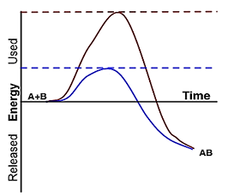Enzymes
       1. Function as biological _____.
          1. _____ up a reaction without being consumed by the reaction.
          2. They are usually _____.
          3. Are usually _____.
          4. Enzymes _____ __ a reaction by lowering the activation energy needed for a reaction to begin.
       2. An enzyme is very _____ in the reaction it catalyzes.
       3. It has a _____ that determines the enzyme’s specificity
       4. The specific reactant that an enzyme acts on is called the enzyme’s _____.
       5. A substrate fits into a region of the enzyme called the _____ _____.
       6. Enzymes are specific because only _____ substrate molecules fit into their active site.
       7. For every enzyme, there are _____ conditions under which it is most effective.
       8. _____ affects molecular motion
          1. An enzyme’s _____ temperature produces the highest rate of contact between the reactants and the enzyme’s active site.
          2. Most human enzymes work best at 35-40**°**C.
       9. The optimal ____ for most enzymes is near neutrality (about 7).
    3. Enzyme Helpers
       1. _____ and _____
       2. Necessary for some _____ to function properly.
       3. Cofactors: inorganic (_____, _____, Zn+2, Fe+2, Ca+2) or organic.
       4. Coenzymes: organic; most _____, NAD, FAD.

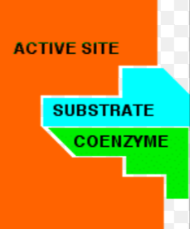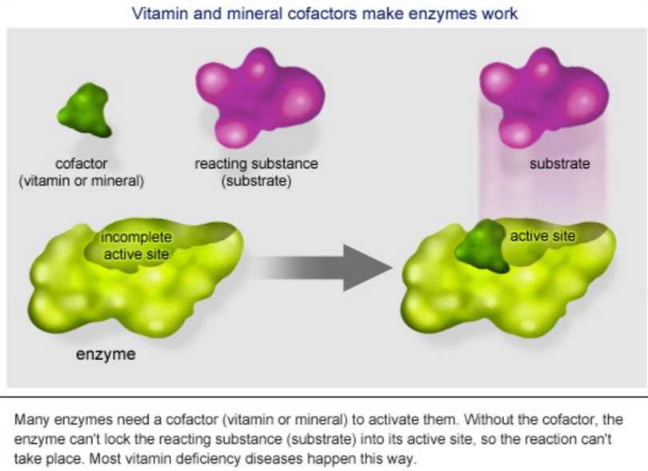

Label the diagram by filling in the text boxes:

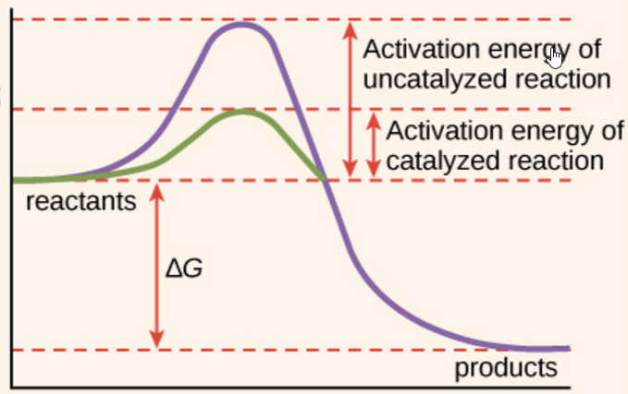

?

?

?

heat

?