*Refer to your textbook: Chapter 12.1-12.2 for guidance.*

**Activity 1 Newton’s First Law of Motion**

**Purpose** To investigate Newton’s 1st Law of Motion in everyday experience.

**Background Information**

Newton’s 1st law of motion states that an object at rest will remain at rest and an object in motion will remain in motion at constant velocity unless acted upon by an unbalanced force. Inertia is the tendency of matter to resist a change in motion. Therefore, Inertia is directly related to mass. The greater the mass of an object, the greater its inertia or resistance to a change in motion.

**Hypothesis**

If a raw egg and a hard-boiled egg are spun on their ends, then the raw egg will continue to spin longer than the hard-boiled egg because of inertia.

If a raw egg and a hard-boiled egg are spun on their sides, stopped, and immediately released, then the raw egg will begin to spin again, but the hard-boiled egg will stay at rest because of inertia.

**Materials** Coin 3 x 5 inch index card small non-glass cup

1 Raw egg 2 hard-boiled eggs

**Procedures**

**Part 1 Coin**

1. Place the small non-glass cup on the table, right side up.

2. Place the 3 x 5 inch index card on top of the upright glass so that the opening of the cup is covered.

3. Center the index card over the center of the cup.

4. Place the coin at the center of the index card.

5. Slowly pull the index card HORIZONTALLY across the glass opening. Record what happens to the coin in the Calculations and Data section.

6. This time, grasp the index card firmly and QUICKLY yank (pull) the index card HORIZONTALLY across the glass opening. Record what happens to the coin in the Calculations and Data section.

**Part 2 Eggs (TWO day process)**

7. You need to hard boil an egg (maybe a couple, just in case you break one).

a. Place 2 eggs in a pan and cover the eggs completely with water 2-3 cm above the eggs.

b. Turn the stove on high and allow the water to boil (with the eggs) for 10-12 minutes. (It takes 15-20 minutes total.)

c. Turn off the stove and wait for the water to stop boiling.

d. Remove the eggs using a large spoon or tongs and place them in cold water.

e. Once you feel it is safe, put the eggs in the refrigerator overnight.

8. Once you are sure you have hard-boiled eggs, you can begin this experiment.

9. Obtain one hard-boiled egg and one raw egg. Have another person place the eggs on the table so that YOU DO NOT KNOW which egg is raw and which is hard-boiled.

10. Predict which egg you think is raw and which is hard-boiled. Record your prediction (in the Calculations and Data section). Explain your choice.

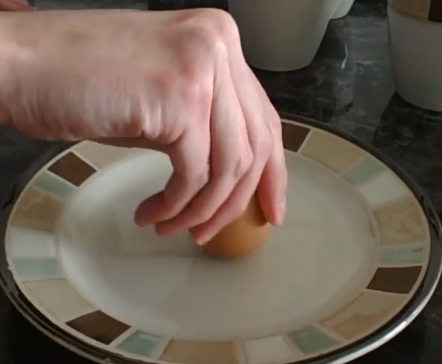

11. Take either egg and hold it on the fatter end so the thinner end is facing the ceiling. Spin the egg and record what happens (in the Calculations and Data section).

12. Repeat step 11 with the other egg and record your observation (in the Calculations and Data section).

13. Based on procedures 11-12, use the hard-boiled egg first (the one that spun the longest).

a. Place it on its SIDE (not the end).

b. Spin the hard-boiled egg for 1 second.

c. Grasp the egg to stop its motion and IMMEDIATELY let it go.

d. Record what happens in the Calculations and Data section.

e. Perform 2-3 trials to make sure you get good results.

14. Repeat step 13 with the raw egg and record your observation (in the Calculations and Data section).

**Calculations and Data**

5. Record your observation when you slowly pulled the index card HORIZONTALLY across the cup opening.

6. Record what happened when the index card was pulled QUICKLY & HORIZONTALLY across the cup opening.

10. Predict which egg you think is raw and which is hard-boiled. Explain your choice.

11-12. What happened when you spun the egg on its END?

13. Record what happened to the hard-boiled egg when spun on its SIDE and stopped and let go.

14. Record what happened to the raw egg when spun on its SIDE and stopped and let go.

## **Conclusions and Questions**

1. What principle was observed when the coin dropped into the cup? Explain why the coin did what it did (in both cases of the procedures).

2. Identify which egg was raw and which egg was hard-boiled when spun on their ENDS. Explain how you know which was which.

3. Explain why the raw egg starting spinning again after it was stopped while the hard-boiled stayed motionless once stopped.

**Activity 2 Newton’s First Law of Motion**

**Purpose** To apply Newton’s 1st Law of Motion in order to make predictions.

**Background Information**

Based on Newton’s First Law of Motion and object in motion will continue in motion unless acted upon by an unbalanced force. Practically, this means an object will travel in a straight line unless acted upon.

**Hypothesis**

If the marble is rolled inside the pie pan, then it will continue in a circular path once it reaches the open end of the pie pan.

**Materials** Aluminum pie pan scissors marble / small ball

**Procedures**

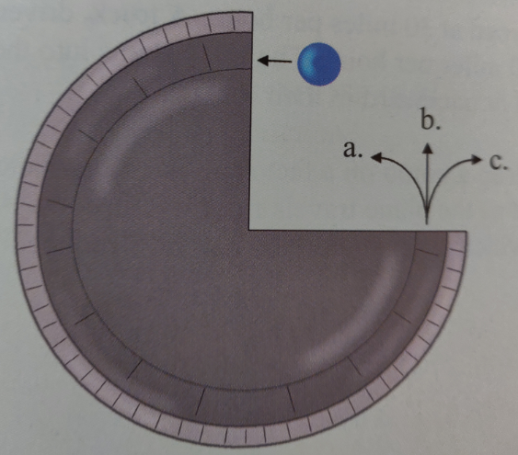

1. Use the scissors to cut a quarter of the pie pan away.

2. In this experiment, you will roll the marble into the pie pan so it is guided by the pie pan’s wall (making a circle). Once the marble reaches the open (cut) part of the pie pan, it will roll on its own.

3. Before performing this experiment, predict the path the marble will take once it begins to roll on its own. Record your prediction in the Calculations and Data section.Give a reason for your prediction.

4. Now, perform the experiment by holding down the pie pan and rolling the marble along the inner edge of the pie pan with enough force so that is stays in a circular pattern and leave the pie pan. Record what happens to the marble when it reaches the open end of the pie pan (in the Calculations and Data section).

## **Calculations and Data**

3. Before performing this experiment, predict the path the marble will take once it begins to roll on its own. Give a reason for your prediction.

5. What happened to the marble (rolled along the inside edge of the pie pan) when it reached the open end of the pie pan?

## **Conclusions and Questions**

Address Hypothesis

1. Why did the marble go in a straight line when leaving the pie pan instead of following the curved path it had in the pie pan?

2. The semi-circular canals inside the human ear maintain our balance. These canals are filled with liquid. Based on Activities 1 & 2, explain why this would relate to our balance.

**Activity 3 Friction**

**Purpose** To investigate how friction affects the motion of objects.

**Background Information**

Friction is a force that always opposes motion, producing negative acceleration or “deceleration”. The four kinds of friction & how to reduce it:

* + - Sliding (*scuff feet on the floor*) - lubrication
    - Rolling (*roller blades, bicycles, cars*) – ball bearings
    - Fluid friction (*oil in crankcase, fish in water*) – lubricate, streamline
    - Static (*it is much harder to move a non-moving object than a moving one*)

**Hypothesis**

If a car horn is approaching the listener, then the pitch becomes higher. If the sound is moving away from the listener, the pitch becomes lower.

**Materials** Smooth, non-carpeted floor Wagon or Wheel barrow Hand Lotion

Carpeted or rough floor Tennis ball (any ball) Work Gloves

**Procedures**

1. In this activity, you will perform several simple experiments which can be adjusted if you lack the proper materials.

2. Complete the table in the Calculations and Data section.

## **Calculations and Data**

|  |  |
| --- | --- |
| **Materials** | **Observation** |
| Smooth, non-carpeted floor and socks on your feet. Try sliding on the floor. |  |
| Carpeted, rough floor and socks on your feet. Try sliding on the floor. |  |
| Smooth, non-carpeted floor and sneakers on your feet. Try sliding on the floor. |  |
| Roll a tennis ball along a smooth floor. |  |
| Roll a tennis ball in the grass. |  |
| Put on a pair of work gloves. Rub your hands together. How easy is it? |  |
| Add hand lotion between the gloves. Rub your hands together. How easy is it? |  |
| Have a person sit in a wheel barrow (or wagon). Move the person 10 feet noticing the effort to start the motion and to keep it going. |  |

## **Conclusions and Questions**

1. Relate the four types of friction observed in this activity with the procedure used to test for it.

2. What is significant about friction? Give examples of how friction can be useful and not useful.

**ANSWERS**

*Refer to your textbook: Chapter 12.1-12.2 for guidance.*

**Activity 1 Newton’s First Law of Motion**

**Calculations and Data**

5. Record your observation when you slowly pulled the index card HORIZONTALLY across the cup opening.

*The coin stayed on the index card, moving along with it.*

6. Record what happened when the index card was pulled QUICKLY & HORIZONTALLY across the cup opening.

*The coin dropped directly downward into the cup.*

10. Predict which egg you think is raw and which is hard-boiled. Explain your choice.

*It’s a random choice. There is no way of knowing which is which yet.*

11-12. What happened when you spun the egg on its END?

*One of the eggs will stop spinning very quickly (raw egg), but the other will continue to spin for a little while (hard-boiled egg).*

13. Record what happened to the hard-boiled egg when spun on its SIDE and stopped and let go.

*The hard-boiled egg stayed motionless.*

14. Record what happened to the raw egg when spun on its SIDE and stopped and let go.

*The raw egg began to spin again once let go.*

## **Conclusions and Questions**

1. What principle was observed when the coin dropped into the cup? Explain why the coin did what it did (in both cases of the procedures).

*The principle observed when the coin stayed on the index card when pulled slowly, and when the coin dropped downward into the cup when the index card was pulled quickly is inertia. An object at rest while stay at rest unless acted upon by an outward force. When the index card was pulled quickly, the coin did not move, therefore, gravity caused it to drop into the cup. When the card was slowly quickly, the coin went along with the card because the card was an outside force acting on it.*

2. Identify which egg was raw and which egg was hard-boiled when spun on their ENDS. Explain how you know which was which.

*When spun on their ends the hard-boiled egg continued to spin because its contents are solid. The raw egg stopped spinning quickly because its contents are loose.*

3. Explain why the raw egg starting spinning again after it was stopped while the hard-boiled stayed motionless once stopped.

*When spun on their sides the raw egg continued to spin because its contents are liquid. So, although the outside of the egg was stopped, the inside contents continued to move due to inertia. The hard-boiled egg stopped spinning quickly because its contents are solid and the outside force of one’s hand stopped the motion.*

**Activity 2 Newton’s First Law of Motion**

## **Calculations and Data**

3. Before performing this experiment, predict the path the marble will take once it begins to roll on its own. Give a reason for your prediction.

*Any prediction is fine. Most people think that the marble will go towards “a” following the same pattern it had inside the pie pan.*

5. What happened to the marble (rolled along the inside edge of the pie pan) when it reached the open end of the pie pan?

*The marble continued towards “b” in a straight line out from the pie pan.*

## **Conclusions and Questions**

The hypothesis that if the marble is rolled inside the pie pan, then it will continue in a circular path once it reaches the open end of the pie pan was proven false by the experiment. The marble travelled in a straight line once it left the pie pan.

1. Why did the marble go in a straight line when leaving the pie pan instead of following the curved path it had in the pie pan?

*The marble within the pie pan was acted upon by an outside unbalanced force (the walls of the pie pan) to keep it in a circular pattern. However, once the marble left the pie pan, there was no longer an outward force acting on it except the friction of the table. Therefore, the marble continued in a straight line.*

2. The semi-circular canals inside the human ear maintain our balance. These canals are filled with liquid. Based on Activities 1 & 2, explain why this would relate to our balance.

*Just as in the raw egg, the liquid in the semi-circular canals of the ear is subject to inertia. If a person moves, the liquid moves along with the body. If there is a sudden change in direction, the liquid in the semi-circular canals wants to travel in a straight line, but the outward force of the head can affect the motion. In other words, the brain thinks one is still moving until the friction force stops the movement of the liquid in the ears.*

**Activity 3 Friction**

## **Calculations and Data**

|  |  |
| --- | --- |
| **Materials** | **Observation** |
| Smooth, non-carpeted floor and socks on your feet. Try sliding on the floor. | *Sliding is possible and relatively easy.* |
| Carpeted, rough floor and socks on your feet. Try sliding on the floor. | *Sliding is very difficult.* |
| Smooth, non-carpeted floor and sneakers on your feet. Try sliding on the floor. | *Sliding is very difficult.* |
| Roll a tennis ball along a smooth floor. | *The tennis ball rolls quite a distance.* |
| Roll a tennis ball in the grass. | *The tennis ball is stopped almost immediately.* |
| Put on a pair of work gloves. Rub your hands together. How easy is it? | *Rubbing is not so easy.* |
| Add hand lotion between the gloves. Rub your hands together. How easy is it? | The lotion made rubbing much easier. |
| Have a person sit in a wheel barrow (or wagon). Move the person 10 feet noticing the effort to start the motion and to keep it going. | *It takes much more effort to start moving the wheel barrow or wagon than to keep it going.* |

## **Conclusions and Questions**

1. Relate the four types of friction observed in this activity with the procedure used to test for it.

*Sliding friction was observed when comparing sliding on a floor with socks versus sneakers.*

*Rolling friction was observed when comparing rolling the tennis ball on the floor versus in the grass. Using the wheel barrow (or wagon) with wheels made it much easy to move a person.*

*Fluid friction was observed with comparing rubbing the work gloves without hand lotion and then with it.*

*Static friction was observed when trying to move the person in the wheel barrow (or wagon). It was much harder to get the object to move at all and easier to keep it moving.*

2. What is significant about friction? Give examples of how friction can be useful and not useful.

*Friction is the one force that always opposes motion. It can be useful to allow us to walk without slipping, stop using brakes, and create warmth. It has to be overcome when sliding objects, when facing air resistance, and when trying to push or lift a heavy object.*