FRICTION Lab

**Introduction**

**Purpose**

To investigate the force of friction (an opposing force) and the factors that affect friction.

**Discussion**

Friction is a force that always opposes motion, producing negative acceleration or “deceleration”

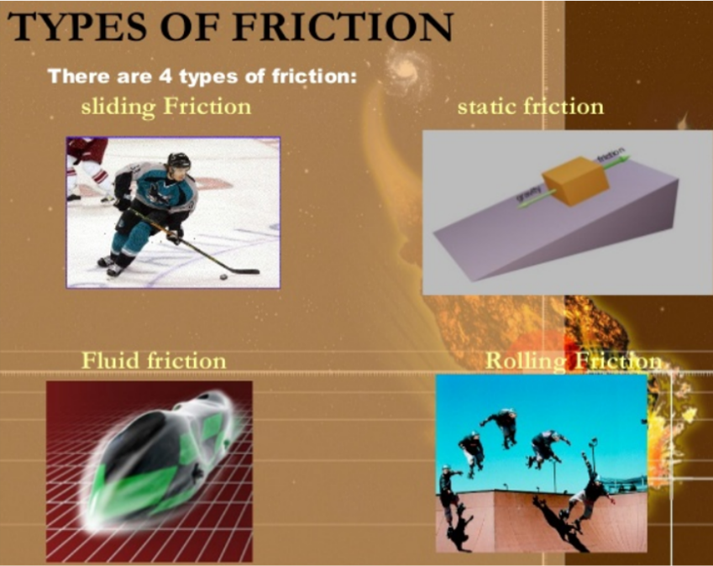

The four kinds of friction & how to reduce it:

* + - Sliding (*scuff feet on the floor*) - lubrication
    - Rolling (*roller blades, bicycles, cars*) – ball bearings
    - Fluid friction (*oil in crankcase, fish in water*) – lubricate, streamline
    - Static (*it is much harder to move a non-moving object than a moving one*)

*“Kinetic” friction includes any object that is moving.*

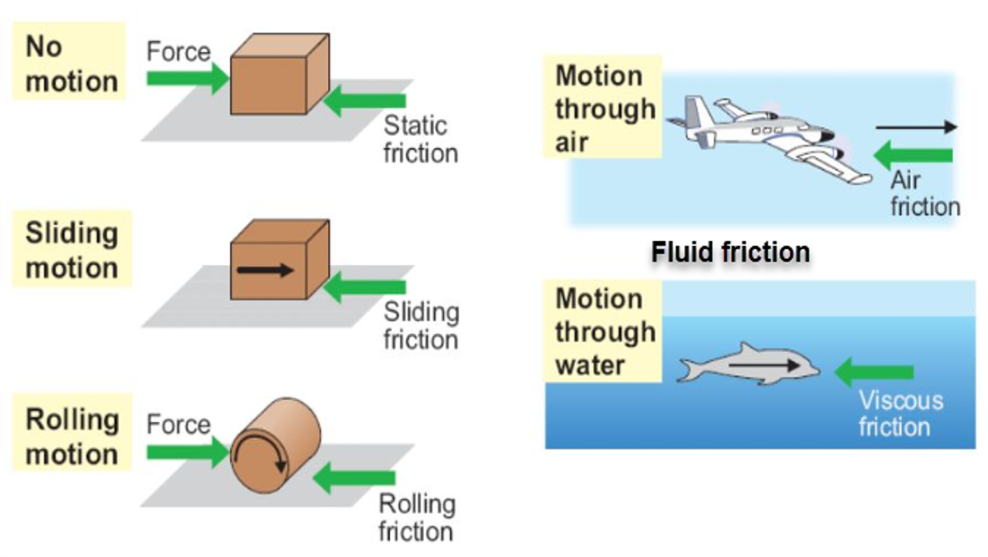

**Hypothesis**

If different surfaces are utilized when moving objects, then friction will vary.

**Materials** Spring balance Metric ruler

Rectangular block of wood fitted with a metal eye 1 m track

Large piece of sandpaper

<http://somup.com/crhT28qX2y> Friction Lab (2:35)

**Procedures**

A. Predict which of the following in each case would be LEAST effected by friction:

1. larger surfaces vs. thinner surfaces
2. smooth surfaces vs. rough surfaces
3. lighter objects vs. heavier objects

**B. Larger, Flat-Surface Friction**

1. Measure and record the mass of a block of wood & convert to Newtons.

|  |  |  |  |  |
| --- | --- | --- | --- | --- |
| Mass of wood block | g | Divide by 1000 | | kg |
| **Force of block in Newtons (kg mass x 10)** | | | **N** | |

2. Place the block flat on the lab table with its larger surface downward as shown below:

Block of wood with eye

Spring scale

3. Hold the spring scale horizontally (*level with the surface of the counter or table*). Pull on the spring scale SLOWLY, noticing the mass in grams. [“**Static Friction**”] Repeat this procedure for 2-3 trials, and record your “best” force.

Calculate the average force in Newtons to overcome resting position.

|  |  |  |  |
| --- | --- | --- | --- |
| Best Trial | g | Divide by 1000 | kg |
| **Force of block in Newtons (kg mass x 10)** | | | **N** |

4. Now you will pull the block with the spring scale across the counter or table until the block is moving at a constant speed. [“**Sliding Friction**”]

Calculate the average force in Newtons to pull the block of wood at constant speed.

A)

|  |  |  |  |
| --- | --- | --- | --- |
| Best Trial | g | Divide by 1000 | kg |
| **Force of block in Newtons (kg mass x 10)** | | | **N** |

B) What does sliding the wood block over the surface produce?

5. **Surface Area**. Measure the dimensions of the larger surface of the wooden block:

|  |  |
| --- | --- |
| Length (*longer side*) | cm |
| Width | cm |
| **Surface Area (L x W)** | **cm2** |

**C. Smaller, Thin-Surface Friction**

1. Place the block on the lab table with its thinner surface (height/thickness side) down as shown:

Block of wood with eye

Spring scale

2. Repeat previous procedures using the **wood block on its thinner side (thickness/height)**.

A) **Static Friction**

|  |  |  |
| --- | --- | --- |
| Best Trial | g | kg |
| **Force of block in Newtons** | | **N** |

B) **Sliding Friction**

|  |  |  |
| --- | --- | --- |
| Best Trial | g | kg |
| **Force of block in Newtons** | | **N** |

What does sliding the wood block over the surface produce?

C) **Surface Area** of the thinner side of the wood block. Measure the dimensions of the thinner surface of the wooden block:

|  |  |
| --- | --- |
| Length (*longer side*) | cm |
| Width | cm |
| **Surface Area (L x W)** | **cm2** |

**D. Rough-Surface Friction**

1. Repeat the previous procedures, sliding only the larger surface of the **wood block over** a piece of **sandpaper**.

A) **Static Friction**

|  |  |  |
| --- | --- | --- |
| Best Trial | g | kg |
| **Force of block in Newtons** | | **N** |

B) **Sliding Friction**

|  |  |  |
| --- | --- | --- |
| Best Trial | g | kg |
| **Force of block in Newtons** | | **N** |

* What does sliding the wood block over the surface produce

C) **Surface Area** of the larger side of the wood block:

|  |  |
| --- | --- |
| Length (*longer side*) | cm |
| Width | cm |
| **Surface Area (L x W)** | **cm2** |

**E. Heavier Objects & Friction**

1. Add another block of wood to your set up or add some weight:

1. Mass of the two blocks

|  |  |  |  |
| --- | --- | --- | --- |
| Mass of the heavier wood block | | | |
| Total Mass | g | Divide by 1000 | kg |
| **Force of block in Newtons (total kg mass x 10)** | | | **N** |

B) **Static Friction**

|  |  |  |
| --- | --- | --- |
| Best Trial | g | kg |
| **Force of block in Newtons** | | **N** |

C) **Sliding Friction**

|  |  |  |
| --- | --- | --- |
| Best Trial | g | kg |
| **Force of block in Newtons** | | **N** |

* What does sliding the wood block over the surface produce?

2. Measure the **Surface Area** of the total wood block used:

|  |  |
| --- | --- |
| Length (*longer side*) | cm |
| Width | cm |
| **Surface Area (L x W)** | **cm2** |

**F. Climbing a Ramp & Friction**

1. Use a 1 m track and set one end on the floor and the other end 30 cm high. Repeat the previous procedures, sliding the larger surface of the wood block up the ramp.

A) **Static Friction**

|  |  |  |
| --- | --- | --- |
| Best Trial | g | kg |
| **Force of block in Newtons** | | **N** |

B) **Sliding Friction**

|  |  |  |
| --- | --- | --- |
| Best Trial | g | kg |
| **Force of block in Newtons** | | **N** |

2. Use a 1 m track and set one end on the floor and the other end 60 cm high. Repeat the previous procedures, sliding the larger surface of the wood block up the ramp.

A) **Static Friction**

|  |  |  |
| --- | --- | --- |
| Best Trial | g | kg |
| **Force of block in Newtons** | | **N** |

B) **Sliding Friction**

|  |  |  |
| --- | --- | --- |
| Best Trial | g | kg |
| **Force of block in Newtons** | | **N** |

**CONCLUSIONS AND QUESTIONS**

1. How did the starting (static) friction compare to the sliding friction?

2. What kind of energy is given off as a result of friction?

3. What do you think accounts for the difference between the static friction and the sliding friction of the wood block?

4. Based on your data, how does the surface area influence the sliding force of friction? Give evidence to support your conclusion.

5. Based on your data, how does texture influence the sliding force of friction? Give evidence to support your conclusion.

6. How does weight influence the sliding force of friction? Give evidence to support your conclusion.

7. How does the height of a ramp influence the sliding force of friction? Give evidence to support your conclusion.

8. List two situations in which friction can be helpful.

9. List two ways you could reduce the friction between two or more surfaces.

10. Why do wheels reduce the force of friction?

11. Which task would require more effort, pushing a 1-kg box across an ordinary floor or pushing a 2000-kg box across a frictionless floor? Explain your answer.

12. Determine what happens to automobile motor oil when the engine heats up. Why is it important to have a heavier oil in summer than in winter?

**Answers**

**Conclusions and Questions**

1. How did the starting friction compare to the sliding friction?

*The starting friction was greater. This would be similar to pushing a stalled car into a parking lot. Initially, it takes a lot more force to get the car moving than to keep it moving at constant speed.*

2. What kind of energy is given off as a result of friction?

*Heat energy is produced as a result of friction.*

3. What do you think accounts for the difference between the starting friction and the sliding friction?

*Inertia had to be overcome.*

4. Based on your data, how does the surface area influence the sliding force of friction?

*The greater the surface area, the greater the friction.*

5. Based on your data, how does texture influence the sliding force of friction?

*A rougher texture/surface produces greater friction.*

6. How does weight influence the sliding force of friction?

*The weight increases the pressure (force per unit area) on the contact surface. Therefore, the force of friction increases with the weight of an object.*

7. How does height of a ramp influence the sliding force of friction?

*The higher a ramp, the more sliding friction exists. This is because the coefficient of friction increases with height of the ramp, meaning that more force is needed to overcome that friction. Gravity is also influencing this scenario as an opposing force, compounding the friction.*

8. List two situations in which friction can be helpful.

*... brakes on a car; nonslip bath mats; rubber soles on boots.*

9. List two ways you could reduce the friction between two or more surfaces.

*… decrease contact area; smooth the surfaces; decrease pressure; use a lubricant; lower the angle or height of a ramp.*

10. Why do wheels reduce the force of friction?

*Wheels provide a smoother surface and reduce the friction. Because wheels are round, this makes less surface on the ground at any given time.*

11. Which task would require more effort, pushing a 1-kg box across an ordinary floor or pushing a 2000-kg box across a frictionless floor? Explain your answer.

*To get the 200-kg box moving initially would take some force, but once it moves on the frictionless surface, no more force is required. The 1 kg box would require a force (balanced or unbalanced) the entire time it is moving on the floor.*

12. Determine what happens to automobile motor oil when the engine heats up. Why is it important to have a heavier oil in summer than in winter?

*Oil is a lubricant to make sure the metal parts do not over heat and meld together. Summer is a hotter weather pattern so the engine heats up much more than in the winter and requires a heavier grade of oil for lubrication.*