Heading
Title
Introduction

Purpose To investigate an ecological pyramid and the effects of the environment.

Discussion
All organisms need an input of energy and nutrients to live. For animals, which are heterotrophs, this comes from the food they eat. For plants, which are autotrophs, the source of energy is the sun — they produce their own food through photosynthesis — and their source of nutrients is the soil.
The feeding relationships between organisms form a food chain. Producers (plants, or autotrophs) capture the sun’s energy and absorb nutrients from the soil to make their own food, representing the largest trophic level. Primary consumers (animals, heterotrophs, or herbivores) eat the plants and capture their energy and nutrients, representing the second trophic level. Secondary consumers (animals, heterotrophs, or carnivores) eat the herbivores and capture their energy and nutrients. Tertiary (Third) and Quaternary (fourth) level consumers continue this chain by eating the lower- level carnivores. Then finally decomposers breakdown waste and dead organism’s recycling the nutrients back into the ecosystem, so they are available for another generation of plants and animals.
When a consumer eats other organisms, only a small fraction of the energy taken is used for growth. About 50% of food is not digested or absorbed and is passed out as waste. About 40% of the energy of the food is lost as heat or used by the animal for cellular respiration, which makes energy for daily life. Only 10% of the food eaten is used for growth and is available as energy for the next tropic level in the food chain. This produces a pyramid of energy and a pyramid of numbers in an ecosystem. The greatest amount of energy and the largest population is the base of the pyramid with the producers. The least amount of energy and smallest population is at the top of the pyramid.

Hypothesis
If the organisms are aligned according to trophic levels, then an ecological pyramid will show the biomass and energy for each trophic level.

Materials Lab Worksheet

Procedures
1. Select the appropriate organisms and number of organisms from page 2 and organize them to create a food chain pyramid at the appropriate trophic level. Start with the largest tropic level at the bottom of your ecosystem pyramid with a biomass of 10,000.
You should be able to click and drag on any text box LINE for each organism or copy and paste them.
2. Correctly label each trophic level (Producers, primary, secondary, tertiary & quaternary consumers).
The numbers indirectly indicate biomass based on the number of organisms.
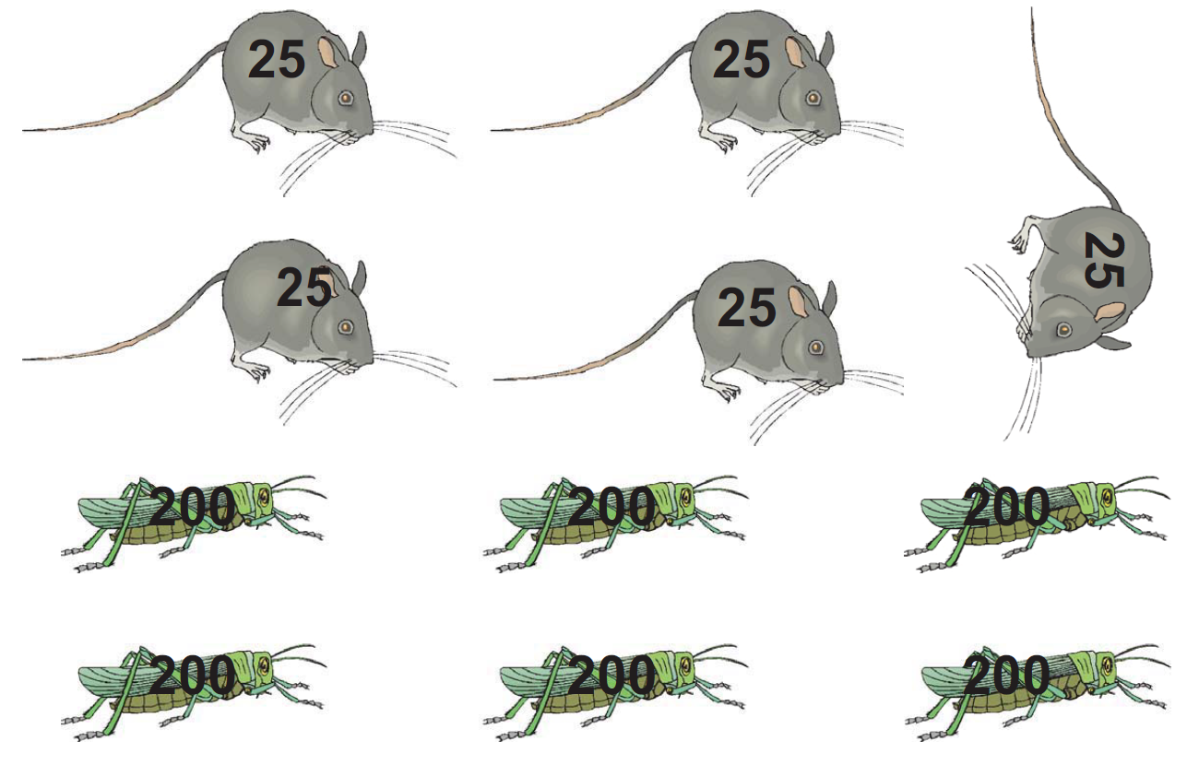
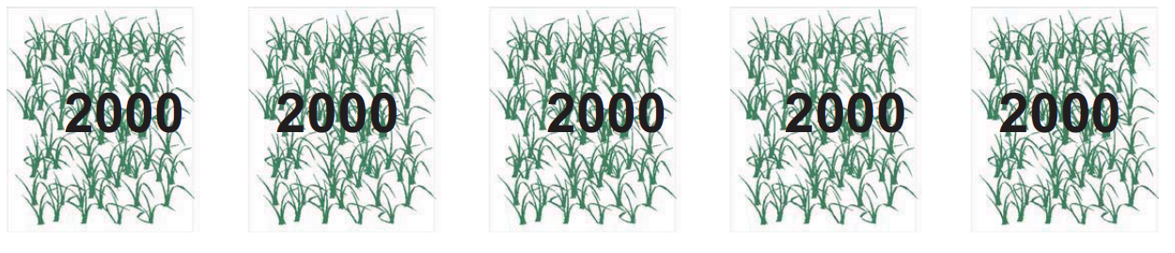
Quaternary Consumers
Tertiary Consumers
Secondary Consumers
Primary Consumers
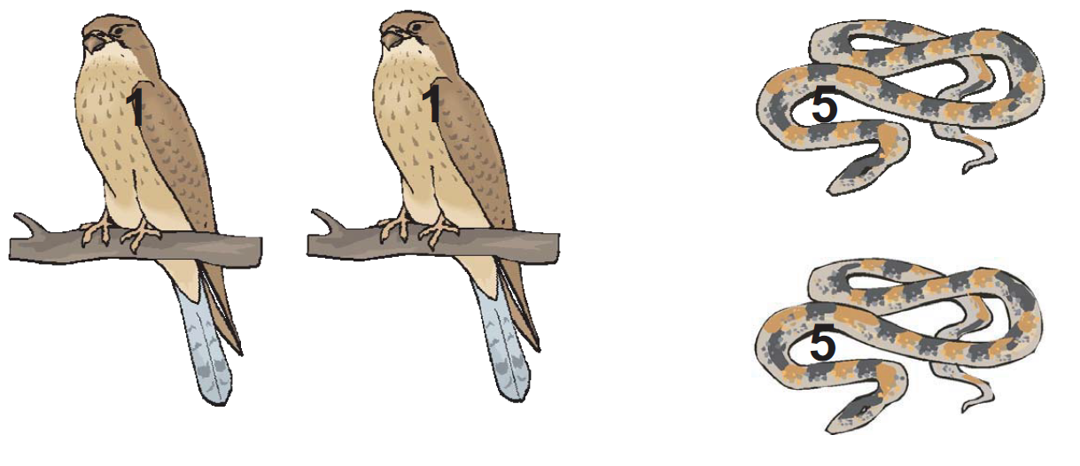
Producers
Calculations and Data

A. Place the energy pyramid on this page as instructed in the procedures.

B. Complete the chart below using the finished ecological pyramid. Also, assume the largest trophic level of the pyramid originally supported 100,000 J of energy.

Trophic Level | Name of Organism | Number of Organisms | Ratio  (Predator: Prey) | Approximate Energy
Producers
Primary Consumers
Secondary Consumers
Tertiary Consumers
Quaternary Consumers

1. Which classification of organisms are not represented in the pyramid? _____

2. Explain why none of the ratios are 1:1. In other words, why does it take more than one prey to feed one predator?

Conclusions

1. What energy source ultimately supports all food chains?

2. One day the people living in houses on the edge of this ecosystem spray an insecticide to kill a wide range of insects on their property. The wind carries the insecticide onto the field and it kills many of the grasshoppers. Discuss the possible effects on this ecosystem from the loss of the grasshoppers.

3. The grass necessary to support this ecosystem needs 10 acres to grow. But this field has been reduced to 5 acres by a tropical storm. Explain what the result of this development will be on each of the trophic levels in this ecosystem.

Errors

Not assigning organisms to the proper trophic level.
Not assigning the proper energy for each trophic level. Therefore, misunderstanding the nature of food chains.

Bibliography Images were taken from the internet.

