**Molar Quantities Chapter 10A**

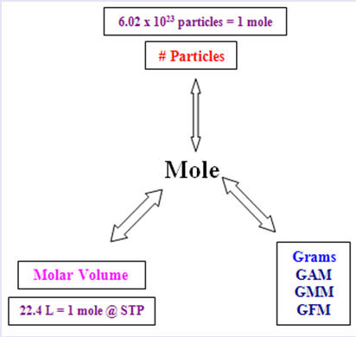

**See** [**https://www.learningctronline.com/courses**](https://www.learningctronline.com/courses) **for Materials and Resources.**

**Topics:**

1. Molar Quantities

**Objectives:**

1. Understand and utilize the mole in mathematical computations according to the mole concept (Avogadro's Number).
2. Calculate Molar Mass of Elements and Compounds. Interconvert moles and mass.
3. Calculate Molar Volume at STP. Interconvert moles and liters, molar mass and density.

TAKE NOTE

1. Notes/Study Guide (2 weeks)
2. Formal Lab Report Definite Proportions due in 4 days (Calculations & Data; Conclusions)
3. Lesson Check/Sample problems or Alternative Worksheets (2 weeks)
4. Lab Quiz: Counting by Weighing
5. Test Corrections (Chemical Formulas)
6. Upcoming (week 16): Molar Quantities Test
7. Upcoming (week 16): Semester Exam (Chapters 1-10, 13) … due within 10 days after week 16’s class … study guide available
8. Class Song: “Hello, My Students”
9. Week 15 Devotional (<https://www.learningctronline.com/devotional>)

**Text**: Chapter 10: Molar Quantities pp. 304-324

Read the assigned pages in the text.

**Class Notes: PowerPoint or PDF**

**Notes/Study Guide:** Fill in the Chapter 10 worksheet to understand the class notes.

**Homework**: Text

(1) Answer the KEYED **“Lesson Check”** questions at the end of each.

(2) Answer the **“Sample problems”** found in the “Sample Problem” boxes throughout the chapter. An answer KEY is provided for you to use to self-correct your homework problems.

* Put your answers into complete thoughts in a Word document. Do NOT just put the answer, but write a phrase or sentence that you can study from for your tests. Save your work in a WORD document and SAVE into your HOMEWORK folder in the Chemistry folder on the desktop.
* Assignments will be “spot checked” during class or submitted via email.

**Alternate Homework**:

1. Molar Quantities Review Worksheet

**Lab**: Counting by Weighing

Complete the experiment “Counting by Weighing” using the worksheet provided (based on p. 324 of the textbook).

* Answer questions 4-5 from the Analyze and Conclude section on p.324 in complete sentences using evidence from the lab.
* Note: Substitute baking soda for the CaCO3. The formula for baking soda is: NaHCO3.
* You will need the following decomposition equations for each compound to calculate moles and moles ratios as directed in the analysis and conclude section.  
    
  H2O → 2 H + 1 O  
  NaCl → Na + Cl  
  CaCO3 → Ca + C + 3 O OR NaHCO3 → Na + H + C + 3 O
* Answers are provided at the end of the document for guidance. Do NOT copy and paste these answers, but write using your own words.
* Save the document into your LAB folder in the Chemistry folder on your desktop.
* Study for understanding, and when ready, take the Lab Quiz.
* You may **NOT** use the worksheet on this lab test.

**TEST:** The test will be given after next week’s lesson.

Supplemental Resources (Optional)

[Mole Day: October 23](http://somup.com/cF6Qr8nnzh) (1:58)  
  
[A Light Shining in a Dark Place 2 Peter 1:19; Thy Word](http://somup.com/cYhDY6jUzU) (4:15)