Stoichiometry of Equations

The goal in manipulating _______ mass, molar _______, and representative particles (___) was to be able to determine exact quantities of a substance in a reaction [analytical or _______ _______] AND how they relate to each other.

The calculations of reactants and products in chemical reactions is called _______.

For chemists, stoichiometry is a form of _______.

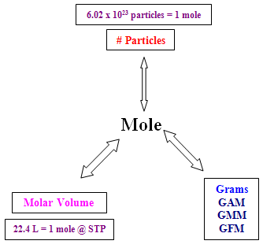

Molar mass

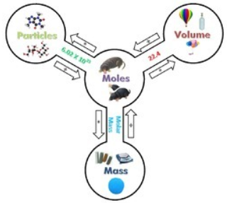

A balanced chemical equation tells you the relative amounts of _______ and _______ in the reaction.

N2(*g*) + 3H2(*g*) → 2NH3(*g*)

The balanced chemical equation can be interpreted using different quantities including numbers of _______, _______, _______, _______, and/or _______.

What are the mole ratios of the molecules?

_______ _______ is the expected moles.

The _______ represent _______ and form mole _______.

Use the _______ to find mass of reactants & products.

This shows the law of _______ of Mass

General Problem Solving Rules

1. Write a _______ equation

* Based on the information given and using the knowledge gained in stoichiometry of formulas

2. Determine _______ of reactants and products

* The “MOLE” concept is the basis, the _______, for Quantitative Analysis

3. Use the MOLE _______ to interconvert between _______ and _______

* _______ in an equation represent the number of _______ of any molecule or compound in that equation
* Since “MOLES” is a standard among all substances, we can use a MOLE _______ to interconvert different quantitative measurements

4. Convert _______ to the desired _______ or _______

You MUST always use _______ as the standard of conversion. Fill in the diagram:

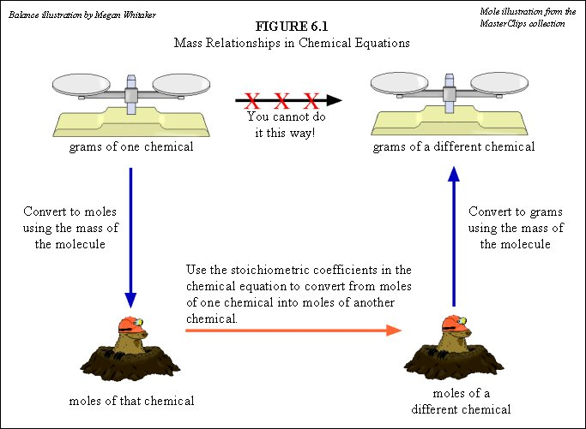

12B. Quantitative Analysis deals with _______ quantities versus _______ quantities. Often you have a “_______” issue that prevents producing what you expected.

_______ Reactant: the reactant that controls the amount of _______ that forms; the reactant that is consumed _______ during a reaction.

_______ Reactant: any reactant that is ____ consumed completely during a reaction and is left over.

Limiting & excess reactant determinations must be based on _______ quantities & _______ relationships.

You cannot tell the limiting reactant based on _______, but only based on _______ (the standard) AND the mole _______. This is _______!

The _______ reactant limits the _______ of the other reactant that can combine, and the amount of _______ that can be formed.

The excess reactant is ____ completely used up in the reaction.

_______ yield, like the theoretical distance you can drive on a tank of gas [*darker line on map to the left*], is actually a _______ possible yield.



In reality, the _______ yield [*green line*] is _______ than the theoretical yield. In other words, you never drive as far on a tank as you calculate.

Percent Yield

The _______ or _______ amount of _______ is called the _______ yield.

The amount of product _______ produced is called the _______ yield.

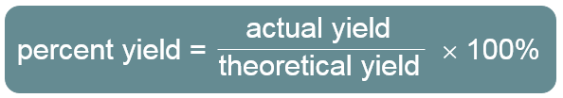

The percent _______ is a measure of the _______ of a reaction carried out in the laboratory.

Reactions do ____ always go to completion; when a reaction is incomplete, _______ than the calculated amount of product is formed.

_______ reactants and competing side reactions may cause unwanted products to form.

_______ yield can be _______ than the theoretical yield due to a _______ of product during filtration or in transferring between containers.

Importance of Percent Yield

Comparing the percent yield for different experimental _______ helps identify the most _______ process.

Finding percent yield helps to determine the _______ of production.

Large deviations in percent yield can indicate problems in a _______ or _______ to equipment.

Theoretical yield is the _______ amount of product a reaction can form as determined by the _______ reactant.

_______ yield is the observed amount of product formed in a _______ reaction.

Actual yield is always _______ than theoretical yield.

Percent yield is the _______ of _______ yield to _______ yield, expressed as a percent.

Identification of the _______ reactant allows the accurate determination of _______ yield.

Percent yield is a comparison of _______ yield with _______ yield.

Fill in the chart below:

